DRAFT REPORT ON SPIRE FEEDHORN MEASUREMENTS MADE USING THE FAR INFRARED LASER FACILITY AT R.A.L.

SPIRE-QMW-NOT-000645

Introduction
The first prototype feedhorns for the SPIRE short wavelength array were made available for test measurements in November 2000. this note describes the feedhorn geometry, optical bench layout used for the measurements, results obtained so far and recommendations for further measurements to be made and improvements to the measurement system.

So far three each of three types of feedhorn have been produced and the beam profiles of these have been measured using the setup described in the next section.

Experimental Setup
Optical flat

FIR LASER

36um Mylar BS
Rotary stage with Golay cell mounted so that horn aperture is at the center of rotation

Optical flat

Beam Monitor

Fig 1 Schematic diagram of the final optical bench layout

The optical bench layout for the measurements is shown in Fig 1. It shows the source, a chopped FIR laser, followed by a Mylar beamsplitter, two Golay cells – one for use as a beam monitor and the other coupled to the test feedhorn. The two plane mirrors are present to enable the system to fit onto the available optical bench space. Eccosorb ® is in place as shielding around the detector and beam monitor to eliminate unwanted stray light. The system is aligned using a HeNe laser placed directly behind the scanning Golay Cell. The HeNe beam was at grazing incidence with the flare end of the feedhorn mounted in the cell and returned from the plane mirror at the exit aperture of the FIR laser. An optical beam splitter was mounted for alignment which was replaced by the Mylar for horn measurements.

The scanning Golay cell with feedhorn was centred on the rotary stage using an alignment telescope to ensure that the horn aperture was as close to the center of rotation as possible.

To begin with the system setup had the beam monitor near the FIR output, but was subsequently altered to make the path length to each Golay cell equal and also to couple the beam monitor Golay cell with a similar feedhorn to the one ‘under test’. These alterations were made when doubts were raised over whether or not the two Golay cells were sampling from the same part of the laser beam. The beam diverges significantly over the path length of the system and is approximately 4.5cm wide at the rotary stage and unless the laser is well tuned to the required line, the beam is not necessarily a top hat shape [1].

Feedhorns
Nine prototype SPIRE feedhorns have been produced: 3 single moded, short wavelength (250um) horns, 3 multimoded, short wavelength horns and 3 FTS, multimoded long wavelength (350um) horns. All are conical, smooth walled feedhorns. Figure 2 shows a representative diagram of the feedhorns with the dimensions shown being for the single moded, short wavelength horn.

22.618mm
2.3mm
0.087mm
0.1mm

Fig2 SPIRE 250 micron feedhorn dimensions

The F#5 feedhorns are smooth walled conical horns with 2Fλ entrance aperture. A diagram showing the horn dimensions is shown in Fig 2. They are electroformed around a mandrel and gold plated. The feedhorn is mounted onto the Golay cell using a bespoke copper mount illustrated in Fig 3 (not to scale).

GOLAY CELL

Fig 3: Jig for mounting feedhorns on Golay cell

Data Acquisition

Data acquisition was performed with a Labview VI via a National Instruments PC DAQ card. The bespoke software takes ten readings of both channels simultaneously, performs a “median clip” and providing there are more than 7 values remaining, calculates the mean of the remaining values. A flowchart is included here in appendix 1.

Results
Results are discussed by feedhorn type. Short Wavelength Single Moded, Short wavelength Multi-moded and Long Wavelength FTS.

Short Wavelength Single Moded feedhorns
All short wavelength feedhorns were measured using 214 micron radiation provided by the FIR laser using Di-Flouromethane gas as the lasing agent. This laser line is easy to find, it being very powerful at around 30 to 50 mW. The first measurements were made using a pyroelectric detector as a beam monitor and manual data acquisition but this was found to be unsatisfactory due the relatively slow response of the pyroelectric detector compared with the Golay cell and the unreliability of manual data logging. The measurements presented here were made using two Golay cells along with PC based data logging to ensure simultaneous reading of the beam monitor and feedhorn detector. The rotary stage was operated manually in the absence of an expensive motorized stage. Measurements were made with resolution of 1 degree as at this stage the main aims were to ascertain the FWHM of the feedhorns, provide a comparison with theoretical models provided by Dr. M. Caldwell and to confirm the general suitability of the measurement system to provide reliable measurements.

The expected beam shape [1] is shown in Fig 4. They show a difference depending upon the plane of polarization of the incident radiation. Ideally both should be measured to ensure correlation with the model. However, time constraints meant that only the principle plane of polarization was measured. From the literature [2] we believe that the 214 micron line is vertically polarized.

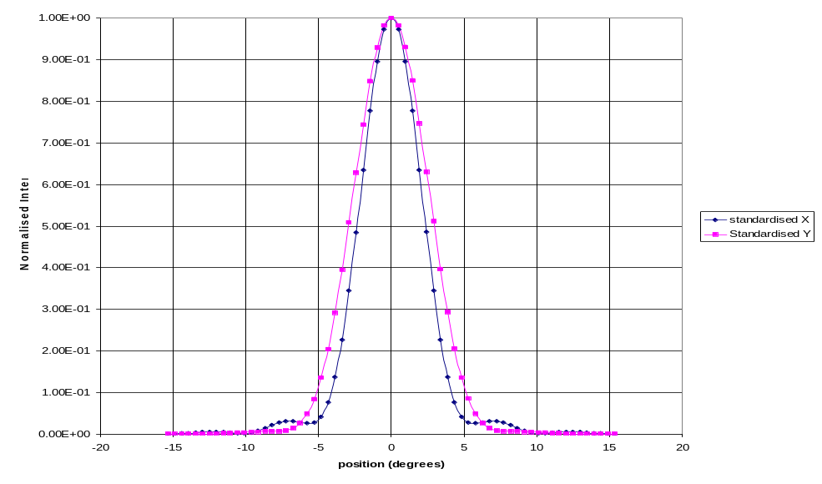
Fig 4: Expected Beam Patterns for Short Wavelength horns at 214 um.

Fig 5 shows composite plots of scans taken of the single mode short wavelength horn on different days. These scans were taken without any software data smoothing techniques described previously.

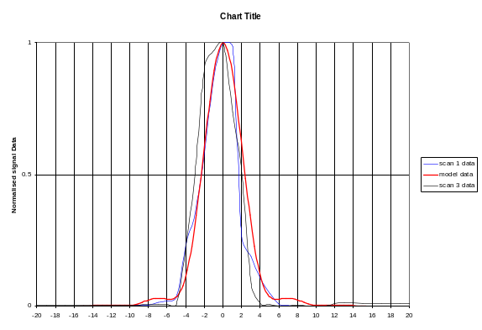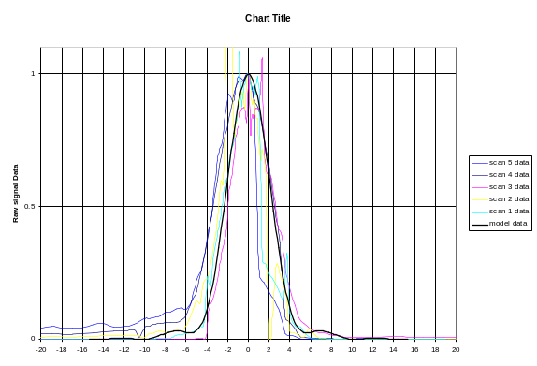
Fig 5: Composite plots of Short wavelength Single-moded feedhorn scans taken without data smoothing

Fig 5 demonstrates the difficulty in obtaining reproducible results with this system which is probably mainly due to the unstable nature of the radiation. Data smoothing techniques were employed in further scans and these can be seen in Fig 6. They show a marked improvement in the repeatability of scans. Also, the FWHM is confirmed as being wider than theory would suggest.
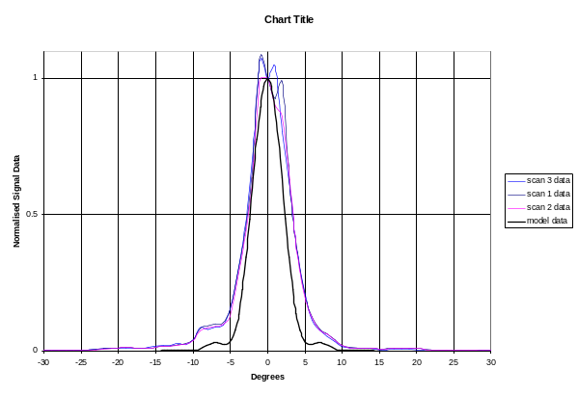
Fig 6: Scans of short wavelength single-moded feedhorn with data smoothing

Short Wavelength Multimoded feedhorns
Again, these feedhorns were measured at 214 microns. At this wavelength with a 280micron waveguide four modes will be present [?] and Fig 7 shows model data of these four modes with a summation of these giving the overall beam shape expected if all four modes couple with the same gain factor.
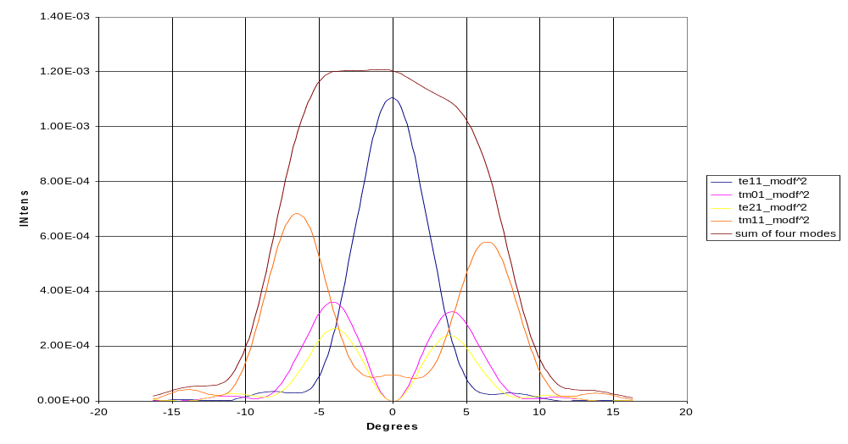
Fig 7: Model data of the four modes present for the Multimoded SW Feedhorn

Composite plots of measured data taken at different times can be seen in Figure 8. It shows that the horn did not couple with the radiation in the expected fashion.

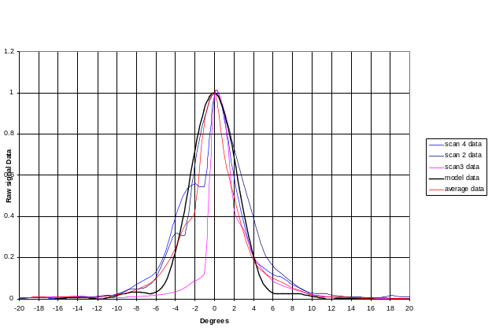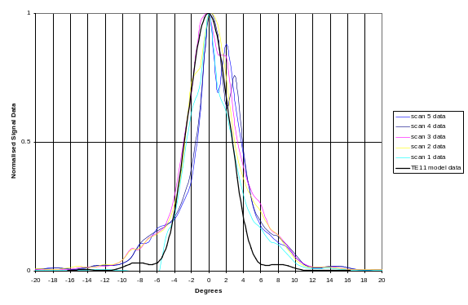
Fig 8: Multimoded feedhorn data plotted in comparison with TE11 model data

In Fig 9 this data is averaged and plotted in comparison with model data. It shows a measured FWHM that is approximately equal to what was predicted for the fundamental mode only suggesting either no coupling to the higher order modes or no higher order modes present.
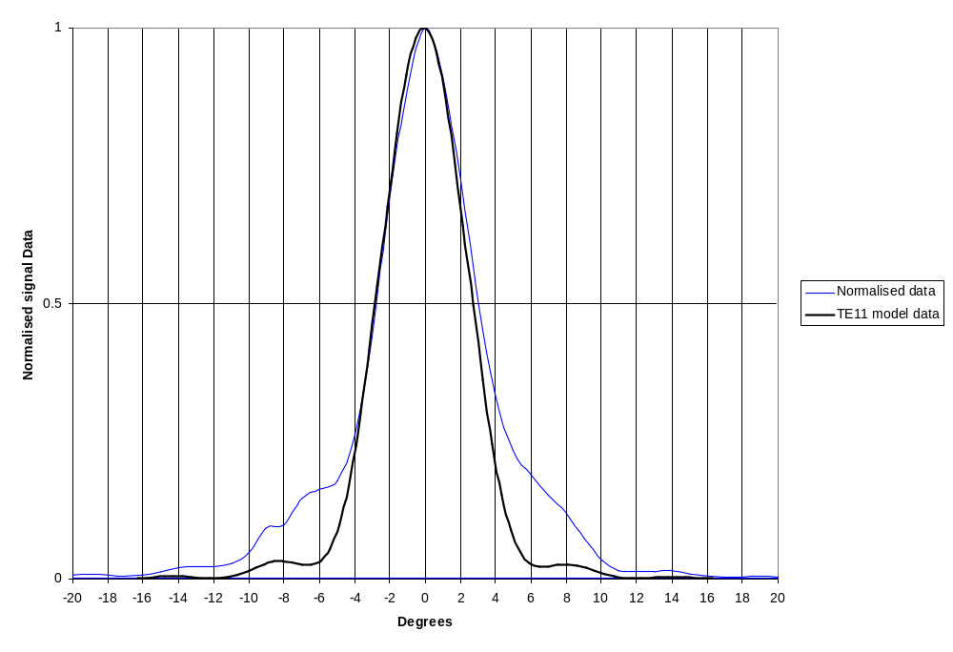
Fig9: Multimoded Short wavelength feedhorn data, averaged and compared with the TE11 mode model data

Long Wavelength FTS feedhorns
These feedhorns were measured using a 432 micron laser line provided by the FIR laser using Formic acid as the lasing gas. This line is much less powerful than the 214 micron line at around 3 – 4 mW. The model predicts that the horn will be single moded at this wavelength. The model data is shown in Fig 10.
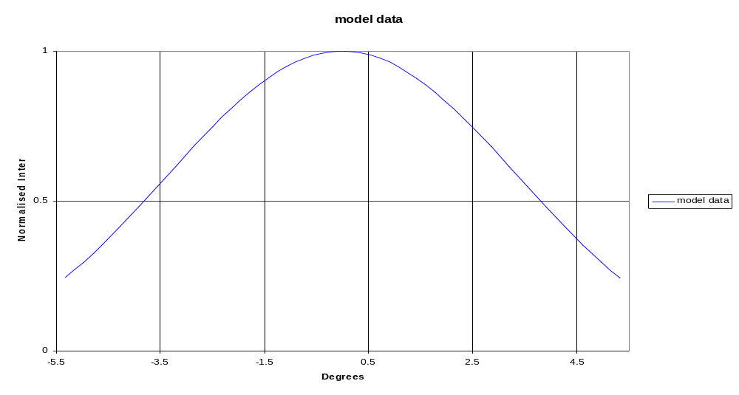
Fig10: Long wavelength feedhorn model data for 432 microns

Measured data is shown in Fig11 compared with the model data. Fig 12 shows that data averaged. The plots show a reasonable agreement with the theoretical model. 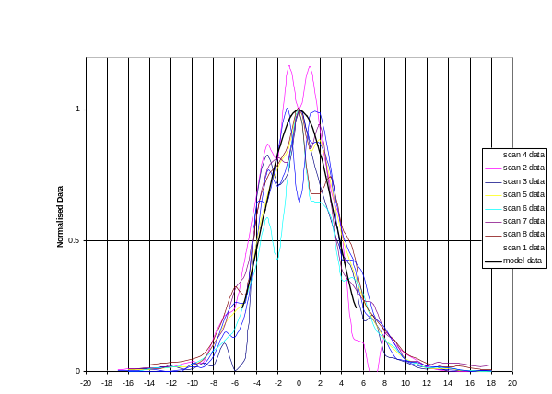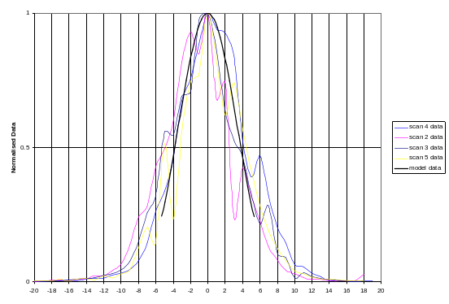
Fig11: Composite plots of all measured data taken at different times
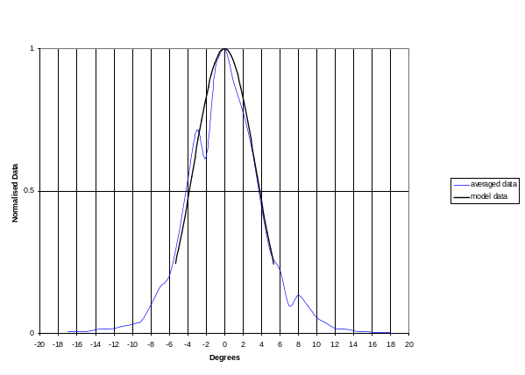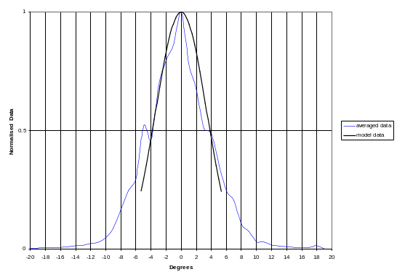
Fig12: Long wavlength feedhorn data, averaged and compared with model data

Conclusions

Beam Patterns: FWHM measurements of the RAL Short wavelength, single moded feedhorns are coming out to be slightly wider than expected wheras the multimoded short wavelength feed horn is much narrower than expected at FWHM. The long wavelength FTS feedhorn is coming out close to theory at the 3dB point. Also the multimoded feedhorns are not agreeing with theoretical models insofar as only the fundamental mode is showing in measured beam patterns. Better understanding of the reasons for this will come from throughput measurements being performed in the US.

The laser is unstable. Regular retuning of the CO2 laser is necessary, sometimes several times during a measurement sequence. This has been a very time-consuming obstacle and a limiting factor when trying to measure horn responses far out into the “wings” of the beam pattern.

Recommendations: Although measurements for the SPIRE calibration will be much faster and more efficient than the horn measurements made here, it will remain a limiting factor and given the tight schedule and extent of the tests planned, it would be wise to try to find funding partners for a laser stabilization system. Such a system is available to order from Edinburgh instruments at a price of around 8,500 pounds sterling.

Further measurements of the feedhorns should be made once the laboratory has been refurbished and designated as a clean room.

The Fabry-Perot, currently in the final stages of hardware development is required to ensure a ‘clean’ laser line.

If this system is to be used extensively in the future, The Project should invest in a Labview DAQ card (the one in use now is on loan from QMW).

The rotary stage should be automated using a simple stepper motor system.

