L.A.M.  FRE 2243 | FIRST  SPIRE | Ref : LAM.PJT.SPI.SPT.20000x Ind 0  Author : K.Dohlen and A. Origné | Page : 1 / 18  Date : 26 Oct 2000
SPIRE Alignment Tools Specification

SPIRE-LAM-PRJ-000636

Distribution List :

RAL | Colin Cunningham | X | Ken J. King | X
 | Bruce Swinyard | X
MSSL | Berend Winter | X | John Coker | X
CNES | Martine Joubert |  | Yvan Blanc
CEA-Sap | Jean-Louis Auguères
DESPA | Guy Michel
GSFC | Don.E. Jennings
LAM | Armand Artinian |  | Jean-Paul Baluteau | X
 | Claude Colin |  | Pascal Dargent | X
 | Kjetil Dohlen | X | Didier Ferrand
 | Michel Jevaud |  | Patrick Levacher
 | Alain Origné | X | Dominique Pouliquen | X

_________________________________________________________________________________
LABORATOIRE d'ASTROPHYSIQUE de MARSEILLE- CNRS BP 8 13376 MARSEILLE Cedex 12 FRANCE
Tél : (33) +4 91 05 59 00 - Fax : (33) +4 91 05 69 59
Update

Date | Indice | Remarks
23 Oct 2000 | 0 | Creation of the document, first draft

Host system | Windows NT
Word Processor | Microsoft Word 97
File | /tmp/lo/0000.doc
Printed | 23/11/2026, 23/11/2026

Table of contents

1. Scope of the document 4
2. Documents 4
2.1. Applicable documents 4
2.2. Reference documents 4
2.3. Glossary 4
3. Alignment philosophy 6
4. Description of the alignment tools 6
4.1. The “3D Tool” 7
4.2. The “Apex tool” 7
4.3. FOR and SOR, telescope and instrument optical references 8
4.4. D-tool 9
4.5. O-tool 10
4.6. PSD-tool 11
4.7. CS-tools 12
4.8. M2-tool 13
4.9. Hartmann tools 14
5. Verification experiments 15
5.1. PSD control bench 15
5.2. MAT Control Bench 16
5.3. Tools Bench 16
6. Requirements 17
6.1. Functional requirements 17
6.1.1. Performance requirements 17
6.1.2. Technical requirements 17
6.2. Operational requirements 18
6.2.1. Relialibility 18
6.2.2. Lifetime 18
6.2.3. Operating modes 18
6.2.4. Telemetry 18
6.2.5. Telecommands 18
6.3. Interface requirements 19
6.4. Design and manufacture requirements 19
6.4.1. Design requirements 19
6.4.2. Design rules 19
6.4.3. Manufacture requirements 19
6.5. Logistic requirements 19
6.6. Environment requirements 19
6.6.1. Natural environement 19
6.6.2. Operating environment 20
6.7. Verification requirements 20

Scope of the document
This specification defines the alignment tools for the SPIRE optical system. It is applicable to the PFM and the FS.

Documents

Applicable documents
 | Title | Author | Reference | Date

Reference documents
 | Title | Author | Reference | Date
RD1 | FIRST SPIRE: Optical alignment verification plan | A. Origne, K. Dohlen | LOOM. KD. SPIRE. 2000.001-2 | 16 May 2000
RD2 | SPIRE Mirrors and Alignment tools Development Plan | D. Pouliquen | LAM. PJT. SPI. NOT. 2000006 Draft 0 | 20 May 2000

Glossary

AD | Applicable Document
BSM | Beam Steering Mirror | LAM | Laboratoire d'Astrophysique de Marseille
BSMm | BSM cryogenic mechanism
CEA | Commissariat à l'Energie Atomique | MGSE | Mechanical Ground Support Equipment
CDR | Critical Design Review | MM | Mechanical Model
CNES | Centre National des Etudes Spatiales | MSSL | Mullard Space Science Laboratory
CoG | Center of Gravity | NA | Not Applicable
CQM | Cryogenic Qualification Model | OGSE | Optical Ground Support Equipment
DDR | Detailed Design Review | PDR | Preliminary Design Review
 |  | PFM | Prototype Flight Model
DM | Development Model | RAL | Rutherford Appleton Laboratory
 |  | RD | Reference Document
 |  | SMEC | Spectrometer mirror MEChanism
 |  | SMECm | SMEC cryogenic mechanism
 |  | SMECp | SMEC cold preamplifier
 |  | SPIRE | Spectral and Photometric Imaging REceiver
FIRST | Far InfraRed Submillimeter Telescope | TBC | To Be Confirmed
FPU | Focal Plane Unit | TBD | To Be Defined
FS | Flight Spare model | TBU | To Be Updated
FTS | Fourier Transform Spectrometer | TBW | To Be Written
GSFC | Goddard Space and Flight Center | WE | Warm Electronics

Alignment philosophy
The SPIRE alignment verification plan [RD1] defines the procedure to be applied for visible-light verification of the instrument optical system. It also describes the alignment tools required for this work. A concise description is also given in [RD2]. On the basis of the indications given in the reference documents, the present document specifies the tools.

The alignment philosophy consists of
1) precise mechanical measurements of the structure/mirror interfaces prior to mirror integration
2) integration of mirrors one by one with line-of(sight verification after each integration to detect anomalies as early as possible
3) Verify alignment of the instrument pupil and image with respec to the externally defined telescope pupil and image.
4) Verify the stability of the alignment during and/or after environmental testing

In case of alignment anomalies, it will be possible to adjust interfaces of certain components, see [RD1].

Description of the alignment tools

Tool | Functions | Description | Note
MAT | Used to check the position of the reticule on the alignement tools |  | Used at room temperature only
Apex Tool | Used to check the position of each pirror Apex in the SPIRE structure. | An aluminium flat mirror with a central reticule whose plane is at the real mirror Apex distance from the interface plane with the SPIRE structure. | Used at room temperature only
3D Tool | Used to check the position of each mirror interface with the SPIRE structure. | An auminium monobloc piece associating a disk and a sphere. | Used at room temperature only
D Tool | Acts as a source in the place of the detectors. | A plate containing central and peripheral sources. Each source is individually lightable. | Used at room and croygeni temperature.
CCA Tool | Replaces SMECm during the spectrometer alignment. | Corner cubes mirrors placed at the ZPD position (TBC) | Used at room temperature only.
CS-Tool | Materializes the cold stop location | Plate with apertures marking centre and edges of cold stop | Used at room temperature only
O-Tool | Materializes the SPIRE object plane | Plate with central and peropheral reticules | Used at room temperature only
M2-Tool | Materializes the telescope pupil (M2) | Plate with central and peripheral reticules | Used at room temperature only
PSD-Tool | Used to check the position of the incoming beam on the entrance plane of the detectors. | Plate with PSD at centre of phot and spec FOVs | Used at room and croygenic temperature.
Hart-mann tool | Verify image quality by Hartmann test | Plate with grid of holes | Used at room temperature only

The “3D Tool”
This tool will be used during step 2, 3D metrology of the structure, to facilitate the measurements in 3D-space of the coordinates of the mirror mount interfaces. It will be mounted and tightend on the interface in the place of the mirror.
The interface is defined in 3D-space by the normal to the support plane and a reference point located at the intersection between the support plane and the axis of the bore that receive the mirror tail.
The tool is a monobloc piece with a shape which associates a disc and a sphere. It will be machined with a great accuracy (TBD). The upper surface of the disc provides the orientation of the interface plane and the half sphere provides the position of the reference point.

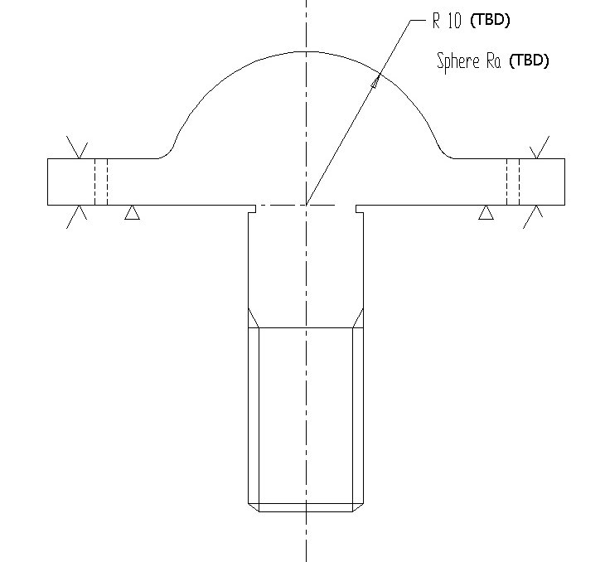 | 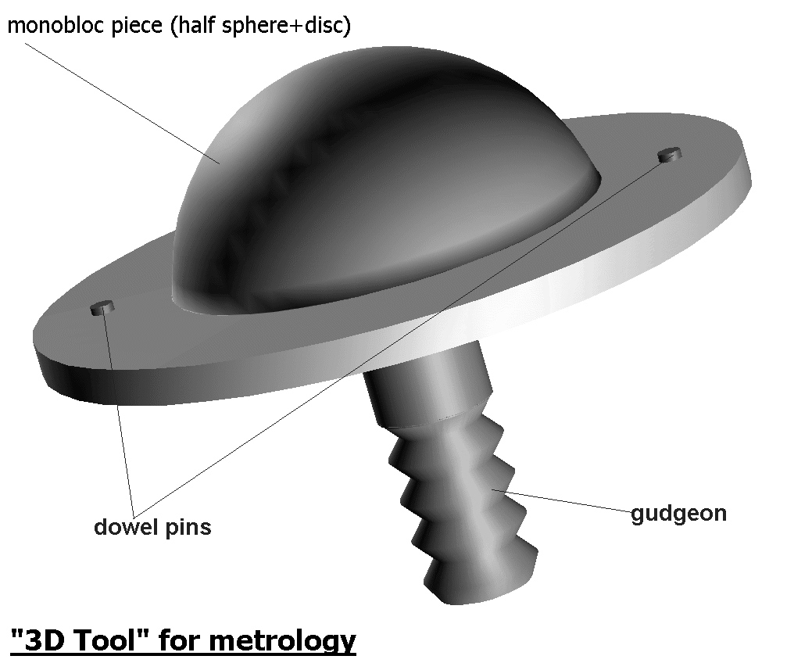
3D Tool for metrology

The “Apex tool”
This tool will be used for alignment control during assembly. It has a standard mirror interface. The purpose of this tool is to materialize the apex of the optical surface. The thickness of the tool corresponds to the distance between the interface plane and the apex of the mirror. As far as possible this distance is the same for all mirrors. If some mirrors have a different thickness, several apex tools may be required.
The reticule drawn in its center allows to aim each mirror apex using the MAT (Micro Alignment Telescope). When mirror N has been mounted, the tool is mounted in the place of mirror N+1, allowing verification of the alignment of mirror N.

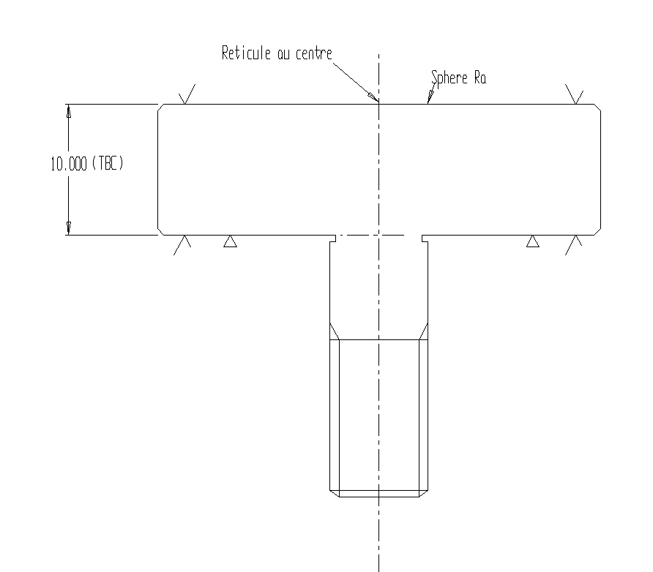 | 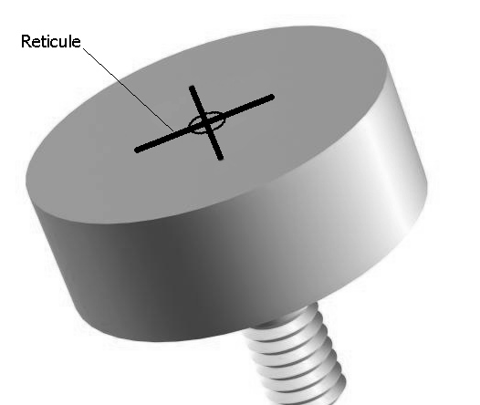
Apex tool

FOR and SOR, telescope and instrument optical references
External alignment of the instrument requires knowledge of the telescope reference frame: optical axis and focal point. These are assumed to be materialized by the FIRST optical reference, FOR, mounted on the FIRST optical bench (FOB). The FOR defines the optical interface between instrument and telescope. It must be positioned accurately with respect to the mechanical interfaces. An FOB simulator containing the same interfaces as the actual FOB is used during integration of the instrument. This allows control of the external optical alignment of the instrument.
We assume FOR is a mirror perpendicular to the FIRST optical axis with a reticule engraved et the intersection with the axis.
The back-bone of the SPIRE instrument is the SPIRE optical bench (SOB). It carries the SPIRE optical reference (SOR), assumed to be a mirror parallel with FOR with a reticule at a known distance from the telescope axis. During optical alignment control we verify the alignment of SOR and FOR, allowing control of the alignment of the instrument on the FOB without access to the internal SPIRE optics. This is necessary since the SPIRE instrument is opaque to visible light.

D-tool
The Detector tool (D-tool) takes the form of a plate containing small sources (LEDs, fibers, …) in strategic points in the FOV: centre and corners for photometer, centre for spectrometer. It is mounted in the position of the long-wavelength detector (PLW) to which visible transmission is assured when dichroics are dismounted. It has a mechanical interface identical to the detector units. Sources can be lit one by one in order to investigate different ray paths through the instrument.

One unit required for photometer, two units required for spectrometer.

To be operated during cold tests.

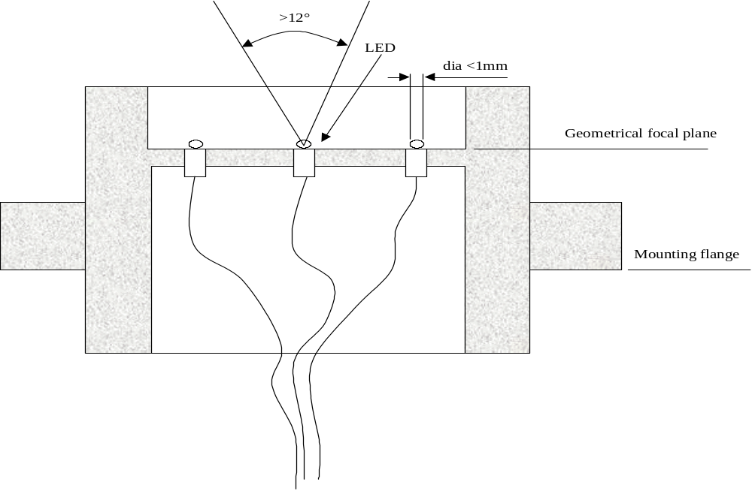

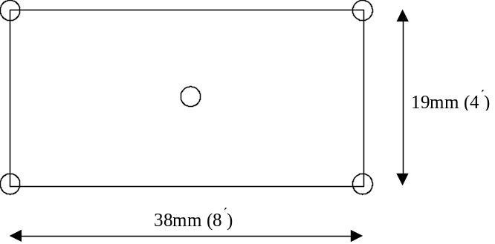 | 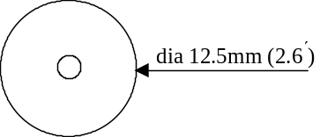
Photometer | Spectrometer

O-tool
The Object tool (O-tool) is mounted in the SPIRE object plane (ie the SPIRE FOV of the FIRST focal surface). It materializes the same strategic points in the FOV as the D-tools (photometer centre and edges, spectrometer centre). It coincides with the FIRST focal surface, ie not perpendicular to the gut ray. Mechanical interface is TBD.

Thin metal plate with laser machined patterns, possibly mounted on a rigid frame, see fig.

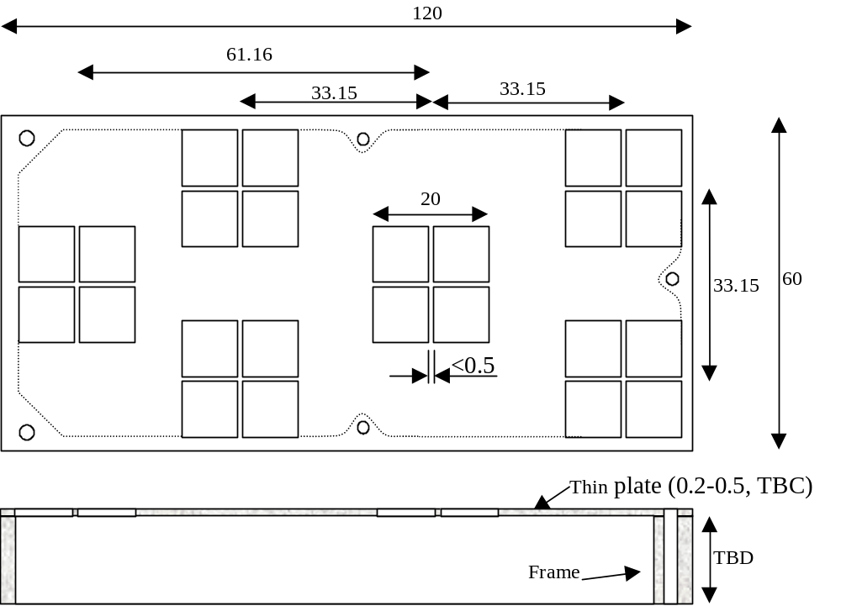

PSD-tool
Tool carrying two (TBC) position sensitive detectors (PSD) located in the SPIRE object plane (telescope focal surface), one in the centre of the photometer FOV, one in the centre of the spectrometer FOV. It permits tracking of the image of the central source of the D-tools.

To be used during thermal tests; the PSD has a simple electrical interface and works well under hard environmental conditions.

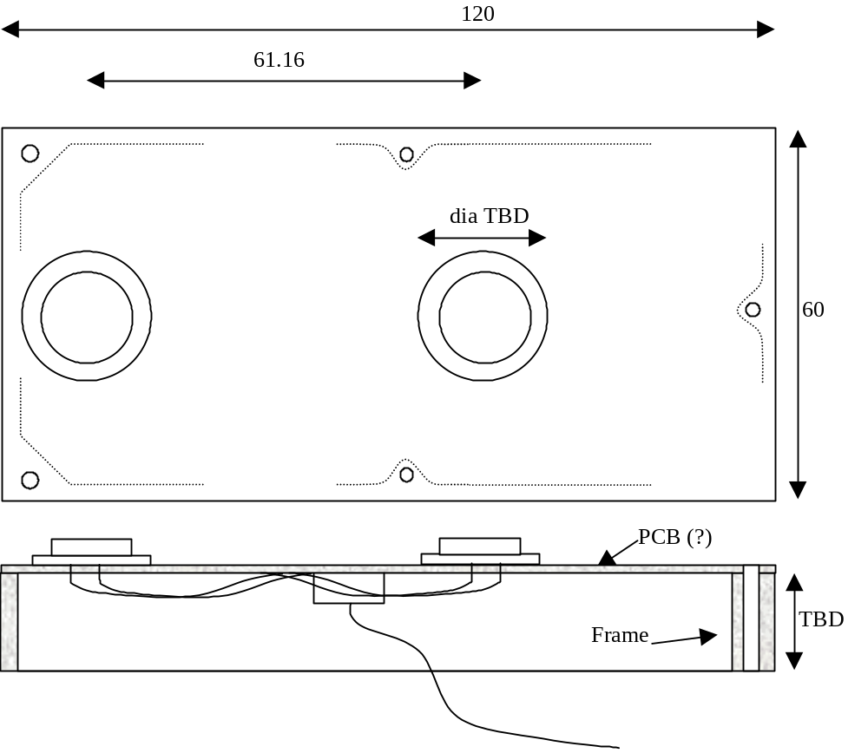

CS-tools
The Cold-stop tools (CS-tool) are mounted in the location of the cold stops (entrance to the 2K box, between PM8 and PM9 for photometer, between SM6 and SM7 for spectrometer). Its function is to materialize the centre of the cold stop and its edges, to control pupil alignment, pupil image quality, and vignetting.

Thin, laser-machined metal plates to be mounted directly onto structure on top of or in place of actual CS masks.

To be used during warm tests only.

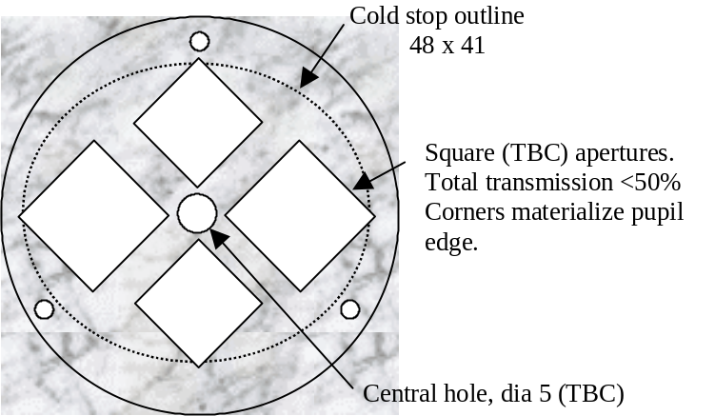

Photometer

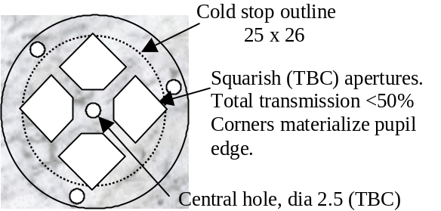

Spectrometer

M2-tool
This tool materializes the telescope pupil (M2) for control of instrument pupil imaging. Its absolute position with respect to the instrument is not important, as the absolute pupil alignment is controlled using the FOR.

The tool has a diameter of about 300mm, located approximately 2.5m outside the instrument. It has reticules materializing the centre and edges of the pupil, corresponding to points used in CS tools.

Consists of an aluminium plate fitted with thin laser machined metal plates for reticules.

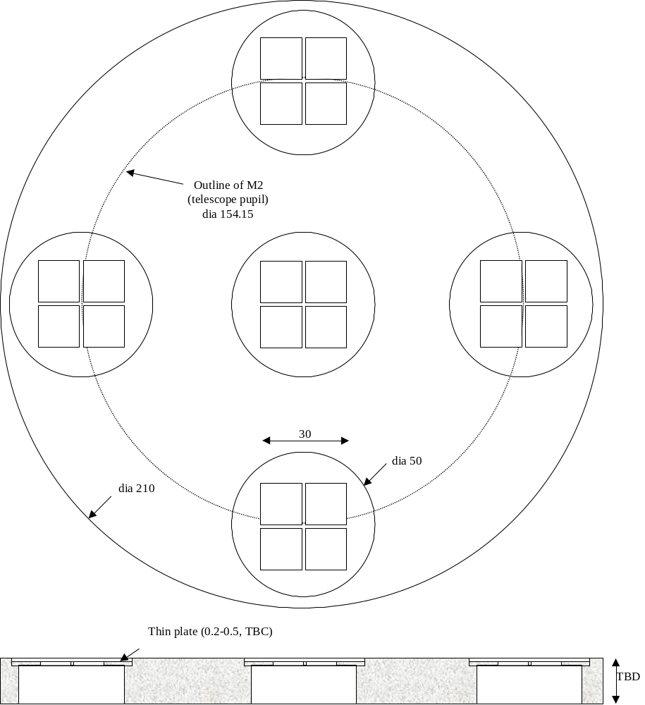

Hartmann tools
As an option for image quality measurement (see 3.2.6), a Hartmann test will be used. A plate with a rectangular grid of holes is mounted in the cold stop. When lit by one of the sources in the D-tool (typically the central source), the projection of the holes through the system materializes geometrical ray paths. Detection of the grid in two planes above and below the SPIRE object plane, allows reconstruction of the geometrical spot diagram. Comparison with theoretical spot diagram gives an excellent measure of the instrument image quality.

Thin, laser-machined metal plates to be mounted directly onto structure on top of or in place of actual CS masks.

To be used during warm tests only.

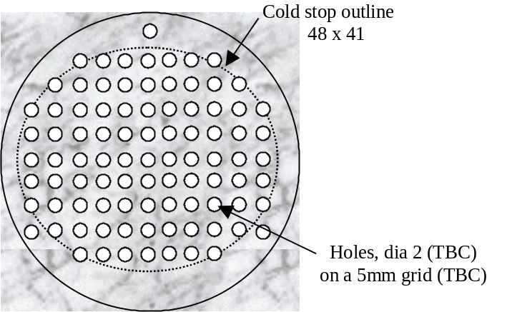

Photometer

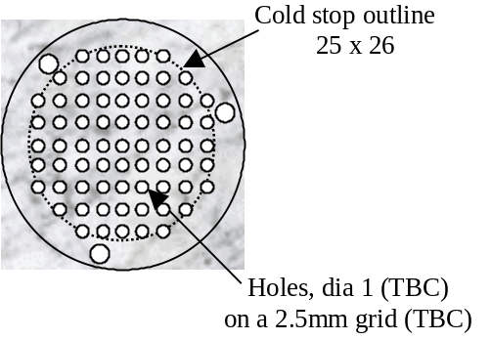

Spectrometer

Verification experiments
A series of bench experiments are foreseen to validate the alignment procedure and the proposed tools. These experiments are outlined in the table below.

Bench | Used to… | Note
PSD Control Bench | Verify function and stability of PSD-tool and D-tool at cryogenic temp
MAT Control Bench  See AO! | … control the supplementary lens and its mounting on the MAT | The optical mounting consists in a set of lenses which projects the image of a reticule behind the position of the MAT.
Tools Bench | Equivalent optical system simulating SPIRE focal and pupil planes and mechanical interfaces for alignment tools. Permits verification of alignment procedures. | Used at room temp only. Cleen room class TBC (would be most useful as a development bench in normal lab environment).

PSD control bench

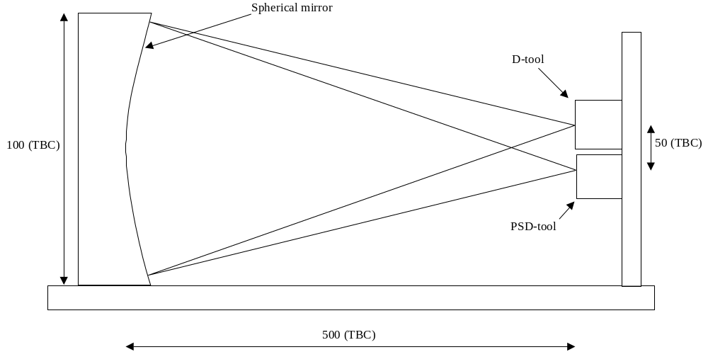

MAT Control Bench
See AO.

Tools Bench

Optical design TBD. In principle two lenses is sufficient (see sketch), but more may be necessary to accommodate the large etendue of the instrument.

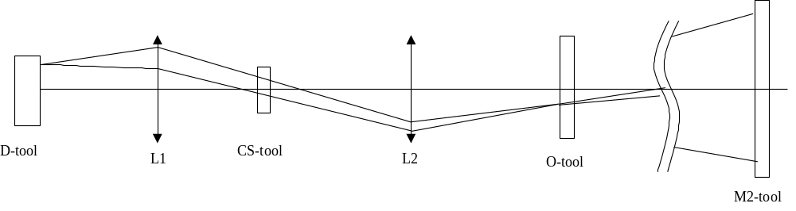

Requirements

Functional requirements

Performance requirements
The performance requirements are listed in [AD1]

# | Parameter | Value | IRD | Note

P1

P2

P3

P4

P5

P6

P7

P8

P9

P10

Technical requirements

# | Parameter | Value | IRD | Note
Tm1
Tm2
Tm3
Tm4
Tm5
Tm6

Operational requirements

Relialibility

Lifetime

# | Parameter | Value | IRD | Note
OL1 | Ground Storage lifetime | 2 years |  | A guess
OL2 | Ground Integrated lifetime | 4 years |  | About
OL3 | Ground operational lifetime | 1.5 years |  | 6 months for subsystem acceptance  6 months for SPIRE acceptance  6 months for FIRST acceptance  Under 1g conditions
OL4 | On orbit operational lifetime | none

Operating modes
Non applicable

Telemetry
Non Applicable

Telecommands
Non Applicable

Interface requirements
The interfaces are defined in the relevant applicable documents.

Part | Interface | With | Document
SMECm | Mechanical | SPIRE Structure | SPIRE 1.1/1.5.2
 | Thermal | SPIRE Structure | SPIRE 1.1.1/1.5.2
 | Optics | SPIRE Optics | SPIRE 1.2 / 1.5.2
SMECp | Mechanical | SPIRE Structure | SPIRE 1.1/1.5.2
 | Thermal | SPIRE Structure | SPIRE 1.1.1/1.5.2
SMECe | Mechanical | DRCU | SPIRE 1.5.2 / 2.2
 | Thermal | DRCU | SPIRE 1.5.2 / 2.2
 | Electronic | DRCU | SPIRE 1.5.2 / 2.2
 | Electronic | MCU | TBW
MCU | Mechanical | DRCU | SPIRE 1.5.2 / 2.2
 | Thermal | DRCU | SPIRE 1.5.2 / 2.2
 | Electronics | DRCU | SPIRE 1.5.2 / 2.2

Design and manufacture requirements

Design requirements
TBD

Design rules
TBD

Manufacture requirements
These are requirements on accessibility, dismountability, testability and manufacturing processes.
- TBD fluids to be forbidden during manufacture to avoid pollution.
- TO BE COMPLETED

Logistic requirements
The subsystem wil be transported to and from RAL.
The containers will have to guarantee that:
- no shocks are greater than those defined for the launch.
- no pollution sneaks to the mirrors
- TO BE COMPLETED

Environment requirements
These requirements describe the environement in which the mirrors will live.

Natural environement
This is the description of the natural environment around the mirrors.

# | Parameter | Value | Note
EN1 | Vacuum | Less than 10-4 Pa | During tests, launch and in operation
EN2 | Operating temperature | during system qualif and on orbit = 4K  during subsystem qualification = 300K and 20K
EN3 | Storage and handling temperature | -20 to +30 °C | Overall, on ground
 | Humidity | Less than 45% | In clean room
 | Cleanliness | Class TBD | In clean room
EN4 | Radiations | Less than 3.5 kRAD | On orbit

Operating environment
This is the description of the environment imposed by the location of the subsystem in SPIRE and in FIRST.

# | Parameter | Value | IRD | Note
ON1 | Vibrations | TBD |  | At 4K
ON2 | Shocks | TBD |  | At 4K
ON3 | Microvibrations | TBD |  | NA
ON4 | Acoustic | NA |  | Launched under vacuum

Verification requirements
TO BE COMPLETED

