SPIRE

SUBJECT: | ICD Structure - Mechanical I/F
PREPARED BY: | Berend Winter
DOCUMENT No: | SPIRE-MSS-PRJ-000617
ISSUE: | 0.1  0.2 | Date: | November 2000  February 2001
CHECKED BY: | …………………………………. | Date: | ………………………….
APPROVED BY: | …………………………………. | Date: | ………………………….

Distribution

J. Long (SPIRE Project Office) | RAL
B. Swinyard | RAL | K. King | RAL
J. Delderfield | RAL | T. Richards | RAL
C. Cunningham | ATC | I. Pain | ATC
T. Paul | ATC
M. Griffin | QMW | P. Hargrave | QMW
D. Pouliquen | LAM | K. Dohlen | LAM
P. Dargent | LAM
J. Bock | JPL | J. Lilienthal | JPL
T. Cafferty | JPL
L. Dubant | CEA
J.L. Auguerre | CEA
B. Winter | MSSL | J. Coker | MSSL

Change Record

ISSUE | DATE
0.1 | November 2000 | New document
0.2 | February 2001 | Update, updated topology, updated I/F drawings and cable lengths

Table of Contents

Applicable Documents 10
Reference Documents 10
1. Introduction 11
1.1 Purpose of Document 11
1.2 SCOPE 12
1.3 The sub-system requirements listed (mechanical and thermal) 15
1.4 General requirements 17
2. Mechanical, Thermal Interface Requirements per Subsystem 20
2.1 Mirrors 21
2.1.1 Functional Description and Block Diagram 21
2.1.2 Inputs 21
2.1.3 Outputs 21
2.1.4 I/F drawing 21
2.1.5 Mass Properties 22
2.1.6 Mechanical Environment 23
2.1.7 Thermal Interface 23
2.1.8 Harness Routing 24
2.1.9 Alignment 24
2.2 Filters 25
2.2.1 Functional Description and Block Diagram 25
2.2.2 Inputs 25
2.2.3 Outputs 25
2.2.4 I/F drawing 25
2.2.5 Mass Properties 26
2.2.6 Mechanical Environment 26
2.2.7 Thermal Interface 27
2.2.8 Harness Routing 27
2.2.9 Alignment 27
2.3 Beam Splitters 28
2.3.1 Functional Description and Block Diagram 28
2.3.2 Inputs 28
2.3.3 Outputs 28
2.3.4 I/F drawing 28
2.3.5 Mass Properties 28
2.3.6 Mechanical Environment 29
2.3.7 Thermal Interface 29
2.3.8 Harness Routing 29
2.3.9 Alignment 29
2.4 Dichroics 30
2.4.1 Functional Description and Block Diagram 30
2.4.2 Inputs 30
2.4.3 Outputs 30
2.4.4 I/F drawing 30
2.4.5 Mass Properties 30
2.4.6 Mechanical Environment 31
2.4.7 Thermal Interface 31
N.A. 31
2.4.8 Harness Routing 31
2.4.9 Alignment 31
2.5 Straylight Baffles and QMW black (Mk2) 32
2.5.1 Functional Description and Block Diagram 32
2.5.2 Inputs 32
2.5.3 Outputs 32
2.5.4 I/F drawing 32
2.5.5 Mass Properties 32
2.5.6 Mechanical Environment 32
2.5.7 Thermal Interface 32
2.5.8 Harness Routing 33
2.5.9 Alignment 33
^{2.6} ³He Cooler 34
2.6.1 Functional Description and Block Diagram 34
2.6.2 Inputs 35
2.6.3 Outputs 35
2.6.4 I/F drawing 36
2.6.5 Mass Properties 36
2.6.6 Mechanical Environment 36
2.6.7 Thermal Interface 37
2.6.8 Harness Routing 37
2.7 Photometer Detectors 38
2.7.1 Functional Description and Block Diagram 38
2.7.2 Inputs 38
2.7.3 Outputs 38
2.7.4 I/F drawing 38
2.7.5 Mass Properties 39
2.7.6 Mechanical Environment 39
2.7.7 Thermal Interface 40
2.7.8 Harness Routing 40
2.8 Spectrometer Detectors 41
2.8.1 Functional Description and Block Diagram 41
2.8.2 Inputs 41
2.8.3 Outputs 41
2.8.4 I/F drawing 41
2.8.5 Mass Properties 41
2.8.6 Mechanical Environment 41
2.8.7 Thermal Interface 41
2.8.8 Harness routing 41
2.8.9 Alignment 41
2.9 Beam Steering Mechanism 42
2.9.1 Functional Description and Block Diagram 42
2.9.2 Inputs 43
2.9.3 Outputs 43
2.9.4 I/F drawing 43
2.9.5 Mass Properties 43
2.9.6 Mechanical Environment 43
2.9.7 Thermal Interface 43
2.9.8 Harness Routing 44
2.10 Spectrometer Mechanism 45
2.10.1 Functional Description and Block Diagram 45
2.10.2 Inputs 45
2.10.3 Outputs 45
2.10.4 I/F drawing 46
2.10.5 Mass Properties 46
2.10.6 Mechanical Environment 46
2.10.7 Thermal Interface 47
2.10.8 Harness Routing 47
2.10.9 Alignment 47
2.11 Shutter Mechanism 48
2.11.1 Functional Description and Block Diagram 48
2.11.2 Inputs 48
2.11.3 Outputs 48
2.11.4 I/F drawing 48
2.11.5 Mass Properties 48
2.11.6 Mechanical Environment 48
2.11.7 Thermal Interface 49
2.11.8 Harness Routing 49
2.12 Spectrometer Calibration Source 50
2.12.1 Functional Description and Block Diagram 50
2.12.2 Inputs 50
2.12.3 Outputs 50
2.12.4 I/F drawing 50
2.12.5 Mass Properties 50
2.12.6 Mechanical Environment 51
2.12.7 Thermal Interface 51
2.12.8 Harness Routing 51
2.12.9 Alignment 51
2.13 Thermal Straps 52
2.13.1 Functional Description and Block Diagram 52
2.13.2 Inputs 52
2.13.3 Outputs 52
2.13.4 I/F drawing 52
2.13.5 Mass Properties 52
2.13.6 Mechanical Environment 52
2.13.7 Thermal Interface 52
2.13.8 Harness Routing 53
2.14 JFET box 54
2.14.1 Functional Description and Block Diagram 54
2.14.2 Inputs 55
2.14.3 Outputs 55
2.14.4 I/F drawing 55
2.14.5 Mass Properties 55
2.14.6 Mechanical Environment 55
2.14.7 Thermal Interface 55
2.14.8 Harness Routing 55
2.15 RF-Filters 57

Glossary

BSM | Beam Steering Mechanism
BSBR | Thermal BuSBaR between cooler and detectors
CBFL1 | Common BaFfLe 1
CFIL1 | Common FILter 1 (entry 4 K enclosure)
CM3-5 | Common Mirror 3-5
CoG | Centre of Gravity
CSTR1 | Cold STRap 1 (level 0, Cryostat to base evaporator heat switch)
CSTR2 | Cold STRap 2 (level 0, Cryostat to base sorption pump heat switch)
CSTR3 | Cold STRap 3 (level 0, Cryostat to photometer detector box)
CSTR4 | Cold STRap 4 (level 1, Vent line to optical bench)
FOB | First Optical Bench
FOR | Firs Optical Reference
³He Cooler | ³He cooler (located in photometer side of the instrument)
JFBX | JFET box
MoI | Moments of inertia
NA | Not Applicable
PBFL2 | Photometer BaFfLe 2
PDBX | Photometer Detector Box
PCAL | Photometer CALibrationsource
PDBX | Photometer Detector BoX
PDIC1 | Photometer DIChroic 1
PDIC2 | Photometer DIChroic 2
PFIL2 | Photometer FILter (entrance PDBX)
PFIL3 | Photometer FILter 2 (4 K-2 K enclosure)
PFIL4L/5L | Photometer FILter 4 and 5 at nose PLW
PFIL4M/5M | Photometer FILter 4 and 5 at nose PMW
PFIL4S/5S | Photometer FILter 4 and 5 at nose PSW
PLW | Photometer Long Wave detector
PM6-11 | Photometer Mirror 6 to 11
PMW | Photometer Medium Wave detector
SBFL1 | Spectrometer BaFfLe 1
SBFL2 | Spectrometer BaFfLe 2
SBS1 | Spectrometer Beam Splitter 1
SBS2 | Spectrometer Beam Splitter 2
SCAL | Spectrometer CALibration source
SCCA | Spectrometer Corner Cube +X
SCCB | Spectrometer Corner Cube –X
SDBX | Spectrometer Detector BoX
SFIL2 | Spectrometer FILter 2 (4 K - 2 K enclosure)
SFIL3L | Spectrometer FILter 3 (long wave)
SFIL3S | Spectrometer FILter 3 (short wave)
SFIL4L/5L | Spectrometer FILter at nose SLW
SFIL4S/5S | Spectrometer FILter at nose SSW
SHUT | Shutter mechanism
SM8A-12A | Spectrometer Mirror 8-12 +X chain
SM8B-12B | Spectrometer Mirror 8-12 –X chain
SM6-7 | Spectrometer Mirror6-7
SMEC | Spectrometer MEChanism
SOB | SPIRE Optical Bench
SOR | Spire Optical Reference
SPIRE | Spectral and Photometric Imaging REceiver

References

Applicable Documents

AD1 | Instrument Requirements Document, issue 0.30, May 2000 (FIRST/SPIRE)
AD2 | Systems Budgets, issue 1.1, 14 June

Reference Documents
RD01 | SPIRE Mirrors: Mass estimate. LAM.PJT.SPI.OPT.990001 ind 3, 20 May 2000
RD02 | SPIRE filters sub-system specification – Draft 1.0 – 16th May 2000
RD03 | BSM subsystem specification, 14 June 2000
RD04 | Cable routing, e-mail J. Bock, 16-Nov-2000
RD05 | Re: Cable routing, e-mail T. Cafferty, 18-Nov-2000
RD06 | ESA fax, B. Guillaume, SCI-PT/IFI/07222, 5-Nov-1999
RD07 | Instrument Interface Document part A, SCI-PT-IIDA-04624, issue 1.0, Sept. 2000

Introduction

Purpose of Document
The purpose of this document is to define the interface between the SPIRE structure and all the sub-systems. Within this document the mechanical and thermal requirements with respect to these interfaces are given. The mechanical interface requirements are related to the actual interface (interface drawing), CoG, MOI, input spectra. The thermal interfacerequiremtents deals with contact area, surface finishes, thermal mass and cross sectional areas.
This issue is a draft issue. The purpose of this issue is to define the interface, such that an agreed baseline interface is available at the beginning of the final design process. During the final design process the definitions may be refined and possibly changed. This must be done following a formal change procedure, agreed by all parties involved in the design of a sub-system linked to that particular interface requirement.
The design of the instrument and its subsystems obeys the requirements as stated in RD1.
An overview in block diagram format of all the sub-systems and their relation ships is given hereafter in block diagram: 1.1-1.

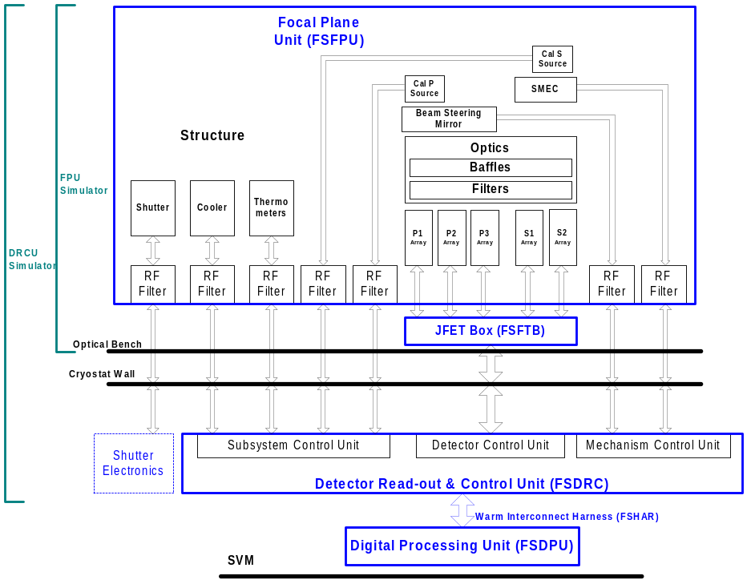
Block diagram: 1.1-1: SPIRE system

SCOPE
The interfaces between the structure and the other subsystems are divided into the mechanical and thermal. For each interface the relevant requirements are listed. The interfaces considered are between the SPIRE structure and the relevant subsystems. Block diagram 1.2-1 gives a graphical interpretation of the interfaces defined, including mechanical and thermal requirements, in this document.

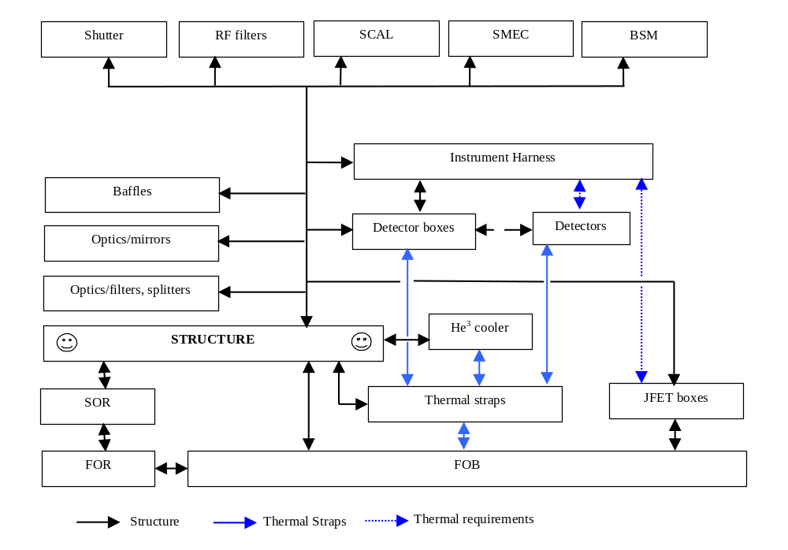
Block diagram: 1.2-1: Connections, mechanical and thermal, between the subsystems

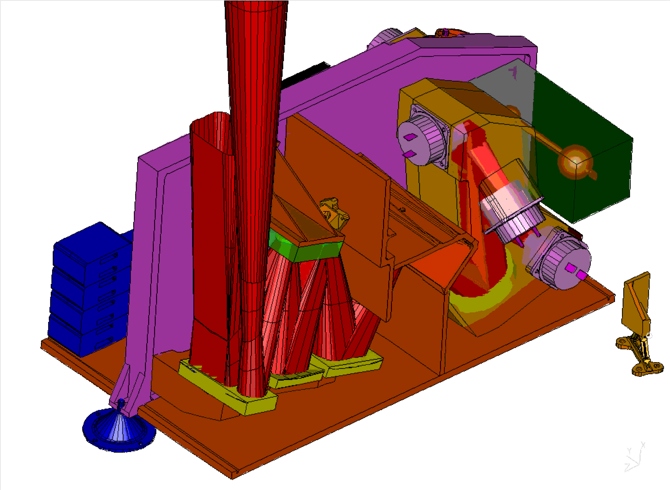
Figure 1.2-1: View of the inside of the instrument – photometer side, cover taken off

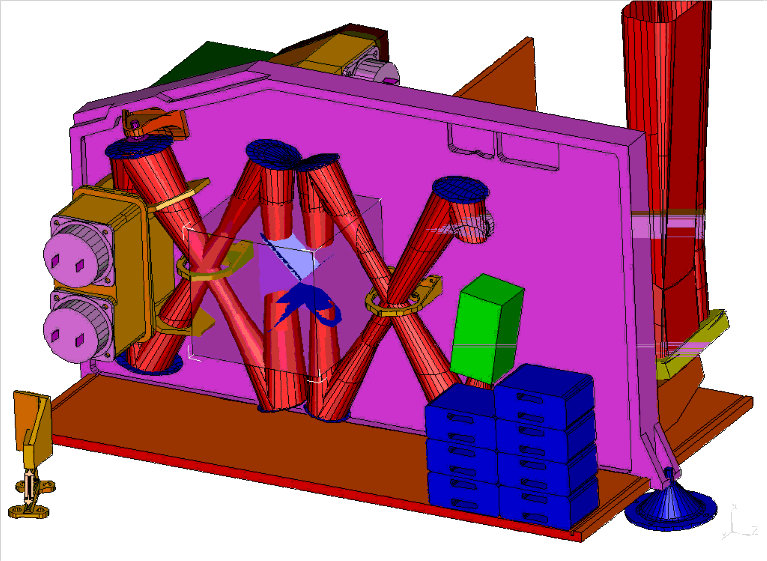
Figure 1.2-2: View of the inside of the instrument – spectrometer side, cover taken off

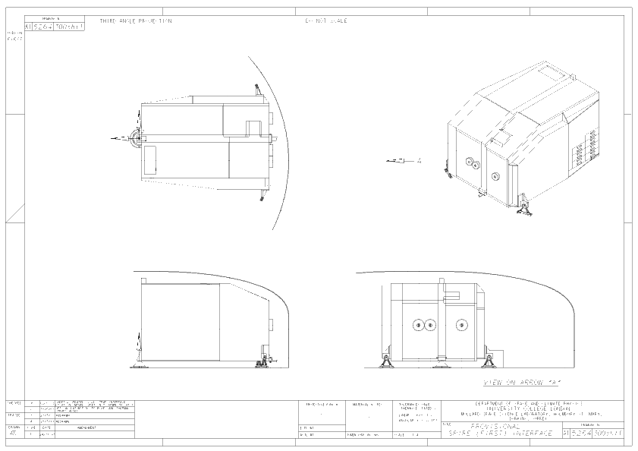
Figure 1.2-3: Interface drawing between structure and FOB-1

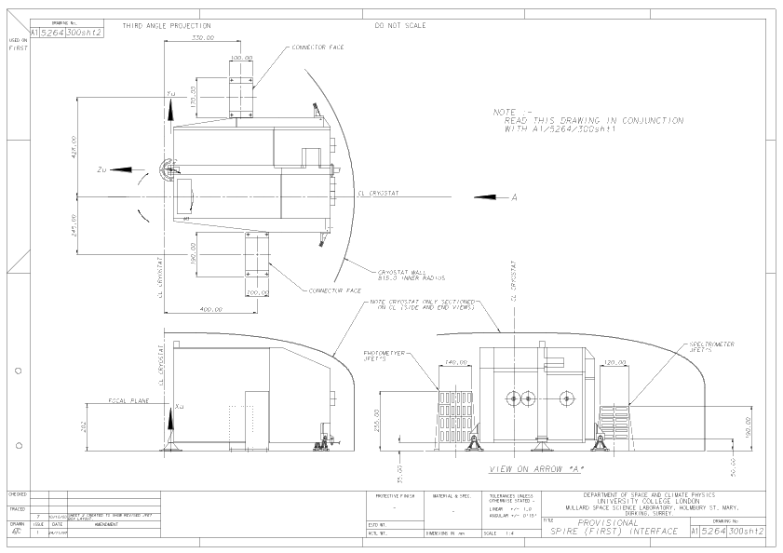
Figure 1.2-4: Interface drawing between structure and FOB-2

The sub-system requirements listed (mechanical and thermal)

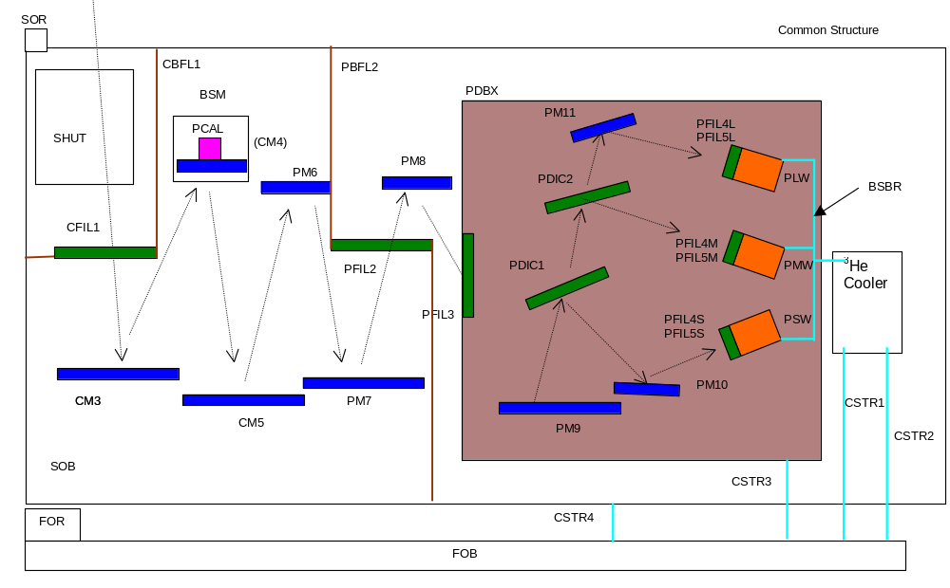Block diagram 1.3-1: Photometer side of the instrument

BSBR Thermal BuSBaR between cooler and detectors
BSM Beam Steering Mechnism
CBFL1 Common BaFfLe1
CFIL1 Common FILter 1 (entry 4 K enclosure)
CM3-5 Common Mirror 3-5
CSTR1 Cold STRap 1
(level 0, Cryostat to base evaporator heat switch)
CSTR2 Cold STRap 2
(level 0, Cryostat to base sorption pump heat switch)
CSTR3 Cold STRap 3
(level 0, Cryostat to photometer detector box)
CSTR4 Cold STRap 4 (level 1, Vent line to optical bench)
FOB First Optical Bench
FOR First Optical Reference
³He Cooler ³He cooler (located in photometer side of
the instrument)
PBFL2 Photometer BaFle2
PCAL Photometer CALibrationsource
PDBX Photometer Detector BoX
PDIC1 Photometer DIChroic 1
PDIC2 Photometer DIChroic 2
PFIL2 Photometer FILter (entrance PDBX)
PFIL3 Photometer FILter 2 (4 K-2 K enclosure)
PFIL4L/5L Photometer FILter 4 and 5 at nose PLW
PFIL4M/5M Photometer FILter 4 and 5 at nose PMW
PFIL4S/5S Photometer FILter 4 and 5 at nose PSW
PLW Photometer Long Wave detector
PM6-11 Photometer Mirror 6 to 11
PMW Photometer Medium Wave detector
PSW Photometer Short Wave detector
SHUT SHUTter mechanism
SOB Spire Optical Bench Panel
SOR SPIRE Optical Reference

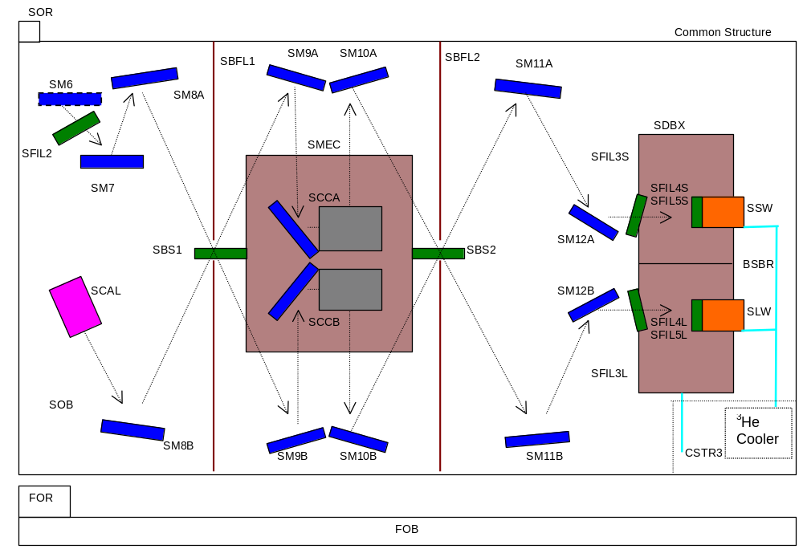
Block diagram 1.3-2: Spectrometer side of the instrument

CSTR3 Cold STRap 3
(Level 0, cryostat base to SDBX, via PDBX)
FOB First Optical Bench
FOR Firs Optical Reference
³He Cooler ³He cooler
(located in photometer side of the instrument)
SBFL1 Spectrometer BaFfLe 1
SBFL2 Spectrometer BaFfLe 2
SBS1 Spectrometer Beam Splitter 1
SBS2 Spectrometer Beam Splitter 2
SCCA Spectrometer Corner Cube +X
SCCB Spectrometer Corner Cube –X
SCAL Spectrometer CALibration source
SDBX Spectrometer Detector BoX
SFIL2 Spectrometer FILter 2 (4 K - 2 K enclosure)
SFIL3L Spectrometer FILter 3 (long wave)
SFIL3S Spectrometer FILter 3 (short wave)
SFIL4L/5L Spectrometer FILter at nose SLW
SFIL4S/5S Spectrometer FILter at nose SSW
SM6-7 Spectrometer Mirror6-7
SM8A-12A Spectrometer Mirror 8-12 +X chain
SM8B-12B Spectrometer Mirror 8-12 –X chain
SMEC Spectrometer MEChanism
SOB Spire Optical Bench Panel
SOR Spire Optical Reference

See for the schematic location in the instrument blockdiagrams 1.3-1 and 1.3-2

Sub system ID | Description | Acronim | Section
1.2 | Mirrors | CM3-CM5  PM6-PM11  SM6-SM12 | 2.1
1.2.1 | Filters | CFIL1, PFIL2, PFIL3, SFIL2, SFIL3L, SFIL3L | 2.2
1.2.1 | Beam splitters | SBS1, SBS2 | 2.3
1.2.1 | Dichroics | PDIC1, PDIC2 | 2.4
1.2.2 | Straylight attenuation (Baffles and QMW-black) | PBFL1, PBFL2, SBFL1, SBFL2 | 2.5
1.3 | He³ Cooler |  | 2.6
1.4.1-1 | Photometer detectors | PSW,PMW,  PLW | 2.7
1.4.1-2 | Spectrometer detectors | SSW,SLW | 2.8
1.5.1 | Beemsteering mechanism | BSM | 2.9
1.5.2 | Spectrometer mechanism | SMEC-m | 2.10
1.5.3 | Shutter mechanism | SHUT | 2.11
1.6.1 | Calibration source Photometer | PCAL | part of the BSM
1.6.2 | Calibration source Spectrometer | SCAL | 2.12
- | Thermal straps | CSTR1-4  BSBR | 2.13
- | JFET box | JFBX | 2.14
- | RF-filters |  | 2.15
Table 1.3-1: Subsystems interfaces listed in this document

General requirements
Mechanical environment
RD07 states the following with regard to the mechanical environment and testing. (General requirements for design and analysis on system level: section 9.4 RD07). The mechanical environment as defined in RD07 will change. So the values listed hereafter are provisional.

Safety factors and Sizing factors (9.4.1.2.3, RD07)
- Qualification factor j_{q} = 1.5
- Yield safety factor j_{y} = 1.1
- Ultimate safety factor j_{u} = 1.25

Material properties/data should be assessed within 99% statistical probability at a confidence level of 95% (A-level) The following sizing factors shall be applied to the limit loads:
- Load at yield failure point:
F_{y} = j_{q} ⋅ j_{y} ⋅ F_{limit}
F_{y} = 1.5 ⋅ 1.1 ⋅ F_{limit} = 1.65 ⋅ F_{limit}

- Load at ultimate failure point:
F_{y} = j_{q} ⋅ j_{u} ⋅ F_{limit}
F_{y} = 1.5 ⋅ 1.25 ⋅ F_{limit} = 1.875 ⋅ F_{limit}
For the SPIRE instrument as a whole the following flight limit load are given:
Quasi-Static
RD07, section 9.4.1.2.4:
Quasi Static levels | Case 1 | Case 2 | Case 3
x-direction | 25 g | - | -
y-direction | - | 14 g | -
z-direction | - | - | 14 g
Table 1.4-1: Instrument qualification levels for quasi-static vibration
All subsystems will be subjected to the same environment as defined above. The in table 1.4-1 defined accelerations are very important for limiting interface loads for the various sub-systems subjected to either sine, random or shock loads. At no point during these tests, the interface load between two subsystems is allowed to exceed the quasi-static interface load. This is the baseline for notching during these tests. For an accurate analysis of the interface loads reduced models of all subsystems are required. These models should give an accurate approximation of the first eigenmode and mass in all three orthogonal directions. There is one condition to be allowed a notch based upon this quasi-static interface load. The condition is that the subsystem is only allowed a notch at a given frequency band, if that system has significant effective mass in that frequency band in the excitation direction.
Sine
RD07, section 9.5.3.3.2, gives as the requirement for the sine vibration test (instrument level):
Sweep rate: 2 oct/min
And the following input .for the SPIRE instrument mounted on the FIRST optical bench:

Sine vibration levels | Frequency range | Input at base (QUAL)
X-direction | 5-40 Hz  40-100 Hz | 30 g  15 g
Y-direction | 5-45 Hz  45-100 Hz | 18 g  7.5 g
Z-direction | 5-45 Hz  45-100 Hz | 18 g  7.5 g
Table 1.4-2: Instrument qualification levels for sine vibration (2 oct/min)
Due to mechanical amplification of the instrument itself, subjected to these levels, the subsystems within the instrument will see a different environment. This has been analysed using FEA. The results of this analysis are translated into sine level specifications for subsystems individually. This will be done taking the following into account:
- Frequency uncertainty: The instrument is designed to meet the frequency requirement including a uncertainty of 10%. To meet the frequency uncertainty requirement the above listed levels are extended to 110 Hz.
- Analysis uncertainty: A analysis uncertainty of 20% will be take into account The analysed amplification is multiplied with the analysis uncertainty factor of 1.2. The latter is assumed to be sufficient since the influence of structural damping is minimal. The input spectrum for each subsystem is analysed (and given) at its interface plane with the instrument structure.

Random
RD07, section 9.5.3.4, gives the following requirements for the SPIRE instrument.
The test duration is 2 minutes and 30 seconds.

Random vibration levels | Frequency range | Input at base (QUAL.) | RMS
X-direction | 20 – 80 Hz  80 - 300 Hz  300 – 2000 Hz | +3 dB Hz  0.077 g²/Hz  -6 dB | 6.67 g RMS
Y-direction | 20 – 80 Hz  80 - 300 Hz  300 – 2000 Hz | +3 dB Hz  0.077 g²/Hz  -6 dB | 6.67 g RMS
Z-direction | 20 – 80 Hz  80 - 300 Hz  300 – 2000 Hz | +3 dB Hz  0.077 g²/Hz  -6 dB | 6.67 g RMS
Table 1.4-3: Instrument levels for random vibration (qualification levels)
Due to mechanical amplification of the instrument itself, subjected to these levels, the subsystems within the instrument will see a different environment. This has been analysed using FEA. The results of this analysis are translated into random level specifications for subsystems individually. This will be done taking the following into account:
- structural damping of 3% between 20 and 200 Hz
- structural damping of 4% between 200 and 400 Hz
- structural damping of 5% above 400 Hz

Mechanical, Thermal Interface Requirements per Subsystem
In the sections here after some of the requirements that are listed are for information only. Since they are defined in higher level documents. The listed requirements, for information only, are:

- Mass, reference document: AD2 Systems budgets

The sections per interface are divided into 9 different sub-sections. The first subsection deals with overall information to give something of a background (briefly) to the function of the subsystem. If needed a block diagram will be added to clarify the inter-relations between the different parts/interfaces.
The second and third sub-section deals with possible inputs and outputs. For a mechanical interface this consists, if applicable, of a definition of input micro-vibrations and output micro-vibrations.
The fourth sub-section gives the interface drawings. One set defining the interface on the instrument side and one set defining the interface on the subsystem side. The drawings in this document itself are not the official drawings. They serve as an illustration only. Proper (A1 or A2) interface drawings will be exchanged between the parties concerned. It is the responsibility of each side of the interface to provide the other side with their interface drawing. The interface drawing should contain a reference hole. This reference hole will be tightly toleranced at both sides. In case of mounting on the SOB, it is the responsibility of the subsystem, mounting on this bench, not to introduce additional stress to the optical bench during and after integration. That is no other than the loads induced through the mechanical en
The fifth sub-section gives the mass properties. As stated before, the mass is given for information only. Together with the mass the centre of gravity and the moments of inertia around the CoG are given. The mass properties listed should contain all mass of the subsystem mounted on this interface. Since the listed mass, in accordance with AD2, will serve as input for the overall CoG and MoI figures for the instrument. According to RD07, the mass properties have to be measured within the following tolerances:
- CoG +/- 1%
- MoI +/- 5%
These margins are the same for the actual mass properties and predictions of both the CQM and the PFM model.
The sixth sub-section gives the mechanical environment. The mechanical environment defines the analysed interface levels as a result of the required input for the instrument as a whole. In effect it is the translation of the ESA requirements at the base of the instrument to responses at the interfaces as outlined in section 1.4. For this analysis the qualification levels for the instrument are used. For the qualification of the subsystems, a extra qualification factor of 1.5 is needed. Unfortunately the specified levels are subject to change due to the fact that the ESA mechanical environment specification has not been frozen.
The seventh sub-section deals with the mechanical implementation of thermal interface requirements. That is, there could be a need for thermal insulation (like the structure support of thermal straps). Or there could be a need for maximised thermal conductance, as in the case of the calibration sources where the generated heat needs to be diffused inside the optical bench.
Sub-section eight deals with the harness routing. The number of connectors involved for each interface, allowable curvature of wiring, cable length, screening requirements.
Sub-section nine deals with alignment requirements if applicable.

Mirrors

Functional Description and Block Diagram
The following holds for all interfaces considered in section 2.1 unless otherwise specified.
Allowable interface loads
The mirror will not add significantly to the rigid body inertia’s of the mirrors themselves. That is the eigenfrequency of the mirrors shall be higher than 350 Hz against a rigid interface. With a mount, mounted against a rigid interface shall be higher than 250 Hz.
Interface drawing
Since the mirrors interface both with their mounting and the infra red beams, which they reflect, the relative position of the mounting in the instrument depends both on the interface with the mounting as well as the thickness of the mirror. Baseline are two different mirror thicknesses. The mounting spigot will be the same for all the mirrors. As a result of this there are only two different interface drawings required. Hereafter these drawings are presented and the datasheet for each mirror will refer to one of these drawings. In the drawings the dimension H-height refers to the thickness of the mirror at its mounting interface. This is either 15 or 7 mm. In principle each mirror has a rotational degree of freedom, since each mirror mount is rotationally symmetrical. This degree of freedom will be suppressed by means of a dowel pin. The location of this pin, indicated on each drawing, is between the mirror mount spigot and the mirror mount bracket interface with the structure. If in case of possible confusion, the position of the dowel pin will be defined explicitly. See section 2.1.4.

No block diagram

Inputs
N.A.

Outputs
N.A.

I/F drawing
Hereafter the interface drawing of the mirror is included, outlining the generic interface. In the drawing (Figure 2.1-1) They should be replaced by 15 (mm) for CM3, CM5, PM7 and PM9. And should read 7 (mm) for the other mirror interfaces.
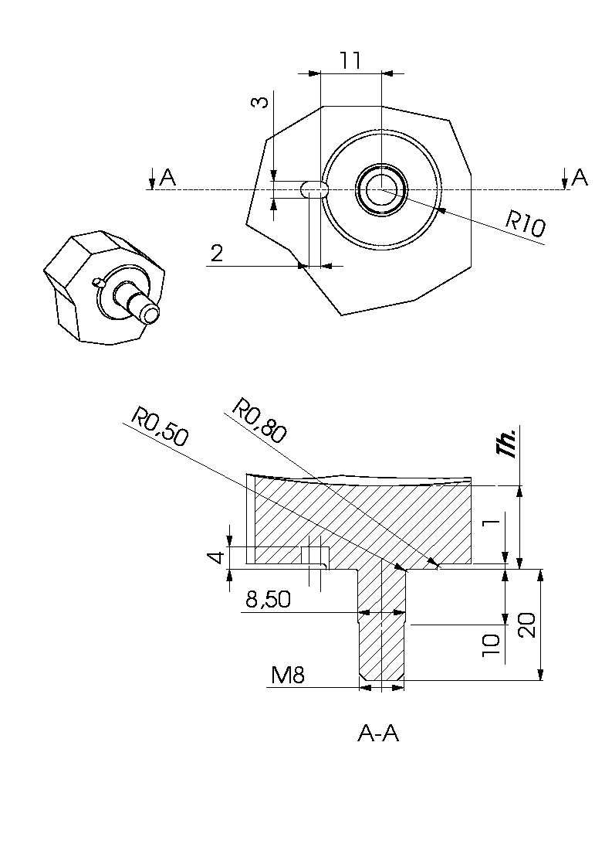
Figure 2.1.4-1: In terface drawing.

Mass Properties
Hereafter for each mirror the CoG and the MoI are listed with respect to the co-ordinate system listed in figure 2.1-2. The Z axis is pointing away from the mirror surface. The Y axis is pointing away from the SOB.
The mass budget for the mirrors is 1720 +1100 gr (AD2, excluding contingency)
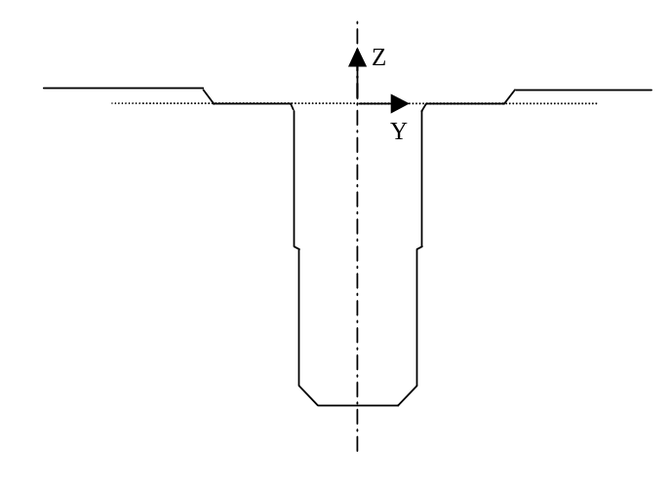
Figure 2.1-2: CoG location reference co-ordinate system for mirrors (Y pointing away form SOB)

ID | L | W | Thick-ness | Mass  nominal | CoG [m] | Ixx | Iyy | Izz
 | [mm] | [mm] | [mm] | [gr] | [mm] | [grmm²] | [grmm²] | [grmm²]
CM3 | 132 | 54 | 15 | 183
CM5 | 161 | 85 | 15 | 360
PM6 | 46 | 27 | 7 | 23+nut
PM7 | 118 | 101 | 15 | 223+nut
PM8 | 60 | 60 | 7 | 37+nut | 2.8
PM9 | 112 | 112 | 15 | 184+nut
PM10 | 78 | 40 | 7 | 65+nut
PM11 | 56 | 53 | 7 | 43+nut
SM6 | 29 | 51 | 7 | 27
SM7 | 40 | 57 | 7 | 40+nut
SM8 | 60 | 60 | 7 | 37+nut
SM9 | 50 | 50 | 7 | 37+nut
SM10 | 60 | 60 | 7 | 55+nut
SM11 | 74 | 74 | 7 | 79+nut
SM12 | 21 | 16 | 7 | 20+nut
Table 2.1.5-1: Mass properties of the mirrors (updated from IGES files)

Mechanical Environment
Assuming a first natural frequency, mounted against a rigid interface above 170 Hz.
As specified in 1.4, including the qualification factor of 1.5. The provisional sine spec is:

Sine vibration levels | Frequency range | Input at base (QUAL)
X-direction | 5-30 Hz  30-100 Hz | 11 mm (0-peak)  40 g
Y-direction | 5-30 Hz  30-100 Hz | 11 mm (0-peak)  25 g
Z-direction | 5-30 Hz  30-100 Hz | 11 mm (0-peak)  25 g
Table 2.1.6-1 Qualification sine input (2 oct/min)
Random spec to be issued.

Thermal Interface
When cooling down the instrument, the mirrors with their overall significant thermal mass, should not lag behind in temperature significantly (time wise). Therefor a significant thermal conductance should exist between the mirrors, through the mirror mounts to the optical bench. Since the contact area between mirror and mirror mount is significant, the mirror mounts themselves are significant no problem is expected. The mirror mounts are mounted with three interface bolts on the optical bench.
Between mirror and mirror mount:
Total contact area: between 100 and 250 mm² (TBC)
Surface roughness of contact area: Ra=1.5 (TBC).

Harness Routing
N.A.

Alignment
The following requirements hold for the alignment of the I/F plane between the mirror mounts and the structure.
- Off centre 0.1 mm all directions simultaneously
- Longitudinal +/-0.5 mm
- Tilt +/-1 arcminute.
- Roll +/-2 arcminute (TBC)

Filters

Functional Description and Block Diagram
The first filters in the chain, situated on the 4-K box, should reflect back to the sky as much unwanted high frequency radiation as possible. Filters on lower temperature shields should then reject radiation from higher temperature boxes and shields.
Strategic placement of filters will enable us to:
- Define the spectral passbands.
- Minimise the thermal loading on the 3He fridge, 2-K, and 4-K stages by rejecting short wavelength thermal energy.
Minimise stray light getting to the detectors.
- Maximise the in-band spectral transmission.
The sequence of filters starts with the 2 common 4-K filters at the input to the instrument. They minimise radiation from T > 4-K entering the instrument. The filters at the entrance of the detector boxes minimise the transmission of radiation from T > 2-K. The 0.3 K filters at the nose of the detectors are not discussed in this document since they interface only with the detectors.
The filters are clamped against the structure using a light tight clamp ring. The function of the OBP (reviewing the interface between the OBP and the filters) is to support the beam splitters and their mounts. The mechanical interface should provide for a precise defined and accurately machined mounting surface. The mechanical interface should provide for sufficient stiffness, such that the mechanical loads on the mirrors are minimised. The same holds for the interfaces with the detector boxes and the dichroics. The dichroics and beam splitters are sensitive to warping, and this is considered in the design of the mounts for these components.

There is no block diagram.

Inputs
N.A.

Outputs
N.A.

I/F drawing
TBD
As a guide the filters will be sized to the envelope the 20% oversized beam at the mounting location. At this location the filters closes an aperture and the area around it, if possible, will be covered with the famous QMW black mk II.

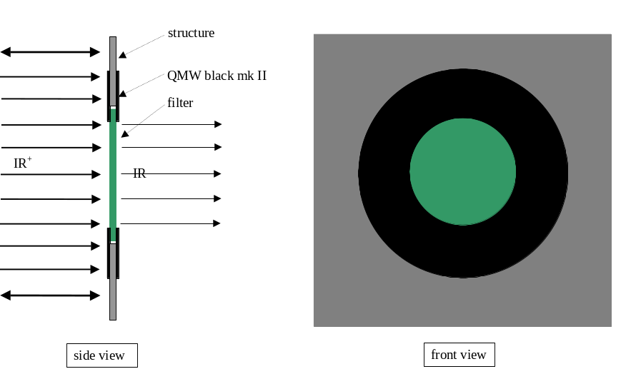
Hot pressed filters may be ring-mounted. TBC on a case by case basis

Mass Properties
The mass budget for the filters is 450 gr (AD2, excluding contingency)

ID | Mass | Ixx | Iyy | Izz
CFIL1 | TBD | TBD | TBD | TBD
PFIL2 | TBD | TBD | TBD | TBD
PFIL3 | TBD | TBD | TBD | TBD
SFIL2 | TBD | TBD | TBD | TBD
SFIL3S | TBD | TBD | TBD | TBD
SFIL3L | TBD | TBD | TBD | TBD
Table 2.2.5-1: Mass properties table, I with regard to CoG

Mechanical Environment
Assuming a first natural frequency, mounted against a rigid interface above 170 Hz.
As specified in 1.4, including the qualification factor of 1.5. The provisional sine spec is:

Sine vibration levels | Frequency range | Input at base (QUAL)
X-direction | 5-30 Hz  30-100 Hz | 11 mm (0-peak)  40 g
Y-direction | 5-30 Hz  30-100 Hz | 11 mm (0-peak)  25 g
Z-direction | 5-30 Hz  30-100 Hz | 11 mm (0-peak)  25 g
Table 2.2.6-1 Qualification sine input (2 oct/min)

Random spec to be issued.

Thermal Interface
TBD

Harness Routing
N.A.

Note some filters may need to be part of the Faraday filters.

Alignment
The following requirements hold for the alignment of the I/F plane between the filter mounts and the structure. RD2
Off centre 1 mm all directions simultaneously (TBC). The flatness of the mounting surface for the cold stops is TBD.

Beam Splitters

Functional Description and Block Diagram
The beam splitters in the FTS part of the instrument reflect 50% and pass 50% of the incident radiation virtually independently of frequency across the entire SPIRE band.

Inputs
N.A.

Outputs
N.A.

I/F drawing
The the outer diameter of the beam splitter is TBD mm.
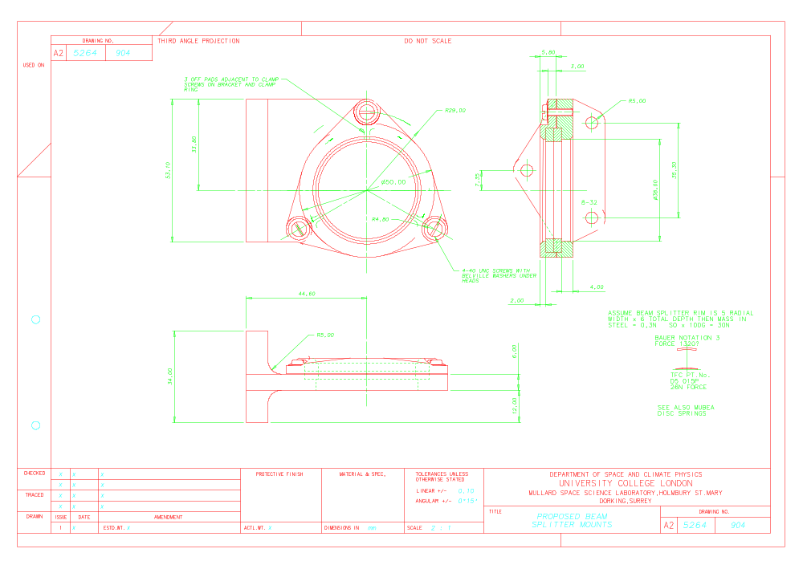

Mass Properties
The mass budget for the splitters is 100 gr (AD2, excluding contingency) (100 gr taken from mass for the spectrometer filters) This is the splitter itself, without mount.

ID | Mass | Ixx | Iyy | Izz
SBS1 | TBD | TBD | TBD | TBD
SBS2 | TBD | TBD | TBD | TBD
Table 2.3.5-1: Mass properties table, I with regard to CoG

Mechanical Environment
Assuming a first natural frequency, mounted against a rigid interface above 170 Hz.
As specified in 1.4, including the qualification factor of 1.5. The provisional sine spec is:

Sine vibration levels | Frequency range | Input at base (QUAL)
X-direction | 5-30 Hz  30-100 Hz | 11 mm (0-peak)  40 g
Y-direction | 5-30 Hz  30-100 Hz | 11 mm (0-peak)  25 g
Z-direction | 5-30 Hz  30-100 Hz | 11 mm (0-peak)  25 g
Table 2.3.6-1 Qualification sine input (2 oct/min)

Random spec to be issued.

Thermal Interface
N.A.

Harness Routing
N.A.

Alignment
TBD

Dichroics

Functional Description and Block Diagram
The dichroics within the PDBX reflect high frequencies and pass low frequencies and hence aid definition of the SPIRE photometer channels.
The maximum warping of the dichroics induced by the structure is TBD .Tilt 1 arcminute (TBC)

Inputs
N.A.

Outputs
N.A.

I/F drawing
The outer dimension of the dichroics are:

PDIC1: TBD mm
PDIC2: TBD mm

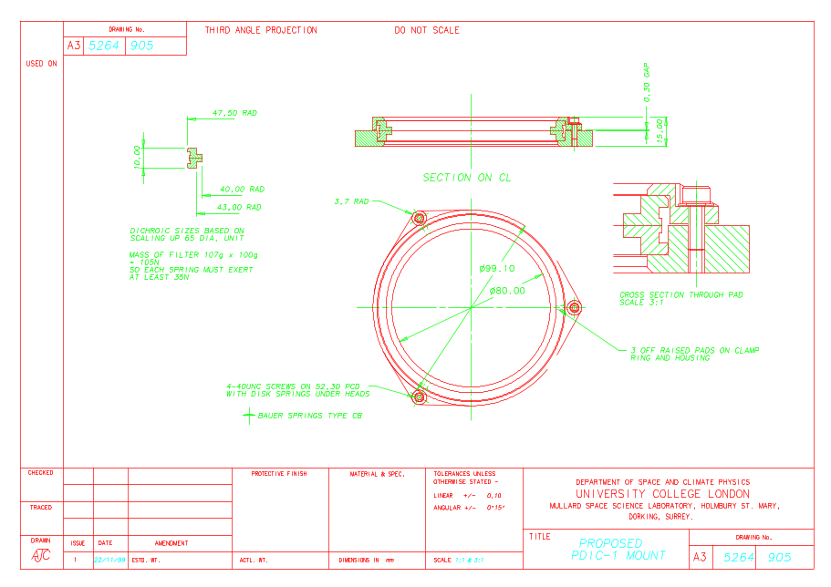

Mass Properties
The mass budget for the splitters is 100 gr (AD2, excluding contingency) (100 gr taken from mass for the spectrometer filters)
ID | Mass | Ixx | Iyy | Izz
PDIC1 | TBD | TBD | TBD | TBD
PDIC2 | TBD | TBD | TBD | TBD
Table 2.4.5-1: Mass properties table, I with regard to CoG

Mechanical Environment
Assuming a first natural frequency, mounted against a rigid interface above 170 Hz.
As specified in 1.4, including the qualification factor of 1.5. The provisional sine spec is:

Sine vibration levels | Frequency range | Input at base (QUAL)
X-direction | 5-30 Hz  30-100 Hz | 11 mm (0-peak)  40 g
Y-direction | 5-30 Hz  30-100 Hz | 11 mm (0-peak)  25 g
Z-direction | 5-30 Hz  30-100 Hz | 11 mm (0-peak)  25 g
Table 2.4.6-1 Qualification sine input

Random spec to be issued.

Thermal Interface

N.A.

Harness Routing
N.A.

Alignment
TBD

Straylight Baffles and QMW black (Mk2)

Functional Description and Block Diagram
The straylight baffles reflect and partially attenuate straylight at various locations in the optical chain. At present 4 baffles are foreseen. The first baffle is located inside the instrument at the entrance of the IR-beam into the instrument. Effectively it is located between the secondary mirror and CM3. It encloses together with the photometer side walls the shutter mechanism. The second one is located between PM7 and PM8. Separating the common environment from the photometer and effectively enclosing the photometer detector box. The third and fourth are located inside the spectrometer enclosure. They split the spectrometer into three zones, each at the beam splitter where the two spectrometer optical chains cross.

See for a block diagram 1.3-1 and 1.3-2

Inputs
N.A.

Outputs
N.A.

I/F drawing
TBD

Mass Properties
TBD

Mechanical Environment
Assuming a first natural frequency, mounted against a rigid interface above 170 Hz.
As specified in 1.4, including the qualification factor of 1.5. The provisional sine spec is:

Sine vibration levels | Frequency range | Input at base (QUAL)
X-direction | 5-30 Hz  30-100 Hz | 11 mm (0-peak)  40 g
Y-direction | 5-30 Hz  30-100 Hz | 11 mm (0-peak)  25 g
Z-direction | 5-30 Hz  30-100 Hz | 11 mm (0-peak)  25 g
Table 2.5.6-1 Qualification sine input (2 oct/min)

Random spec to be issued.

Thermal Interface
N.A.

Harness Routing
N.A.

Alignment
The opening in the straylight baffles will be sufficient to allow the 20% oversized beam to cross it with a positive margin of no more than 0.5 mm.

³He Cooler

Functional Description and Block Diagram
The structure of the cooler is mounted on the SPIRE optical bench panel (SOB) at ~4 K. The cooler interfaces via 2 thermal straps with the level 0 thermal sink (~1.8 K) inside the FIRST cryostat. The cold finger of the cooler interfaces via a thermal busbar with all detectors (3 photometer detectors and 2 spectrometer detectors). The cooler harness interfaces with the DRCU outside the SPIRE structure via the RF-filter box mounted inside the structure.

- SOB – Cooler (mounting)
- PSW – Cooler (thermal strap)*
- PMW – Cooler (thermal strap)*
- PLW – Cooler (thermal strap)*
- SLB – Cooler (thermal strap)*
- SHB – Cooler (thermal strap)*
- Cooler – level 0 heat sink (two different straps)
- Harness routing (from cooler via structure to RF-filter boxes)

*It should be noted that the interface between the detectors and the cooler, is it is currently foreseen, will run via a thermal busbar. Strictly speaking there will be in this case no (direct) interface between the cooler and the detectors.
The cooler’s purpose is to provide for the cooling of the sensors within the detectors down to ~.3 K. For this the cooler needs to be able to dump excess heat during its recycling and operating phase, via 2 straps to the level 0 heat sink within the cryostat. During operation and recycling different parts within the cooler will be connected to the level 0 heat sink This will be done using heat switches, which are located inside the cooler itself. The (support) structure of the cooler will be interfacing with the optical bench panel only (at level 1).

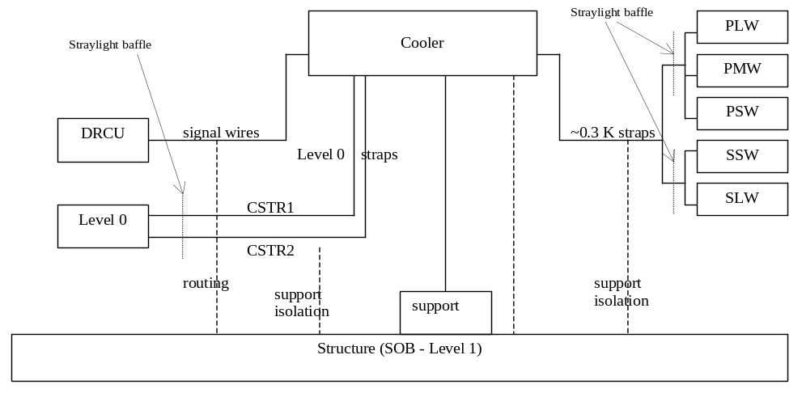
Figure 2.6.1-1: Block diagram

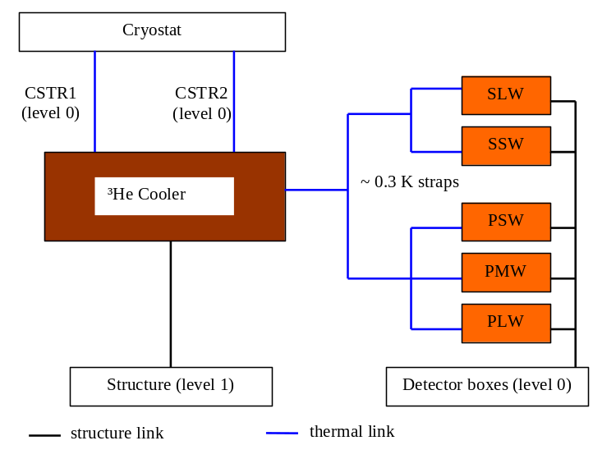
Figure 2.6.1-2: Thermal straps, conductive paths

Inputs
mounting interface structure (SOB)
Two separate straps, connected with level 0 heat sink
control wiring (routing towards RF-filter box)
Heat flow from level 1 towards cooler
Heat flow from cooler into Level 0

Micro vib. n.a.

To be specified: allowable interface load for the thermal strap-interface (CSTR1 and CSTR2)
To be specified: stiffness for the thermal strap interface.

Outputs
Strap to the thermal busbar between both detector boxes
Heat flow from detectors into cooler

Micro vib. n.a.

I/F drawing
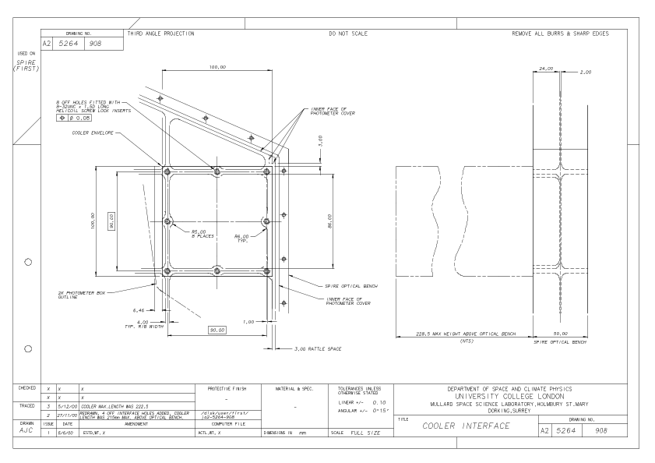
Figure 2.6.4-1: Outdated interface drawing, current I/F has 8 I/F holes, indicated with dotted circles

Mass Properties
Current mass budget for the cooler is 1.4 kg + 20% (TBC) contingency, see AD2 (to be updated).
COG and MOIto be defined.

Mechanical Environment
Assuming a first natural frequency, mounted against a rigid interface above 170 Hz.
As specified in 1.4, including the qualification factor of 1.5. The provisional sine spec is:

Sine vibration levels | Frequency range | Input at base (QUAL)
X-direction | 5-30 Hz  30-100 Hz | 11 mm (0-peak)  40 g
Y-direction | 5-30 Hz  30-100 Hz | 11 mm (0-peak)  25 g
Z-direction | 5-30 Hz  30-100 Hz | 11 mm (0-peak)  25 g
Table 2.6.6-1 Qualification sine input (2 oct/min)

Random spec to be issued.

 | X | Y | Z
f | g^2/hz | g^2/hz | g^2/hz
20 | 0.042 | 0.042 | 0.042
80 | 0.208 | 0.229 | 0.229
100 | 0.229 | 1.04 | 0.249
120 | 2.08 | 218.0 | 2.08
140 | 20.8 | 218.0 | 104.0
160 | 83.1 | 12.5.0 | 104.0
180 | 83.1 | 12.5.0 | 16.6.0
200 | 18.7 | 12.5.0 | 16.6.0
300 | 18.7 | 12.5.0 | 16.6.0
400 | 1.25 | 12.5.0 | 0.312
600 | 0.416 | 12.5.0 | 0.021
800 | 0.010 | 0.021 | 0.010
1000 | 0.002 | 0.002 | 0.002
g rms | 109.9 | 125.0 | 50.0
Table 2.6.6-3: Cooler qualification levels for random vibration (2.5 minutes) TBC

Thermal Interface

See for budgets thermal configuration control document.
CSTR1
minimal thermal resistance between structure and CSTR1 support is TBD W/K
CSTR2
minimal thermal resistance between structure and CSTR2 support is TBD W/K

Thermal Busbar
maximal heat leak from structure into the busbar is 1 micro-W (TBC)

Harness Routing

Two connectors on cooler housing and interconnect harness between cooler and RF-filter box. The connectors are 37 pins. Two of them located at the outside of the cooler housing. Provisional location indicated on cooler design, 25 October 2000, still to be included in the I/F drawing.
Harness length: Cooler RF-filter box 845 ± 170 mm
The harness length from the cooler to the RF-filter boxes is: TBD mm

Alignment
There are no strict alignment requirements on the cooler. The thermal straps attached to the cooler need to be able to sustain 0.5 mm (TBC) differential motion between the interface with the structure and the cooler. This does not take into account differential thermal contraction.

Photometer Detectors

Functional Description and Block Diagram
The photometer detectors consist of a set of three detectors PSW, PMW and PLW. The detectors are mounted on the photometer detector box. Inside the box the detectors interface with the thermal busbar and outside the box with the harness routing towards the JFET modules outside the structure.

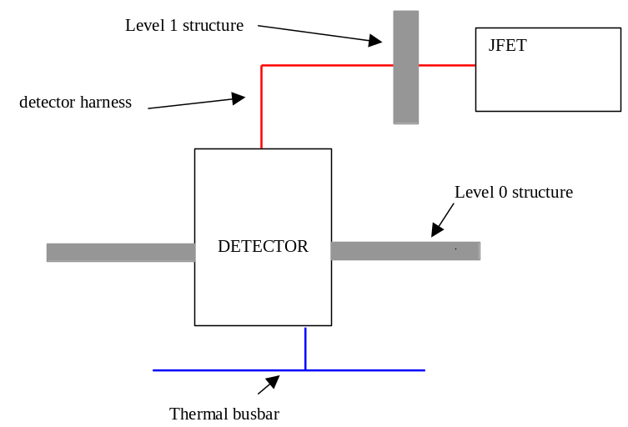
Block diagram 2.7.1-1:

Inputs
N.A.

Outputs
N.A.

I/F drawing
The listed drawings hereafter are draft versions. The current design has 4 interface bolt-holes.

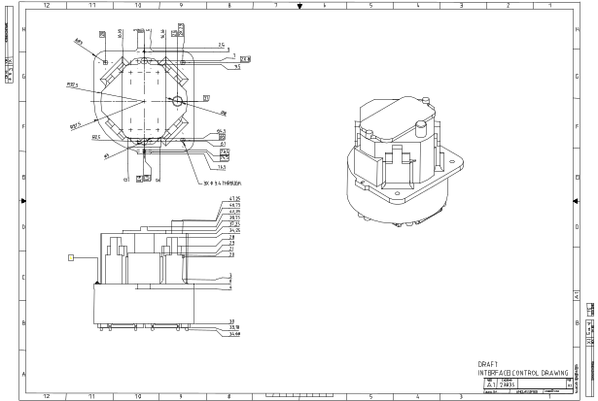
2.7.4-1: Overview of the detector
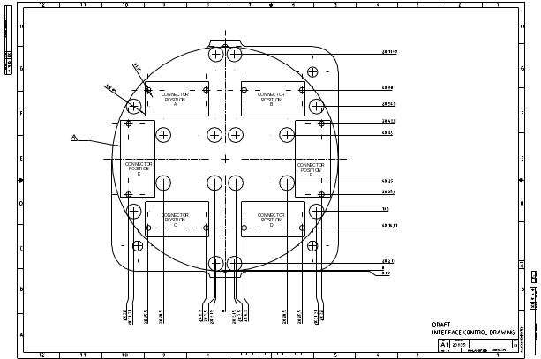
2.7.4-2: Back of the detector with 6 possible connector positions
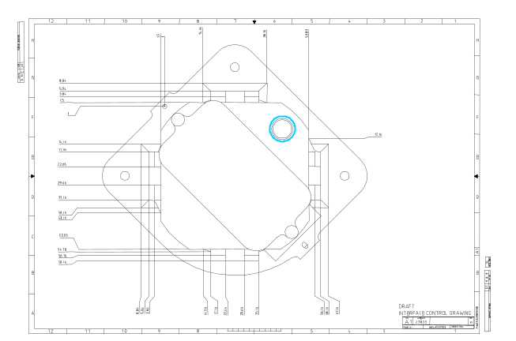
2.7.4.-3 Front of the detector with filter. Thermal interface indicated in blue

Mass Properties
On average the mass (for all five detectors) of the detector is 500 gr excluding contingency, see AD2.

Mechanical Environment
Assuming a first natural frequency, mounted against a rigid interface above 170 Hz.
As specified in 1.4, including the qualification factor of 1.5. The provisional sine spec is:

Sine vibration levels | Frequency range | Input at base (QUAL)
X-direction | 5-30 Hz  30-100 Hz | 11 mm (0-peak)  40 g
Y-direction | 5-30 Hz  30-100 Hz | 11 mm (0-peak)  25 g
Z-direction | 5-30 Hz  30-100 Hz | 11 mm (0-peak)  25 g
Table 2.7.6-1 Qualification sine input (2 oct/min)

Random spec to be issued.

Thermal Interface
The detector interfaces with the 0.3 K thermal busbar inside the photometer detector box. The connection will be made at the nose of the detector, as outlined in the draft interface drawing. The detector structure will be supported of the 2 K detector box.
There are thermal requirements for the 0.3 K busbar, they are listed in section…

- Minimum cable length between detector connector and common structure is 80 mm. (RD5)
- The cable loom support between the structure and the JFET rack is allowed a maximum parasitic heatload of TBD mW
The connector at the back of the detector serves also as a 2 K heat sink.

Harness Routing
The requirements for the harness routing are:
- Firmly connected to (support) structure to minimise microphonics
- Baseline routing is from the back of the detector down to the detector box routed along the A-frames supporting the detector box down to the SPIRE optical bench. After that the cable loom will be routed to the edge of the optical bench where it is routed through an interface plate provided for by JPL. The interface plate will be bolted to the optical bench interface bracket. Subsequently the loom is routed along the outer panel to the JFET rack. Between the SPIRE structure and the JFET rack the cable loom will be supported via a thermal insulating structure.
- PLW to connector panel: 1200 mm TBC
- PMW to connector panel: 1000 mm TBC
- PSW to connector panel: 1100 mm TBC
- Connector panel to JFET modules: 200 mm TBC

Spectrometer Detectors

Functional Description and Block Diagram
For the spectrometer detectors the same hold as for the photometer detectors, unless specified otherwise.

Inputs
See 2.7.

Outputs
See 2.7.

I/F drawing
See 2.7.

Mass Properties
See 2.7.

Mechanical Environment
See 2.7.

Thermal Interface
See 2.7.

Harness routing

See 2.7.

The harness lengths are:
- SLW to connector panel 600 mm TBC
- SLW to connector panel 700 mm TBC
- Connector panel to JFET modules: 200 mmTBC

Alignment
See 2.7.

Beam Steering Mechanism

Functional Description and Block Diagram
The BSM is used to steer the optical beam of the SPIRE photometer channel over the detector arrays.
The BSM comprises a flat mirror mounted on a pivot system which system allows precise angular motion of the mirror over a small range of angular travel in two orthogonal axes. Electrical actuators are used to provide motion of the mirror. Electrical transducers are used to measure the mirror position to allow control of the mirror position.
The BSM also provides an aperture through which the Photometer Calibration Source is directed towards the detector arrays. The Photometer Calibration Source is mounted behind the BSM.
The BSM comprises 3 main parts; the cryogenic mechanism (BSMm), the structural support (BSMs), and the warm electronics (BSMe). The structural support may be integral to the BSMm housing, or attached as a distinct entity (TBD). This document only deals with the interface between the BSM support and the SOB.
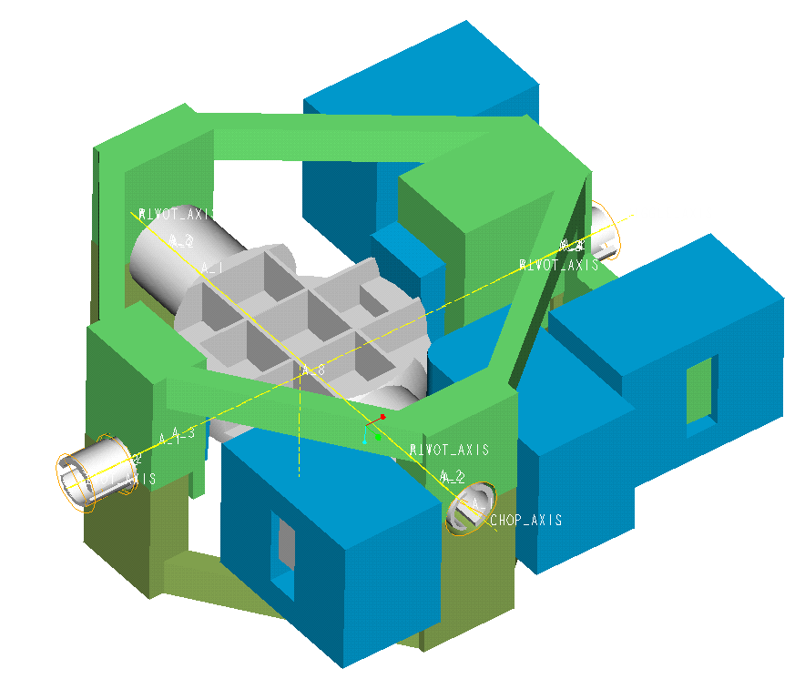
Figure 2.9.1-1: BSM mechanism, green-support structure, blue-actuators, grey-bottom view mirror RD3

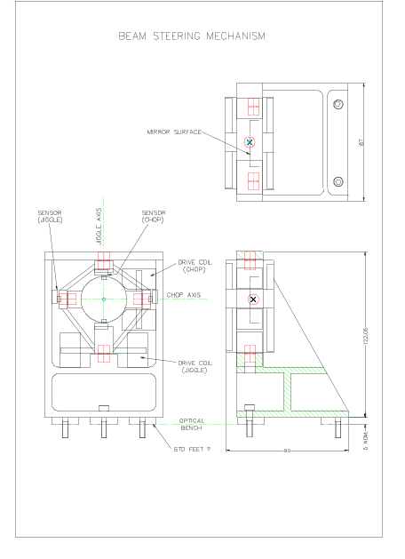
Figure 2.9.1-2: Sketch of the BSM support with BSM and Calibration source RD3
The support structure mounts the beam steering mirror mechanism from the SPIRE optical bench. Note that there will be a baffle incorporated to minimise straylight and emission into the optical beam. Electrical wiring and connectors are not shown. The photometer calibrator will also be mounted on this structure, and its wiring incorporated into the BSM harness. The outline design shown here is at present non-optimised, and will be further refined following FEA.

No block diagram

Inputs
Micro vibrations: TBD

Outputs
Micro vibrations: TBD

I/F drawing
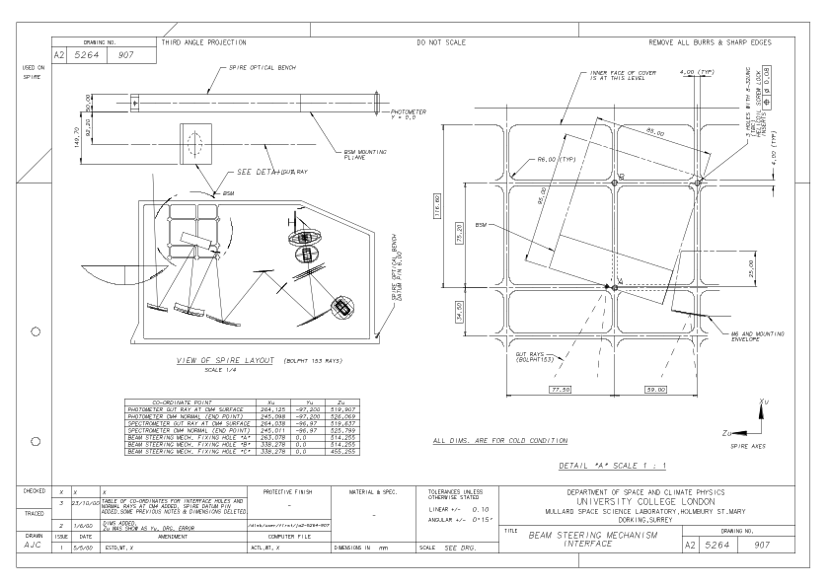

Mass Properties
The mass budget for the BSM is 1100 gr including harness. (AD2, excluding contingency) excluding calibrator.

CoG and MoI TBD

Mechanical Environment
As specified in 1.4, including the qualification factor of 1.5. The provisional sine spec is:

Sine vibration levels | Frequency range | Input at base (QUAL)
X-direction | 5-30 Hz  30-100 Hz | 11 mm (0-peak)  40 g
Y-direction | 5-30 Hz  30-100 Hz | 11 mm (0-peak)  25 g
Z-direction | 5-30 Hz  30-100 Hz | 11 mm (0-peak)  25 g
Table 2.9.6-1 Qualification sine input (2 oct/min)

Random spec to be issued. Thermal Interface
This interface needs to dissipate heat generated by the photometer calibration source into the SOB. This could be viat the currently defined interface or via a thermal strap. In the last case we need to specify a thermal strap bolt hole.

Harness Routing

- Harness will be connected to the RF-filter boxes and routed over the SOB.
- The harness length form the BSM connectors to the RF-filter boxes is 415 mm ±90 mm

Alignment

Spectrometer Mechanism

Functional Description and Block Diagram
The SMEC holds the central corner cube mirror’s of the FTS part of the FIRST/SPIRE instrument. These mirrors need to travel between the two ray paths within the spectromter, shortening one ray path and simultaneously lengthen the other. The total required travel is 32 mm in +X direction and 3.2 mm in –X direction (AD1, IRD-SMEC-R01) (Where +X is the launch direction). There will be an over-travel on top of this which still needs to be specified. It is expected that the overall total travel will be about something like 40 mm.
Mechanism Interface with other components
- Spire optical bench (SOB)
- Optics
- RF-filter boxes, via the harness

The function of the SOB (reviewing the interface between the SOB and the SMEC) is to support the mechanism. The mechanical interface should provide for a precise defined and accurately machined mounting surface. The mechanical interface should provide for sufficient stiffness, such that the mechanical loads on the SMEC are minimised.

There is no block diagram

Inputs
Micro-vibrations coming from the SOB TBS

Outputs
Micro-vibrations going into the SOB TBS

I/F drawing
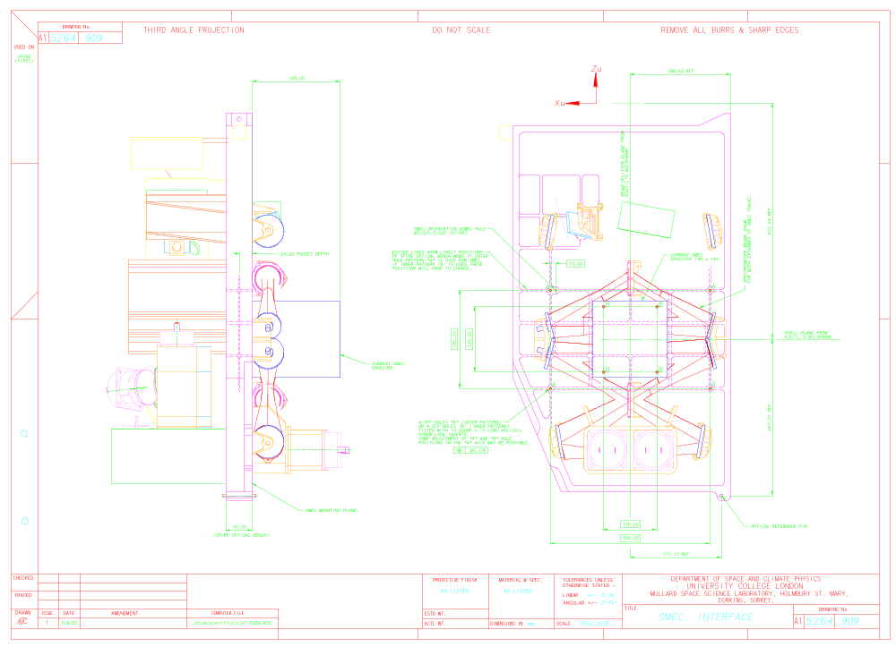
2.10.4-1: Interface drawing, the interface bolt hole pattern is indicated on the inside of the optical bench within the are enclosed by the collimating mirrors and the beam splitters..

Mass Properties
The current mass budget for the SMEC is 1.0 kg + 20% contingency, without mirrors and without harness? See AD2.

d.d. 28 Nov 2000

SMEC-m: 1100 gr
SMEC-p: 200 gr (mounted somewhere on the SOB, near the RF-filter boxes.
SMEC-m mirrors: 200 gr (about)

Mechanical Environment
Assuming a first natural frequency, mounted against a rigid interface above 170 Hz.
As specified in 1.4, including the qualification factor of 1.5. The provisional sine spec is:

Sine vibration levels | Frequency range | Input at base (QUAL)
X-direction | 5-30 Hz  30-100 Hz | 11 mm (0-peak)  40 g
Y-direction | 5-30 Hz  30-100 Hz | 11 mm (0-peak)  25 g
Z-direction | 5-30 Hz  30-100 Hz | 11 mm (0-peak)  25 g
Table 2.10.6-1 Qualification sine input (2 oct/min)

Random spec to be issued.

Thermal Interface
An extra interface bolt hole (on top of the 4) will be added to the interface to provide for a possible thermal strap mounting interface.

Harness Routing
Connectors (number TBD) on SMEC interface and harness between connector and RF-filter boxes.
The harness length form the SMEC connectors to the RF-filter boxes is 425 ± 85 mm

Alignment
The overall alignment of the interface plane dictates that the planarity stays within 0.1 mm, the interface bolt holes are located within +/- 0.1 mm. TBC.

Shutter Mechanism

Functional Description and Block Diagram

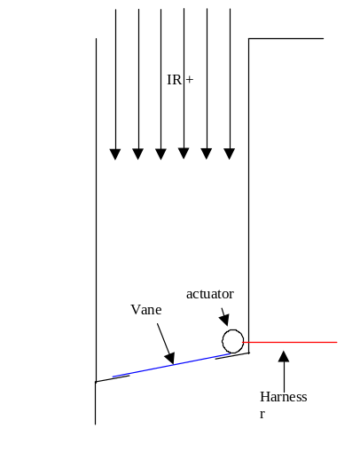
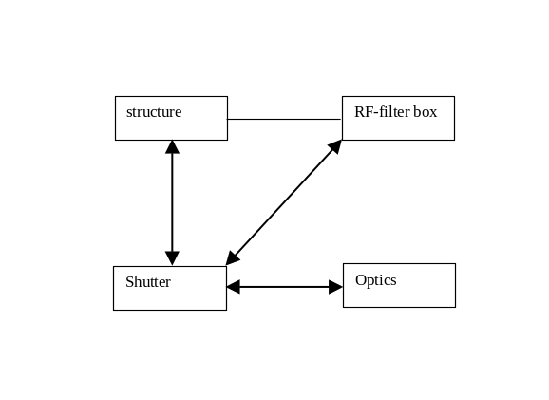

Table 2.11.1-1: Block diagram

Inputs
N.A.

Outputs
N.A.

I/F drawing
Action: MSSL to define available envelope for the shutter. Currently the volume constraint is about X x Y x Z = 80 x 50 x 50 mm³ for the actuator (if mounted of the SOB). And the volume constraint for the vane is: 80 x 150 x 50.
Mounting surface is either the SOB or the straylight baffle (to be decided) depends on RF-sealing of the instrument.

Mass Properties
See AD2, 200 gr without contingency.

Mechanical Environment
Assuming a first natural frequency, mounted against a rigid interface above 170 Hz.
As specified in 1.4, including the qualification factor of 1.5. The provisional sine spec is:

Sine vibration levels | Frequency range | Input at base (QUAL)
X-direction | 5-30 Hz  30-100 Hz | 11 mm (0-peak)  40 g
Y-direction | 5-30 Hz  30-100 Hz | 11 mm (0-peak)  25 g
Z-direction | 5-30 Hz  30-100 Hz | 11 mm (0-peak)  25 g
Table 2.11.6-1 Qualification sine input (2 oct/min)

Random spec to be issued.

Thermal Interface
Maximum allowed heat load on the SOB is 1 mW during operation of the vane (telescope broadband background simulation). TBD/TBC RAL. This does not include latching and short term events. These peak events will not exceed an influx of more than 0.01 J (?) into the instrument

Harness Routing
The harness will be routed over and through the SOB.
The harness length form the Shutter connector to the RF-filter boxes is 410 ±95 mm
The number of connectors is one at the shutter and possibly 2 at the RF-filter box. RAL needs to clarify this.

Spectrometer Calibration Source

Functional Description and Block Diagram
The spectrometer calibration source provides for a reference channel for the Fourier Transform Spectrometer. It consists of a heated black body inside a cavity. The heat generated inside the housing needs to be diffused in the optical bench. It is mounted with four bolts. The available envelope is 50 x 50 x 100 mm possibly extendable to 60 x 60 x 100 mm.

No block diagram

Inputs
N.A.

Outputs
N.A.

I/F drawing
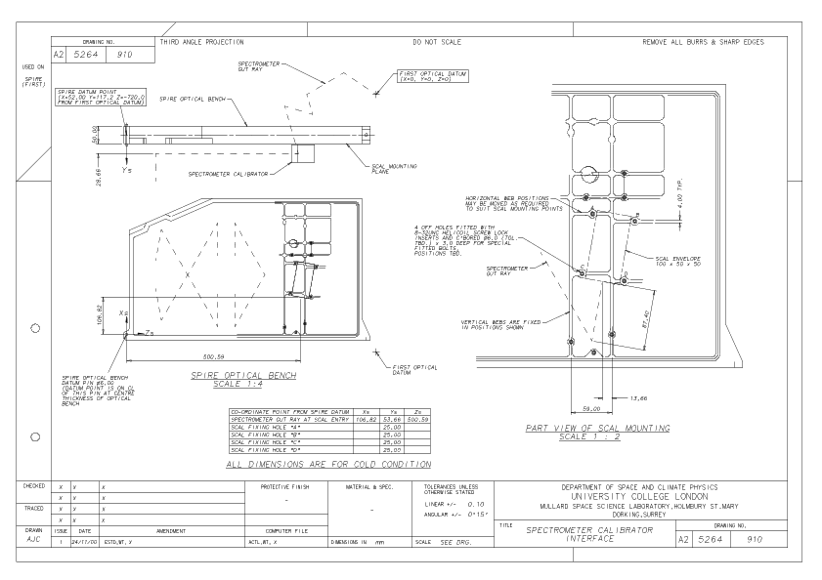

Mass Properties
The mass allocated to the SCAL is 200 gr without contingency, including harness. See AD2

Mechanical Environment
Assuming a first natural frequency, mounted against a rigid interface above 170 Hz.
As specified in 1.4, including the qualification factor of 1.5. The provisional sine spec is:

Sine vibration levels | Frequency range | Input at base (QUAL)
X-direction | 5-30 Hz  30-100 Hz | 11 mm (0-peak)  40 g
Y-direction | 5-30 Hz  30-100 Hz | 11 mm (0-peak)  25 g
Z-direction | 5-30 Hz  30-100 Hz | 11 mm (0-peak)  25 g
Table 2.12.6-1 Qualification sine input (2 oct/min)

Random spec to be issued. Thermal Interface
The connection with the SOB should allow for thermal conductance in order to dissipate the heat generated by the SCAL sufficiently.

- Minimum surface area for I/F: TBD
- Minimum torque for each bolt: TBD
- Surface treatment… TBD
- Use of a thermal gasket is TBD/TBC

Harness Routing
The harness is routed via the SOB to the RF-filter boxes. The harness routing will be part of the I/F drawing, likely on a separate sheet(s).
The length of the harness from the SCAL to the RF-filter boxes will be 325 ±65 mm.

Alignment
The overall alignment of the interface plane dictates that the planarity stays within 0.1 mm, the interface bolt holes are located within +/- 0.1 mm. TBC.

Thermal Straps

Functional Description and Block Diagram
SPIRE has several different temperature stages. In order to diffuse excess heat to the cryostat, various components of the instrument are connected directly or indirectly to the cryostat. Baseline the straps are made of copper.

Level 0 straps.
There are three level 0 straps attached to the instrument. Two of them are connected to the cooler and one connected to the photometer detector box and the spectrometer detector box. The level 0 thermal straps are directly connected with the cryostat. There nominal temperature is between 1.7 and 1.8 Kelvin.

Level 1 strap
There is one level 1 strap attached to the structure. It is routed from the vent line, running around the FOB to the optical bench.

Thermal busbar
The thermal busbar runs from the cold end of the cooler to the photometer detector box and the spectrometer detector box. It branches of inside these boxes and runs along the detectors. At each detector interface a copper strap branches of and is connected to the thermal interface with the detector.

Inputs
N.A.

Outputs
N.A.

I/F drawing
TBD

Mass Properties
TBD

Mechanical Environment
Assuming a first natural frequency, mounted against a rigid interface above 170 Hz.
As specified in 1.4, including the qualification factor of 1.5. The provisional sine spec is:

Sine vibration levels | Frequency range | Input at base (QUAL)
X-direction | 5-30 Hz  30-100 Hz | 11 mm (0-peak)  40 g
Y-direction | 5-30 Hz  30-100 Hz | 11 mm (0-peak)  25 g
Z-direction | 5-30 Hz  30-100 Hz | 11 mm (0-peak)  25 g
Table 2.13.6-1 Qualification sine input (2 oct/min)

Random spec to be issued. Thermal Interface

ID | Maximum parasitic load from the structure | Boundary temperatures
CSTR1 | TBD | 4.0 K | 2.0 K
CSTR2 | TBD | 4.0 K | 2.0 K
CSTR3 | TBD | 4.0 K | 2.0 K
CSTR4 | N.A. | 4.0 K | 4.0 K
Thermal busbar | 1 micro-W | 1.7 K | 0.3 K

Table 2.13.7:

Add bolt patterns (I/F drawing) + torques + surface finish

Harness Routing
N.A.

JFET box

Functional Description and Block Diagram
The JFET modules are stored outside the instrument because the added heat load from the JFETs themselves would seriously add to the overall (parasitic) heat load of the instrument. Stored outside the common structure on the FOB the heat can be dissipated via that bench and through additional ventlines (level 2) if needed. The JFET modules run at a temperature of about 120 Kelvin.
In order to minimise the cable length between the detectors and the JFET modules the JFETs are mounted in two different enclosures. One located near the photometer detectors, 6 modules in all, and one located near the spectrometer detectors, 3 modules in all. The JFET modules interface between the detector harness coming from the instrument and the cry-harness provided for by ESA. See the pictures here after for a global view of SPIRE and the JFET boxes on the FOB.

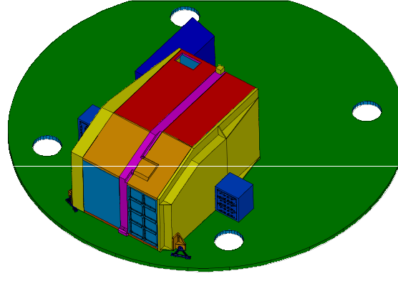
Figure 2.14.1-1: View on the spectrometer FBX

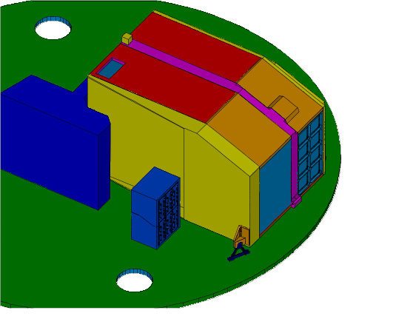
Figure 2.14.1-2: View on the photometer FBX

Inputs

Outputs

I/F drawing
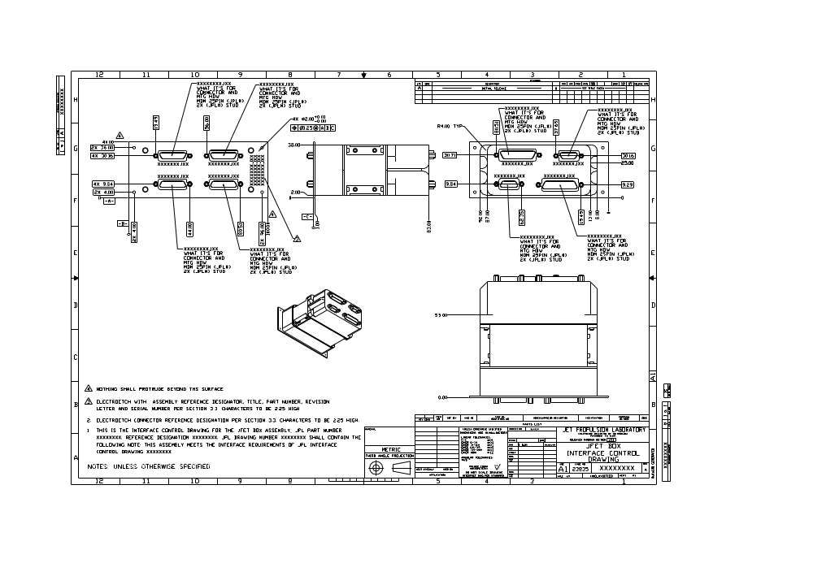

Mass Properties
TBD

Mechanical Environment

As defined by the in

Thermal Interface

Harness Routing
RD4
- The cables should be kept short. We wish to achieve a capacitance
of 50 pF between signal lines, including all sources of capacitance.
Please give us a rough length so we can investigate cable capacitance
per unit length.
- The minimum mechanical frequency of the cables should be 1 kHz.
The cables must not be disturbed during servicing of the instrument.
- Minimum bend radius is 3 mm (TBC).
- We would like to investigate the possibility of eliminating the
connectors on the 4 K shield, instead connecting a drilled aluminum
plate to connect the shield to the RF box. This eliminates the connectors
and simplifies the cable.

The harness will be supported of both the SPIRE structure as well of the JFET structure. This in order to minimise the parasitic heat load from the JFETs into the structure and to meet the stiffness requirement of the cables.

RF-Filters
To be written.

Currently five units with 2 25 way connectors are foreseen.

Thermometry harness
To be written.

For the structure there will only be two flight thermometers on the detector boxes (+ redundant thermometers TBC) and possibly a extra thermometer on the secondary optical bench for ground testing purposes.

