Section 10 Appendix 6
Thermal Calculations

Contents

Calculation: thermal equilibrium of motor coils, materials G10 vs Aluminium 2
1.1 Variables: 2
1.2 Results 4
2 Mirror temperature estimate 6
2.1 Block Diagram 6
2.2 Calculation 7
2.3 Results 8
2.4 Check on limiting heat path 9
3 Cernox 1030 Thermometer data sheet 11

Figures

Figure 1 : Cooling with G10. At dissipations of 1mW the motor coils would radiate at 50-70K 4
Figure 2: Cooling with aluminium: at dissipations below 18mW the background temperature would remain in specification (<1K) 5
Figure 3: thermal block diagram 6
Figure 4 mirror temperature sensitivity 8

Calculation: thermal equilibrium of motor coils, materials G10 vs Aluminium

Variables:

Motor Dissipation (W) | 0-1.5 | mW
Surface area (coils) | 0.0005208 | m²
Stephan-Boltzmann constant, σ | 5.67E-08
BSM structure temperature (worst case) | 6.0 | K

Coil surface area based on dimensions (mm)
L | B | W
15.5 | 12 | 6.2

Heat loading from motors Q= A x σ x (T1^4-T2^4)
The temperature, T1 of the motor coil was then calculated assuming pure radiative cooling,

The minimum section of the motro block (neglecting cooling from any thermal or magmetics shield) - dimensions
W | H
2.1 | 4.5

Conductive cooling via G10
c(6.2-4.0 K) | 0.2 | W/m
Conductive cooling via Aluminium
c(6.2-4.0 K) | 33.6 | W/m
Conductive cooling via aluminium bolted joint | 60 | W/ m² K
Area of Aluminium (min restriction) | 0.0000378 | m²
Area of aluminium bolted joint | 0.00028875 | m²
length (to inner coil) | 0.0097 | m
length (to outer coil) | 0.0199 | m

However, the aluminium case thermal path has a limit on conduction - from the bolted joint interface

Based on a 1K differential (conservative), the limit is | 0.017325 W

Q = A.c/L
Heat conduction then calculated for the inner or outer coil
Temperature of coil, with balance cooled radiatively plotted below

Results

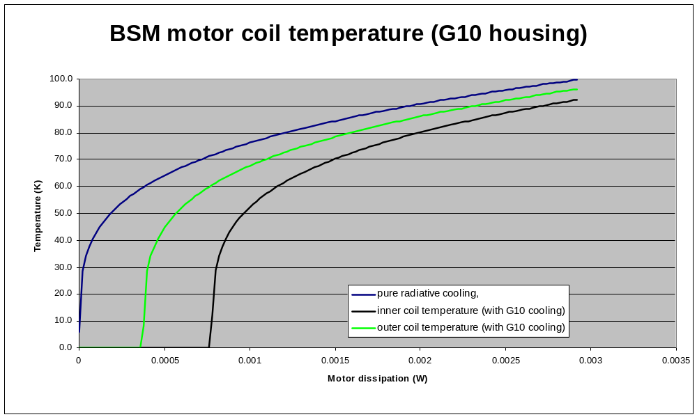
Figure 1 : Cooling with G10. At dissipations of 1mW the motor coils would radiate at 50-70K

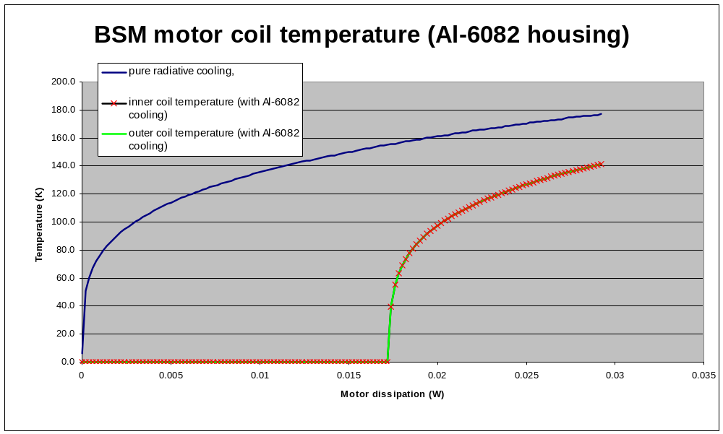
Figure 2: Cooling with aluminium: at dissipations below 18mW the background temperature would remain in specification (<1K)

Mirror temperature estimate

Block Diagram
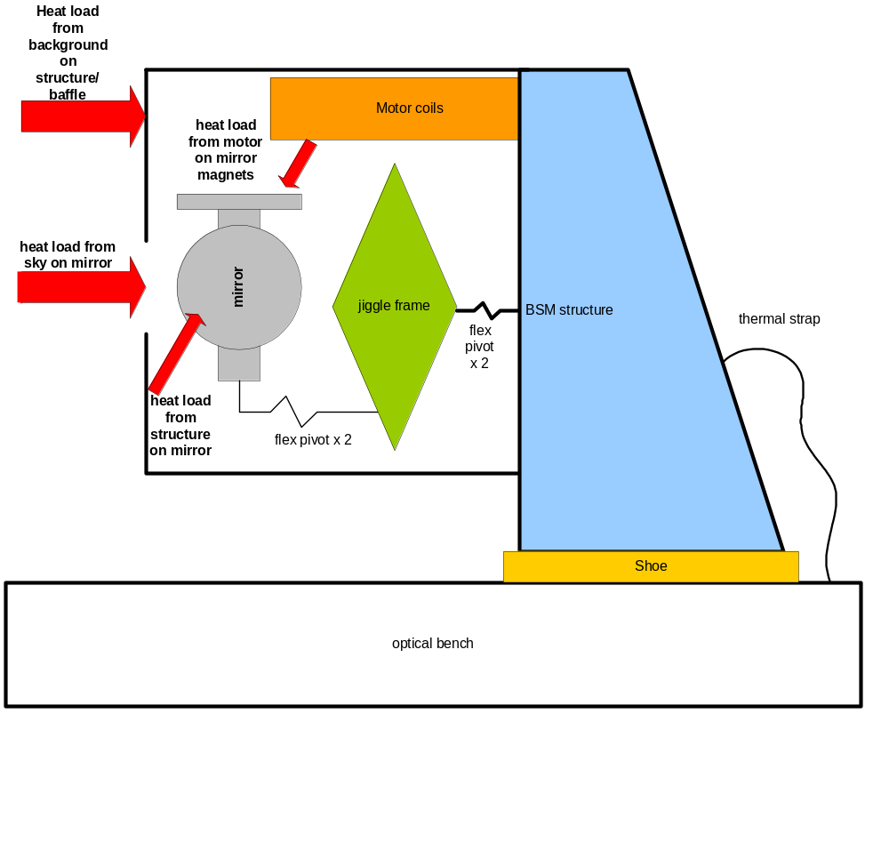
Figure 3: thermal block diagram

Calculation

Ac | 8.30E-04 | m² | Chop axis area sees sky
Am | 3.00E-04 | m² | Chop axis area sees motor
Ap | 4.48E-07 | m² | csa pivots
Cp | 0.6 | W/ m² | conduction pivots (stainless steel)
Lp | 6.53E-03 | m | length pivots (approx)
Tj | 5 | K | bsm structure & jiggle frame temp
Ts | 4-150 | K | Temperature of sky
Tm | 4-180 | K | temperature of motors

Steady state:

Q sky + Q motor = Q flex pivot (ignoring re-radiation by mirror)

Ac.σ.( Ts⁴- Tc⁴) + Am σ.( Tm⁴- Tc⁴) = Ap.cp/Lp (Tc - Tj)

(Ac-Am)Tc⁴ +(Ap.Cp/Lp. σ).Tc = (Ap.cp/Lp. σ).Tj + Ac.Ts⁴ +Am.Tm⁴

Solve for Tc, results below

Results
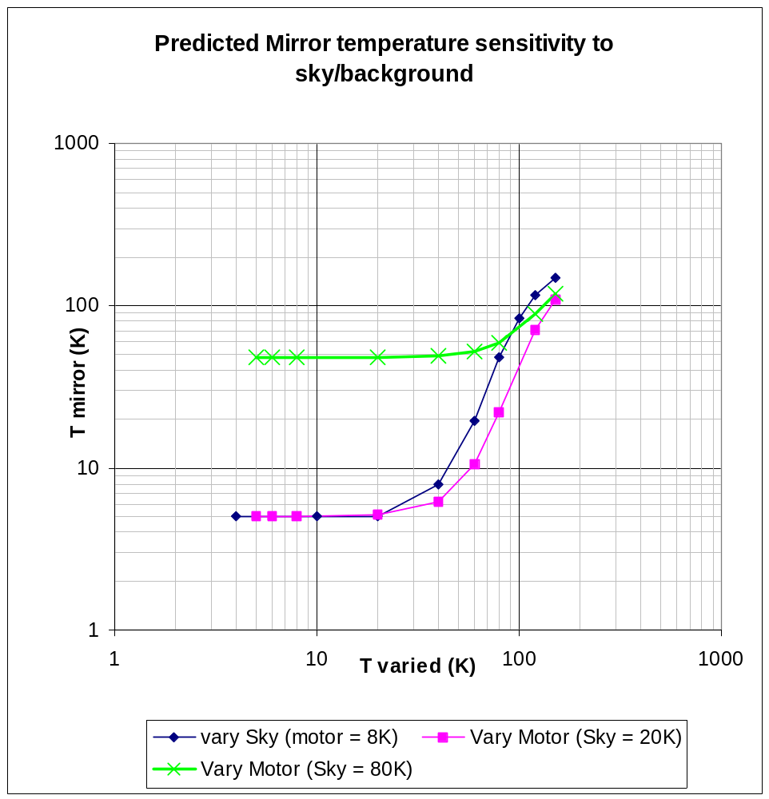
Figure 4 mirror temperature sensitivity

Check on limiting heat path

Note the above assumes the flex pivots are the limit on the heat path. This can be confirmed by crude calculation, below.

Allowing a 0.1 deg K differential across each section or interface, the chop axis pivot clearly has the lowest conducted heat.

Component | Conduction (4-6k) | conductance (W/m^2K) | Contact Area | min CSA | Length | max Conducted heat (W) | Delta-T | Notes
Optical Bench |  |  |  |  |  |  | 0.1
Bench-Shoe interface |  | 7.50E+02 | 4.10E-04 |  |  | 3.08E-02 | 0.1 | Al-Au-Al
Shoe minimum section | 33.600 |  |  | 4.00E-04 | 0.008 | 1.68E+00 | 0.1 | Al 6082
shoe-BSMs interface |  | 7.50E+02 | 4.00E-04 |  |  | 3.00E-02 | 0.1 | Al-Au-Al
BSMs minimum section | 33.600 |  |  | 3.37E-04 | 0.093 | 1.22E-01 | 0.1 | Al 6082
BSMs-flex pivot capture sleeve |  | 6.00E+01 | 1.30E-04 |  |  | 7.80E-04 | 0.1 | al-al. surface area of top pivot half factored by .75 to allow for joint conduction
Flex pivot capture sleeve x2 | 33.600 |  |  | 2.14E-02 | 0.006 | 2.40E+02 | 0.1 | Al 6082
Flex pivot capture sleeve- flex pivot x2 |  | 4.00E+02 | 1.37E-04 |  |  | 5.48E-03 | 0.1 | Al-eccobon-inconel
Jiggle flex pivot minimum section x2 | 0.600 |  |  | 3.00E-06 | 0.008 | 4.50E-04 | 0.1 | Inconel (or stainless)
Jiggle flex pivot - jiggle frame |  | 4.00E+02 | 1.00E-02 |  |  | 4.00E-01 | 0.1 | inconel-al
Jiggle frame minimum section | 33.600 |  |  | 2.00E-05 | 0.040 | 1.68E-02 | 0.1 | Al 6082
Jiggle frame - capture sleeve x2 |  | 6.00E+01 | 1.00E-02 |  |  | 6.00E-02 | 0.1 | al-al
capture sleeve - chop flex pivot x2 |  | 4.00E+02 | 1.00E-02 |  |  | 4.00E-01 | 0.1 | Al-eccobon-inconel
chop flex pivot min section x2 | 0.600 |  |  | 2.00E-06 | 0.008 | 3.00E-04 | 0.1 | Inconel (or stainless)
chop flex pivot - chop stage |  | 4.00E+02 | 1.00E-02 |  |  | 4.00E-01 | 0.1 | inconel-al
Chop stage (mirror) min section | 33.600 |  |  | 2.00E-05 | 0.025 | 2.69E-02 | 0.1 | Al 6061

Data:

Aluminium thermal integral (AL 6082) | 33.6 | 6-4.2K | W/m | RAL doc gives ~14 W/mK |  |  | ATC has 85 for Al 6063
inconel (use stainless steel) | 0.6 | 6-4.2K | W/m | RAL & ATC agree
vespel sp-1 | 0.0125 | 6-4.2K | W/m | RAL
joints :
al-al |  | 6.00E+01 | W/m^2K
al-au-al |  | 7.50E+02 | W/m^2K
stainless-stainless |  | 1.00E+02 | W/m^2K
inconel-al |  | 4.00E+02 | W/m^2K | guess
Al-eccobon-inconel |  | 4.00E+02 | W/m^2K | guess

Cernox 1030 Thermometer data sheet

