L.A.M.  FRE 2243 | FIRST  SPIRE | Ref : LAM.PJT.SPI.SPT.200007 Ind 6  Author : K.Dohlen and D.Pouliquen | Page : 1 / 13  Date : 12 June 2001
SPIRE Mirrors Specification

Distribution List :

RAL | Colin Cunningham | X | Ken J. King | X
 | Bruce Swinyard | X | Tony Richards | X
CNES | Martine Joubert |  | Yvan Blanc
CEA-Sap | Jean-Louis Auguères
DESPA | Guy Michel
GSFC | Don.E. Jennings
LAM | Armand Artinian |  | Jean-Paul Baluteau | X
 | Claude Colin |  | Pascal Dargent | X
 | Kjetil Dohlen | X | Didier Ferrand
 | Michel Jevaud |  | Patrick Levacher
 | Alain Origné | X | Dominique Pouliquen | X

_________________________________________________________________________________
LABORATOIRE d'ASTROPHYSIQUE de MARSEILLE- CNRS BP 8 13376 MARSEILLE Cedex 12 FRANCE
Tél : (33) +4 91 05 59 00 - Fax : (33) +4 91 05 69 59
Update

Date | Indice | Remarks
5 June 2000 | 1 | Creation of the document
12 Oct 2000 | 2 | Updated mirror dimensions. Spec P5 added.
28 Nov 2000 | 3 | Corrected illustration of CM3 (p. 9)
18 Dec 2000 | 4 | Remodified CM3 dimension. Spec P6 added (RoC)
21 Feb 2001 | 5 | Fig. p5 replaced by CM3. Sec. 3.3: no. of sets. Added notes in table 1. Corrected baseline version numbers
12 June 2001 | 6 | Clarification of dimensions and decenters in Table 1.

Host system | Windows 95
Word Processor | Microsoft Word 97
File | /tmp/in/input.doc

Table of contents

1. Scope of the document 4
2. Documents 4
2.1. Applicable documents 4
2.2. Glossary 4
3. The mirrors 5
3.1. Instrument description 5
3.2. Mirrors description 6
3.3. Mission profile 6
3.4. Product tree 7
4. Requirements 7
4.1. Functional requirements 7
4.1.1. Performance requirements 7
4.1.2. Technical requirements 7
4.1.3. Mirror parameters 8
4.2. Operational requirements 11
4.2.1. Relialibility 11
4.2.2. Lifetime 11
4.2.3. Operating modes 11
4.2.4. Telemetry 11
4.2.5. Telecommands 11
4.3. Interface requirements 12
4.4. Design and manufacture requirements 12
4.4.1. Design requirements 12
4.4.2. Design rules 12
4.4.3. Manufacture requirements 12
4.5. Logistic requirements 12
4.6. Environment requirements 13
4.6.1. Natural environement 13
4.6.2. Operating environment 13
4.7. Verification requirements 13

Scope of the document
This specification defines the requirements applied to the performances, the design and the qualification of the SPIRE mirrors. It is applicable to the PFM and the FS.

SPIRE (Spectral and Photometric Imaging REceiver) is one of the three instruments which will equip the Far Infrared Space Telescope (FIRST), an ESA mission planned to be launched in 2007. It will provide astronomical images in the 200-670 µm band.

Documents

Applicable documents
 | Title | Author | Reference | Date
AD1 | Instrument Requirements Document | B.M.Swinyard | SPIRE-RAL-PRJ-000034 Issue 0.21 | 30 nov 1999
AD2 | Structure/Optics Interface |  | SPIRE 1.1/1.2
AD3 | SMEC / Optics Interface |  | SPIRE 1.2/1.5.2

Glossary

AD | Applicable Document
BSM | Beam Steering Mirror | LAM | Laboratoire d'Astrophysique de Marseille
BSMm | BSM cryogenic mechanism
CEA | Commissariat à l'Energie Atomique | MGSE | Mechanical Ground Support Equipment
CDR | Critical Design Review | MM | Mechanical Model
CNES | Centre National des Etudes Spatiales | MSSL | Mullard Space Science Laboratory
CoG | Center of Gravity | NA | Not Applicable
CQM | Cryogenic Qualification Model | OGSE | Optical Ground Support Equipment
DDR | Detailed Design Review | PDR | Preliminary Design Review
 |  | PFM | Prototype Flight Model
DM | Development Model | RAL | Rutherford Appleton Laboratory
 |  | RD | Reference Document
 |  | SMEC | Spectrometer mirror MEChanism
 |  | SMECm | SMEC cryogenic mechanism
 |  | SMECp | SMEC cold preamplifier
 |  | SPIRE | Spectral and Photometric Imaging REceiver
FIRST | Far InfraRed Submillimeter Telescope | TBC | To Be Confirmed
FPU | Focal Plane Unit | TBD | To Be Defined
FS | Flight Spare model | TBU | To Be Updated
FTS | Fourier Transform Spectrometer | TBW | To Be Written
GSFC | Goddard Space and Flight Center | WE | Warm Electronics

The mirrors

Instrument description
Figure 1 shows a schematic overview of the SPIRE instrument. It consists of two channels, Photometer (upper) and Spectrometer (lower), located one on either side of a central panel. Mirrors CM3, CM4 and CM5 are common. Mirrors PM6 and SM6 are field mirrors picking off a part of the beam for each channel.

Photometer channel.
Spectrometer channel.

Figure 1. Schematic layout and nomenclature for the SPIRE instrument.

Mirrors description
The basic design of the mirrors is the same as the one used for ISO-LWS.
The mirrors are made in Aluminium 6061.
They all have a standard interface with the structure, i.e. an M8 screw and a pin.
Each mirror is machined in a single block of aluminium (diamond cutting). The screw part of the attachment exerts pressure only on the shoulder part of the mirror, avoiding deformation of the optical surface.
The mount of each mirror is located on the optical bench by means of a pin.
This pin ensures that in case of dismounting of the mirror it will be mounted again in the same position.
During integration of the mirrors in the SPIRE structure, the mirrors are mounted on brackets which are provided by MSSL.
The figure below gives a drawing of the CM3 mirror, which is the more complex.

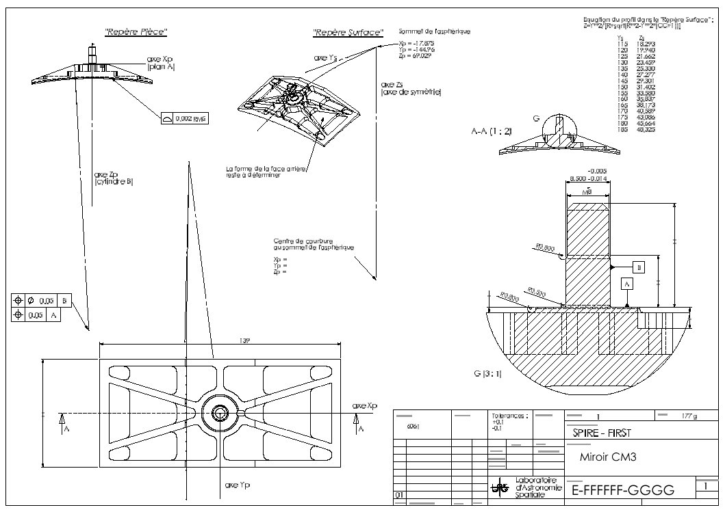
Figure 2.

The interface between the corner cube mirrors and the SMEC mechanism is TBD.

Mission profile
Here are the successive phases of the subsystem life from the end of manufacturing to the end of life.
These are for information only. Discrepancies with actual AIV and operation plan are allowed.
Durations are TBC.

Operation | Where | Duration | Note
Bakeout | LAM | 1 week
Control | LAM | 4 weeks
Warm Vibrations | LAM | 1 week | On the CM5 mirror only
Thermal cycles | LAM | 4 weeks
Control | LAM | 4 weeks
Transport | From LAM to RAL | 2 days
Integration in the SPIRE Structure | RAL | TBD
Bakeout | RAL | 1 week
Warm vibrations | RAL | 1 week
Transport | From RAL to ? | TBD
Cold vibrations | ? | 3+ weeks
Transport | From ? to RAL | TBD
Thermal cycles | RAL | TBD
Calibrations | RAL | TBD
Transport | From RAL to ESA | TBD
Satellite tests | ESA | TBD
Storage | ESA | 2 years (TBC)
Launch | Kourou | TBD
Beginning of operation | Orbit | TBD
Operations | Orbit | 4.25 years
End of operations | Orbit | TBD

Product tree
Each mirror is made of three parts : the mirror, a dowell pin and a nut.
The corner cubes are not yet defined.

Two complete sets of mirrors are required.

Requirements

Functional requirements

Performance requirements
The overall instrument performance requirements are listed in [AD1] and have been translated into the following requirements for the mirrors.

# | Parameter | Value | IRD | Note
P1 | Infrared relflectivity | >0.99
P2 | Infrared emissivity | <0.01
P3 | Visible reflectivity | >0.8 (TBC) |  | For vis. alignment purpose
P4 | Surface roughness | < 10nm RMS |  | For vis. alignment purpose
P5 | Surface shape | < 1 µm RMS (TBC) |  | Corresponds to 2 µm on the reflected wave, i.e., λ/100 at 200µm
P6 | Radius of curvature | ΔR/R < 10⁻³ |  | For non-flat surfaces

P7

P8

P9

P10

Technical requirements

# | Parameter | Value | IRD | Note
Tm1 | Axis definition | TBD
Tm2 | Alignment tolerances | 0.5arcmin, 0.05mm
Tm3 | Dimensions |  |  | See table 1 below
Tm4 | Center of gravity | TBD
Tm5 | Mass | 2.5 kg including 20% margin |  | See table 1 below
Tm6 | Inertia | TBD

Mirror parameters
All the data given in Table 1 are generated from the optical design model. Current baseline designs are BOLPHT155 (photometer) and BOLSP501F (spectrometer). The dimensions given are valid at operating conditions (4K). A scaling factor of 1.00415 (TBC) allows calculating room temperature values. No factor must be applied to the conic constant, CC, which is dimensionless.

The mirrors are defined with respect to a co-ordinate system local to each mirror whose z-axis is perpendicular to the optical surface at the summit of the surface, not necessarily coinciding with the centre of the mirror.

Positive radius of curvature signifies concave mirror. For toric mirrors, Ry is the radius of curvature in the y-z plane and Rx is the radius of curvature in the x-z plane.

Dimensions of the mirrors are given for the projection of the mirror aperture onto the local x-y plane. The differences with respect to actual mirror dimensions are particularly important for CM3. The following dimensions are given:
Rectangular mirrors (rect): a and b are sides along x and y axes, respectively
Elliptical mirrors (ellipt): a and b are diameters along x and y axes, respectively
Circular mirrors (circle): dia is diameter

Decentering data are projected onto the local x-y plane. One identifies three points in this plane, see Figure 3:
The surface summit, origin of the local co-ordinate system (0,0)
The projection of the spigot intersection point between mirror surface and spigot axis (xs,ys)
The centre of the projected mirror aperture (c,d)

Mirror thickness at the spigot is 15 mm (TBC) at room temp (TBC) for CM3, CM5, PM7, PM9. All the other mirrors have centre thickness 7 mm (TBC) at room temp (TBC).

Calculated masses are TBC and exclude margin.

CM4 and CC faces are not part of the main mirror manufacturing contract.

Figure 3. Illustration of aperture dimensions and decentering.

Table 1 : Mirror parameters

Subass'y | Mirror | Type | R or Ry  (mm) | CC or Rx  (mm) | Shape and size  a x b or dia | Spigot intersection  xs, ys | Aperture centre  c, d | Nb. of parts per model | Mass (kg)
Fore optics | CM3 | Off-axis asphere | 365.963 | -0.5095 | Rect  139x62 | -19.5, 145  See fig. 4. | -19.5, 145 | 1 | 0.256
 | CM4 (BSM) | Flat |  |  | Ellipt.  30x32 |  |  | 1 | 0.021
 | CM5 | Toric | 294.638 | 278.418 | Rect  161x85 | 19.5, -1.5 | 19.5, -1.5 | 1 | 0.360
Photometer | PM6  (Pick-off) | Toric | -307.49 | -359.42 | Rect  46x27 |  |  | 1 | 0.027
 | PM7 | Sphere | 330.70 |  | Rect  118x101 |  | 0, -1.0 | 1 | 0.300
 | PM8 | Sphere | -286.651 |  | Circle  Ø 60 |  |  | 1 | 0.056
 | PM9 | Sphere | 350.851 |  | Circle  Ø 112 |  |  | 1 | 0.223
 | PM10  (Fold mirror) | Flat |  |  | Rect  78x40 |  | 2.5, 0 | 1 | 0.065
 | PM11  (Fold mirror) | Flat |  |  | Rect  56x53 |  | 0, -2.75 | 1 | 0.060
Spectrometer | SM6  (Pick-off) | Toric | 523.79 | 269.92 | Ellipt  18x24 |  | 0, 1.0 | 1 | NB a corriger
 | SM7  (Fold mirror) | Flat |  |  | Rect  40x57 |  | 0, 4.0 | 1 | 0.044
 | SM8A, B  (Relay in) | Toric | 230.34 | 202.00 | Circle  Ø 60 |  |  | 2 | 0.112
 | SM9A, B  (Collimator) | Sphere | 259.50 |  | See fig. 5.  Ø50 |  |  | 2 | 0.074
 | CC face1 | Flat |  |  | See fig. 6  40x60 |  |  | 2 | 0.044
 | CC face2 | Flat |  |  | See fig. 6  28x68 |  |  | 2 | 0.070
 | CC face3 | Flat |  |  | See fig. 6  28x68 |  |  | 2 | 0.070
 | SM10A, B  (Camera) | Sphere | 260.00 |  | See fig. 5  Ø60 |  |  | 2 | 0.112
 | SM11A, B  (Relay out) | Toric | 196.99 | 169.84 | Circle  Ø 74 |  | 0, 1 | 2 | 0.194
 | SM12A, B  (Fold mirrors) | Flat |  |  | Ellipt  42x32 |  | -1, 0 | 2 | 0.050
Total |  |  |  |  |  |  |  | 27 | 2.167

Figure 4. Mirror CM3, off-axis part of asphere. Values of a, b, c and d are given in Table 1. The symmetric substrate radius is calculated by: $e=\sqrt{{\left(a/2+\left|c\right|\right)}^{2}+{\left(b/2+\left|d\right|\right)}^{2}}$. Its current value is 202 mm.

Figure 5. Mirrors SM9 and SM10. "Chopped-off" circular apertures.

(a) | (b)

Figure 6. Corner cube faces. (a): face 1, (b): faces 2 and 3.

Operational requirements

Relialibility

Lifetime

# | Parameter | Value | IRD | Note
OL1 | Ground Storage lifetime | 2 years |  | A guess
OL2 | Ground Integrated lifetime | 4 years |  | About
OL3 | Ground operational lifetime | 1.5 years |  | 6 months for subsystem acceptance  6 months for SPIRE acceptance  6 months for FIRST acceptance  Under 1g conditions
OL4 | On orbit operational lifetime | 4.25 years

Operating modes
Non applicable

Telemetry
Non Applicable

Telecommands
Non Applicable

Interface requirements
The interfaces are defined in the relevant applicable documents.

Part | Interface | With | Document
SMECm | Mechanical | SPIRE Structure | SPIRE 1.1/1.5.2
 | Thermal | SPIRE Structure | SPIRE 1.1.1/1.5.2
 | Optics | SPIRE Optics | SPIRE 1.2 / 1.5.2
SMECp | Mechanical | SPIRE Structure | SPIRE 1.1/1.5.2
 | Thermal | SPIRE Structure | SPIRE 1.1.1/1.5.2
SMECe | Mechanical | DRCU | SPIRE 1.5.2 / 2.2
 | Thermal | DRCU | SPIRE 1.5.2 / 2.2
 | Electronic | DRCU | SPIRE 1.5.2 / 2.2
 | Electronic | MCU | TBW
MCU | Mechanical | DRCU | SPIRE 1.5.2 / 2.2
 | Thermal | DRCU | SPIRE 1.5.2 / 2.2
 | Electronics | DRCU | SPIRE 1.5.2 / 2.2

Design and manufacture requirements

Design requirements
TBD

Design rules
TBD

Manufacture requirements
These are requirements on accessibility, dismountability, testability and manufacturing processes.
- TBD fluids to be forbidden during manufacture to avoid pollution.
- TO BE COMPLETED

Logistic requirements
The subsystem wil be transported to and from RAL.
The containers will have to guarantee that:
- no shocks are greater than those defined for the launch.
- no pollution sneaks to the mirrors
- TO BE COMPLETED

Environment requirements
These requirements describe the environement in which the mirrors will live.

Natural environement
This is the description of the natural environment around the mirrors.

# | Parameter | Value | Note
EN1 | Vacuum | Less than 10-4 Pa | During tests, launch and in operation
EN2 | Operating temperature | during system qualif and on orbit = 4K  during subsystem qualification = 300K and 20K
EN3 | Storage and handling temperature | -20 to +30 °C | Overall, on ground
 | Humidity | Less than 45% | In clean room
 | Cleanliness | Class TBD | In clean room
EN4 | Radiations | Less than 3.5 kRAD | On orbit

Operating environment
This is the description of the environment imposed by the location of the subsystem in SPIRE and in FIRST.

# | Parameter | Value | IRD | Note
ON1 | Vibrations | TBD |  | At 4K
ON2 | Shocks | TBD |  | At 4K
ON3 | Microvibrations | TBD |  | NA
ON4 | Acoustic | NA |  | Launched under vacuum

Verification requirements
TO BE COMPLETED

