FIRST SPIRE

Detector Subsystem

Specification Document

Document Ref.: SPIRE-JPL-PRJ-000456

Issue: Version 1.0

Prepared by: James Bock Date: 2 August 2000
Gerald Lilienthal
Bruce Swinyard

Approved by: Matt Griffin
Ken King

Distribution List :

QMW | Matt Griffin | X | Peter Hargrave | X
ATC | Colin Cunningham | X
RAL | Bruce Swinyard | X | Ken King | X
CEA-Sap | Jean-Louis Auguères | X | Christophe Cara | X
JPL/Caltech | Jerry Lilienthal | X | Jamie Bock | X
 | Victor Hristov | X | ……
IFSI | Riccardo Cerulli-Irelli | X
MSSL | Berend Winter | X
CEA-SBT | Lionel Duband | X
LAM | Dominique Pouliquen | X

1 Introduction 6
1.1 Purpose of the document 6
1.2 Acronyms and Abbreviations 6
1.2.1 Acronyms 6
1.3 References 7
1.3.1 Applicable Documents 7
1.3.2 Reference Documents 7
1.4 Overview of the document 7
2 Subsystem Description 8
2.1 Design 10
2.1.1 Bolometer Detector Array 10
2.1.2 JFET Amplifier Modules 11
2.1.3 RF Filter Modules 11
2.1.4 JFET Box Mechanical Enclosure 12
2.1.5 JFET Box Interconnect Harness 12
2.1.6 Cold Interconnect harness and connectors 12
2.1.7 Detector readout 14
2.1.8 Thermal Interconnects 15
2.1.9 Thermal Control Hardware 15
2.1.10 Cold Detector Simulator 15
2.2 Mission Profile 16
2.3 Product Tree 16
3 Specification 18
3.1 Functional 18
3.1.1 Performance Specification 18
3.1.2 Functional specification 19
3.1.3 Technical specification 20
3.2 Operational Specification 22
3.2.1 Operational Safety 22
3.2.2 Reliability 22
3.3 Interface Requirements 23
3.3.1 3He Cooler 23
3.3.2 Wiring Harness 23
3.4 Design and Manufacture Specification 25
3.5 Logistic Requirements 27
3.6 Environment Requirements 27
3.6.1 Natural environment 27
3.6.2 Operating Environment 27
3.7 Verification Requirements 27
APPENDIX 1: QUALIFICATION TESTS DESCRIPTION 29

Document Status Sheet:

Document Title: FIRST SPIRE Detector Subsystem Specification Document
Issue | Revision | Date | Reason for Change
Draft 1 |  | 16 June 2000 | First draft
Draft 2 | Made into spec for all units of detector subsystem and compatible with IRD | 4 July 2000 | Second Draft
Draft 3 | Combine comments from Bruce and Jamie, redefine terminology. | 10 July 2000 | Third draft
Draft 4 | Further finessing | 17 July 2000 | Fourth Draft
Draft 5 | Include CRR RFA | 2 August 2000 | Fifth Draft
Draft 6 | Change wording in section 3.1 | 3 August 2000 | Sixth Draft

Document Change Record:

Document Title: FIRST SPIRE Detector Subsystem Specification Document
Document Reference Number: FIRST-SPI-PRJ-000103
Document Issue/Revision Number: Draft 6.0
Section | Reason For Change

Introduction

Purpose of the document

This specification defines the requirements applied to the performance, design, qualification, and interfaces of the SPIRE detector subsystem. It is applicable to the STM, the CQM, the PFM and the FS as described in this document.

Acronyms and Abbreviations

Acronyms

AD | Architectural Design
ATP | Acceptance Test Plan
AVM | Avionic Model
BDA | Bolometric Detector Array
CPP | Common parts Procurement
CQM | Cryogenic Qualification Model
DCU | Detector Control Unit
DDD | Detailed Design Document
DQE | Detective Quantum Efficiency
DRCU | Detector Control and Readout Unit
EMC | ElectroMagnetic Compatibility
EMI | ElectroMagnetic Interference
ESA | European Space Agency
FIRST | Far InfraRed and Submillimeter Telescope
FPS | Focal Plane Structure (mechanical housing)
FPU | Focal Plane Unit
FS | Flight Spare
IBDR | Instrument Baseline Design Review
ICD | Interface Control Document
ICDR | Instrument Critical Design Review
IRD | Instrument Requirements Document
ISVR | Instrument Science Verification Review
JFET | Junction Field Effect Transistor
JPL | Jet Propulsion Laboratory
NA | Not Applicable
NEP | Noise Equivalent Power
PA | Product Assurance
PFM | Proto Flight Model
SPIRE | Spectral and Photometric Imaging REceiver
STM | Structural Thermal Model
TBC | To Be Confirmed
TBD | To Be Defined
TBW | To Be Written

References

Applicable Documents

Document  Reference | Name | Number/version/date
AD1 | SPIRE Instrument Requirements Document | SPIRE-RAL-PRJ-000034 Draft .31  25 May 2000
AD2 | FIRST/Planck Instrument Interface Document Part A | SPIRE-ESA-DOC-000178 Rev 0-3  15 May 2000
AD3 | FIRST/Planck Instrument Interface Document Part B  Instrument “SPIRE” | SPIRE-ESA-DOC-000275 Rev 0-4  15 May 2000

Reference Documents

Document  Reference | Name | Number/version
RD1 | SPIRE A Bolometer Instrument for FIRST  (The SPIRE proposal to ESA)  The SPIRE Consortium | SPIRE-RAL-PRJ-000020

Overview of the document
TBW

Subsystem Description

The SPIRE instrument is designed to observe astronomical sources in the 200 to 700 μm waveband. To accomplish this it will use bolometric detector arrays based on silicon nitride “spider web” absorbers with NTD germanium thermistors. The detectors will have feedhorn focal plane optics to efficiently couple the radiation from the SPIRE optics onto the bolometers.

The detector sub-system consists of five Bolometric Detector Arrays (BDA) – three for the SPIRE photometer channel:

PLW – Long wavelength photometer array
PMW – Medium wavelength photometer array
PSW – Short wavelength photometer array

And two for the SPIRE spectrometer channel:

SLW – Long wavelength spectrometer array
SSW – Short wavelength spectrometer array

These arrays are cooled to an operating temperature of close to 300 mK by means of thermal straps to a ³He sorption cooler. Electrical cables connect the BDAs to the JFET readout modules. As the JFET box is located outside of the 4 K structure, the cables must be routed through the 2 K and 4 K structure and out to the JFET modules. A mechanical interface defines the mounting of JFET modules into the JFET housing. The electrical outputs from the JFET modules connect to a wiring harness that leads from the optical bench to hermetic connectors at the wall of the FIRST cryostat, and then to the SPIRE warm electronics units. Electrical signals from the JFETs are amplified and conditioned by the Detector Control Unit (DCU), which is a sub-unit of the Detector Readout and Control Unit (DRCU). A block diagram of the SPIRE detector sub-system is shown in figure 2.1 and indicates those units which are the subject of this specification document. A block diagram of the SPIRE instrument is shown in figure 2.2 to indicate the relationship between the detector subsystem and the other sub-systems within the instrument.
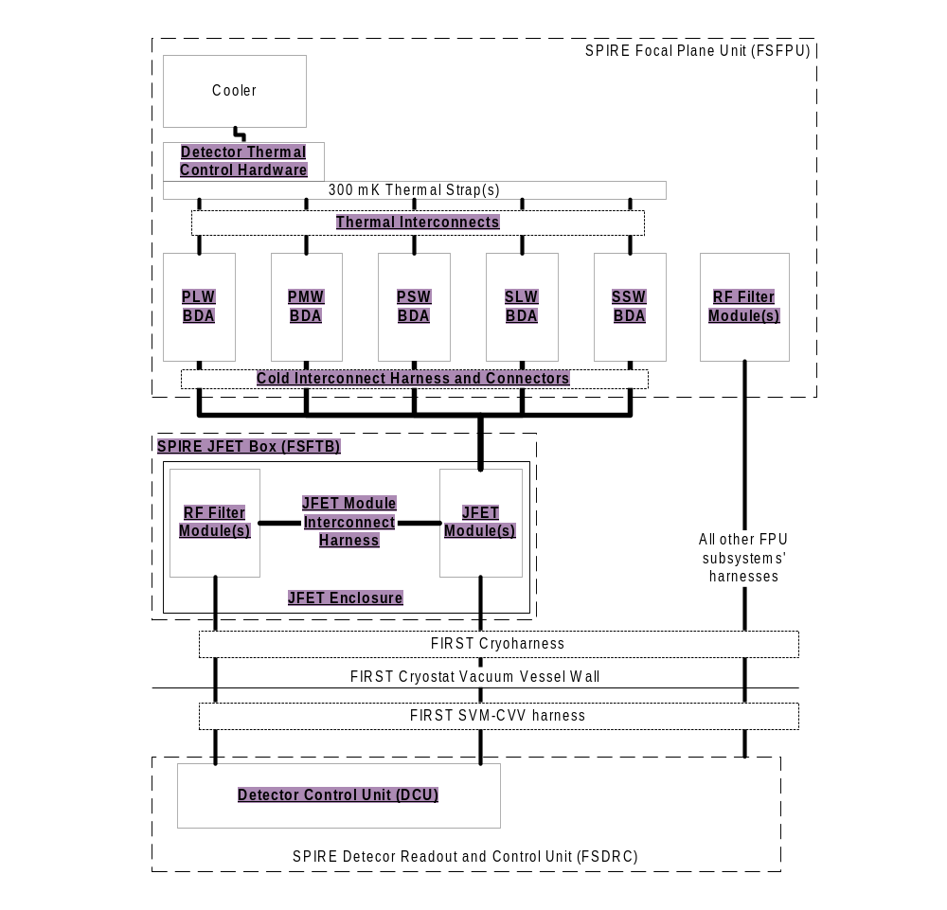
Figure 2-1: Block diagram of the SPIRE detector sub-system. The units that are indicated in underlined bold text belong to the detector subsystem and are the subject of the present specification document.

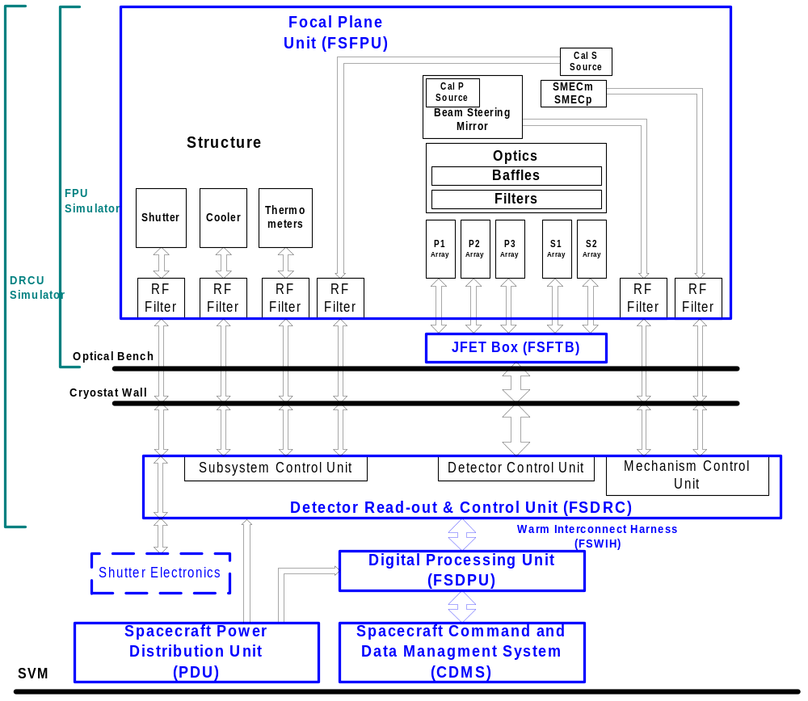
Figure 2-2: SPIRE instrument sub-system block diagram

Design

Bolometer Detector Array
The BDA is designed to accommodate a focal plane array of bolometric detectors operating at a temperature of close to 300 mK. The detectors couple to the cold optics of the SPIRE instrument via an array of collimating feedhorns mounted adjacent to the detector array. The feedhorns collimate sub-millimeter radiation onto the detectors, and define the detector field of view. A band-defining sub-millimeter filter is located over the feedhorn apertures at 300 mK. The focal plane array is mechanically supported and thermally isolated from the 2 K environment by a low-conductivity kevlar suspension system. The kevlar suspension must meet the tight thermal and mechanical requirements of the SPIRE instrument. The focal plane arrays are cooled to close to 300 mK by means of thermal straps to the ³He sorption cooler which attach to the BDA at a defined location. A flange at 2 K provides the mechanical interface for the BDA to mount onto the 2 K structure.

The bolometric detectors are addressed by cryogenic readout cables, routed from the 300 mK focal plane array to the bottom 2 K surface. The 2 K surface serves to enclose the back end of the focal plane array from straylight. Connectors will be located at the 2 K surface to allow for ready integration into the instrument.

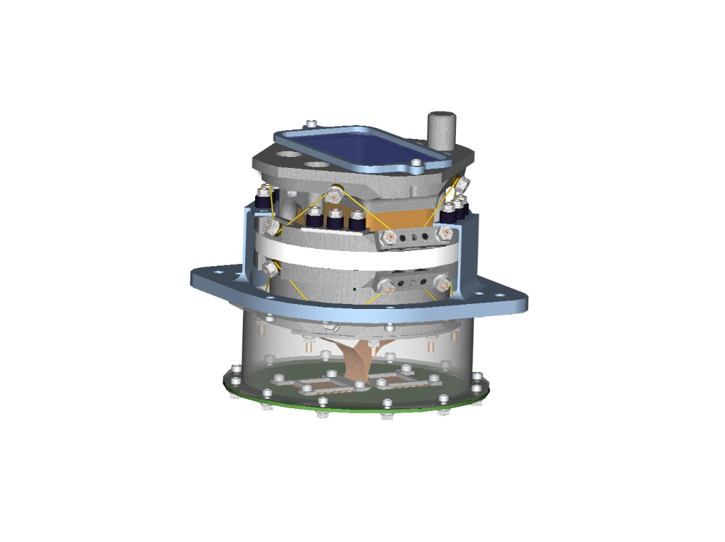
2 K mounting flange
300 mK strap attachment
Kevlar supports
Readout cable attachment
Optical entrance
Figure 2-3: Schematic BDA Mechanical Design

JFET Amplifier Modules
The detector signals are power amplified by cryogenic JFET modules located at the FIRST cryostat level 2 temperature – nominally between 9 and 15 K. These modules house 24 dual JFETs that meet the tight thermal dissipation and noise specifications of the SPIRE instrument. The JFET modules are mounted into a housing at a mechanical interface defined by a mounting flange and connector interface. The JFET module is designed to attenuate thermal radiation from the 120 K JFETs by means of a light wall. Passive RF filter components located on circuit boards inside the module housing provide RF attenuation coming from the output cables. Output connectors interface to the cryogenic wiring harness going to the CVV connectors and then the warm electronics.

RF Filter Modules
In addition to the JFET modules there will also need to be passive RF filter modules present on all power; bias and heater lines entering the JFET Box. These will be housed in modules similar in design to the JFET modules but with only passive components. All subsystem wiring entering the FPU enclosure will also require RF filtering (see figure 2-2). These modules will be identical to those used in the JFET box and will be provided as part of the Detector Subsystem.

JFET Box Mechanical Enclosure
The JFET modules and RF filter modules will be mounted on the FIRST optical bench in a mechanical enclosure close to the SPIRE FPU structure. This enclosure will interface to directly to the FIRST cryostat level 2 temperature stage – at about 10 K – and will also provide a mechanical interface between the SPIRE FPU structure and the JFET modules through which the cold interconnect harness can be supported.

JFET Box Interconnect Harness
Any connections between the RF filter modules and the JFET modules in the JFET box will be made by use of a dedicated internal harness. This harness will be iso-thermal and can therefore be implemented in standard copper wire technology.

Cold Interconnect harness and connectors
The wiring diagram for a BDA is described in Fig. 2-6. Readout wires for each detector are fanned out at the focal plane array and wire bonded to a load resistor module located inside the BDA at 300 mK. The signal lines then connect to lithographed kapton cables which wirebond to an alumina fanout located at the 2 K surface at the bottom of the BDA. Connectors located at the 2 K surface allow for ready mounting and demounting of the BDA. Low-conductivity cables connect the outputs of the BDA to the JFET modules, and run from the 2 K structure to the 4 K structure to the JFET modules. Intervening connectors may be required (TBD) to allow for integration of the cables into the instrument. The outputs of the JFET modules pass through RF filters and connect to the wiring harness. Detector bias, JFET power, and JFET heater power pass through 2 separate, redundant RF filters and connect on a backplane connector into each JFET module. Separating these lines simplifies the wiring harness and reduces electrical cross talk.
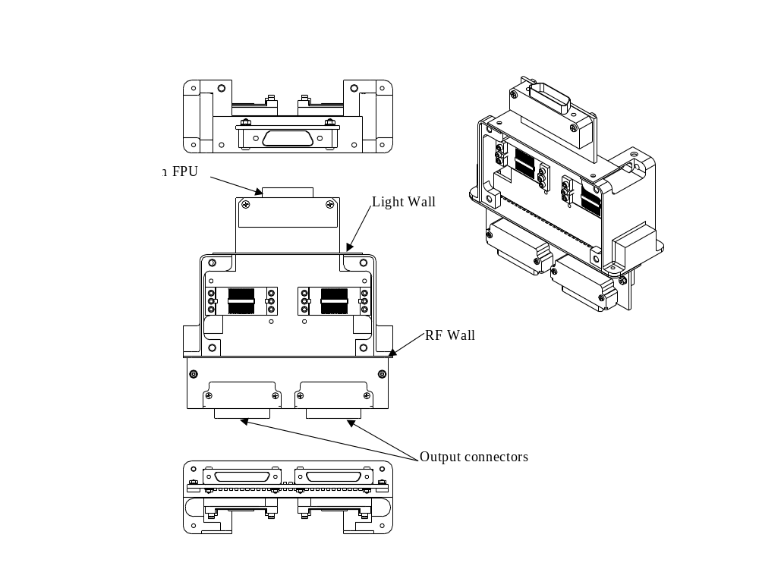

Figure 2-4: Schematic mechanical design of 2 JFET modules.

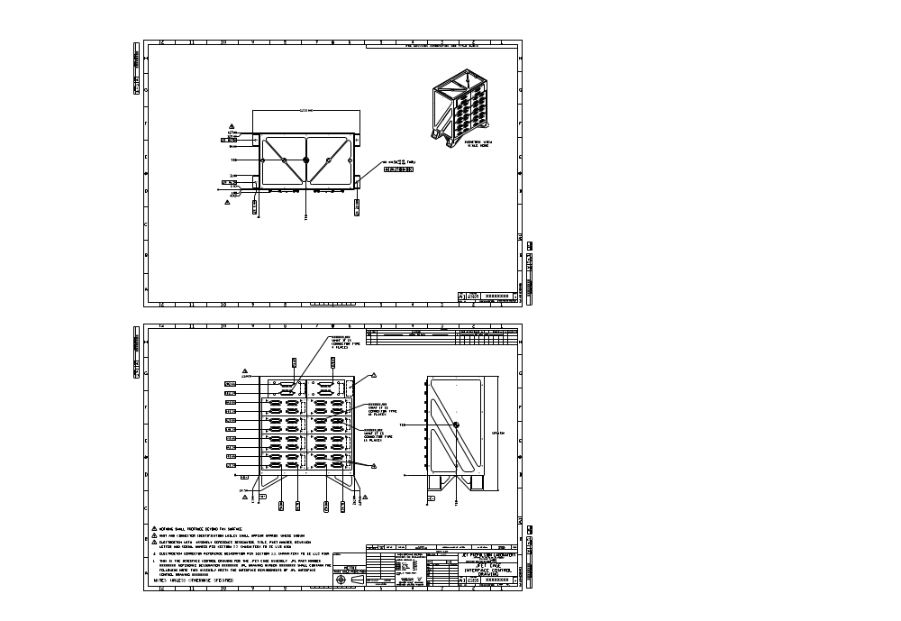
Figure 2-5: Schematic layout of the JFET box mechanical enclosure.

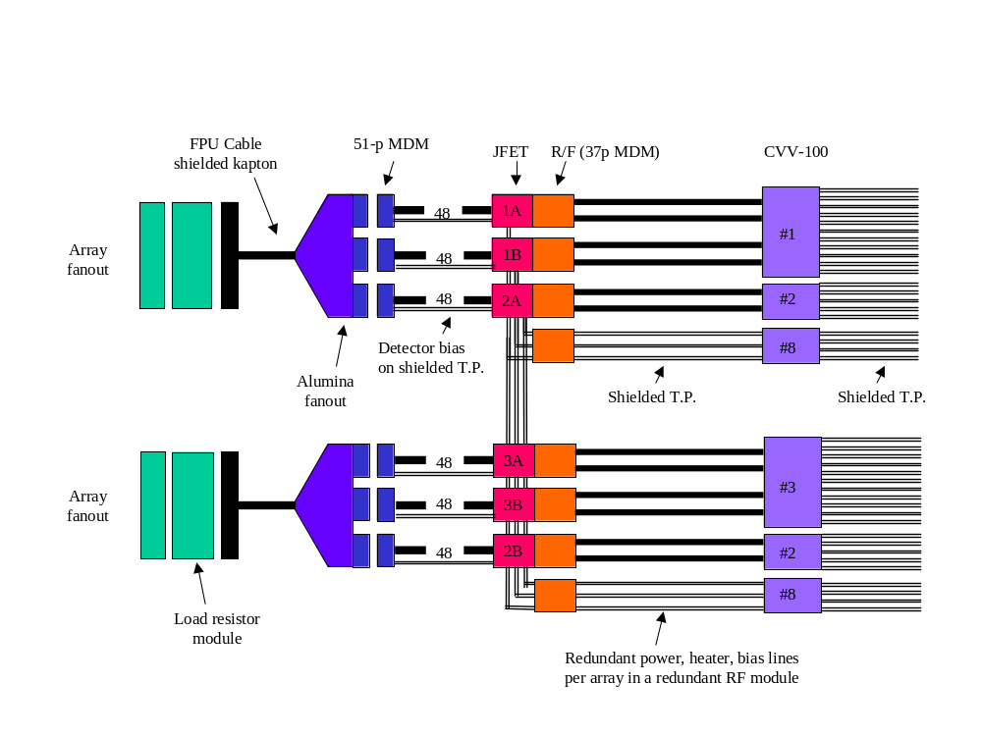
Figure 2-6: Wiring diagram for P/LW array.

Detector readout
The BDA arrays are readout using an AC bias and demodulation supplied by the warm DRCU (see Fig. 2-4). The AC bias modulates the signal at 100 – 300 Hz, above the 1/f knee of the JFET amplifiers and readout electronics. This relaxes the noise requirements on the JFETs, which could not be met at the audio frequencies of the detectors at the power dissipations allowed. Each BDA receives an independent bias. The warm electronics also supply power and heater lines for the JFET modules. Because the bias and JFET power lines represent single-point failures for many detectors, they are designed to be redundant.
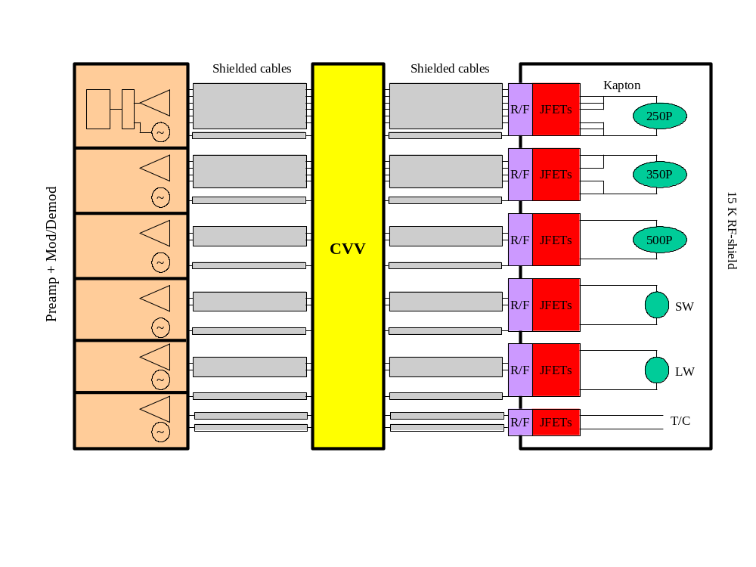
Figure 2-7: Schematic of readout of BDAs.

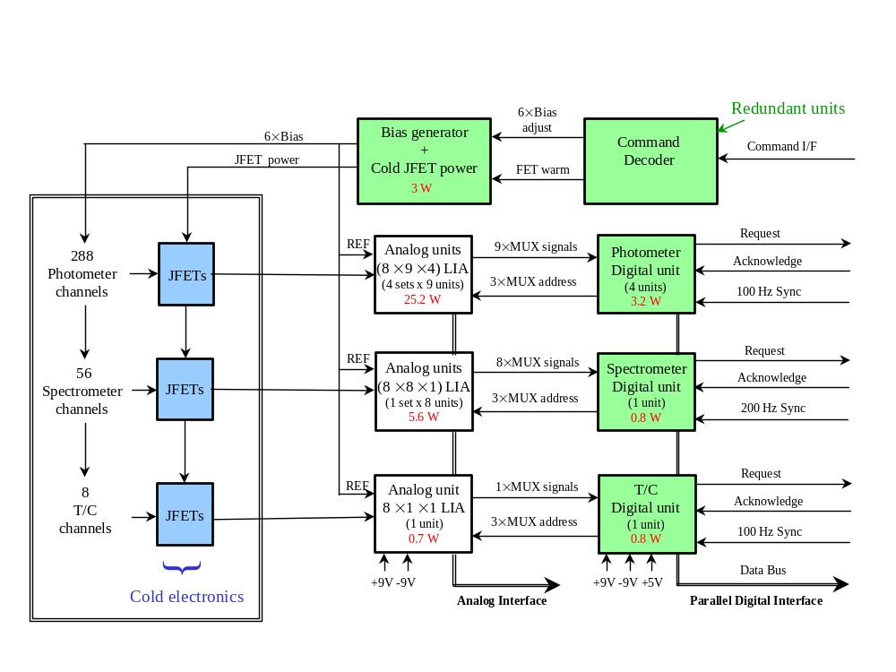

Figure 2-8: Interface between DRCU, BDA, and JFET modules.

Thermal Interconnects
The BDAs are mounted on the 2-K instrument structure up to 50 cm from the cold tip of the ³He cooler. This necessitates the use of thermal straps between the cooler and the BDAs. These are considered part of the SPIRE structure for the purposes of subsystem definition. However, there does need to be a connection made between the thermal straps and the BDAs. The hardware associated with this connection (e.g. a copper wire) is part of the detector sub-system.

Thermal Control Hardware
If the ³He cooler can meet the requirements placed on it in this document, there should be no need to have active control of the detector temperature. However, if, following the development phase of the instrument, there is a requirement for active control of the detector temperature, then the cold hardware for this will be provided as part of the detector sub-system. The cold hardware will consist of NTD germanium thermistors in a bridge arrangement and resistive heaters.

Cold Detector Simulator
The cryoharness to be provided by ESA for the FIRST cryostat, and the one to be provided for the AIV cryostat, will need to be tested to ensure that it is compatible with the requirements of the detector subsystem. To allow this a cold detector simulator will be built that will have the same electrical (noise; impedance etc) characteristics as the detector sub-systems as seen by the cryoharness. This will most likely consist of resistors in one or more JFET module housing(s) that will have the same noise and impedance characteristics when cold and the same interface to the cryoharness. The Structural Thermal Model of the JFET modules may be used for this unit.

Mission Profile
The proto-flight model of the detector sub-system units will be designed to be used for 3 (TBC) years use on the ground, 2 (TBC) years of storage and 4.25 (TBC) years in orbit.

Product Tree
Table 2-1 shows the deliverables required for each instrument model. Notes on what each model should consist of are given below. Where a unit – such as the BDA – has not been broken down into piece parts it is because all parts are the responsibility of a single institute.

ITEM | STM | CQM | PFM | FSM | Responsible Organisation
PLW BDA | See note 1 | X | X | See note 12 | JPL
PMW BDA | See note 1 | X | X | See note 12 | JPL
PSW BDA | See note 1 | X | X | See note 12 | JPL
SLW BDA | See note 1 | X | X | See note 12 | JPL
SSW BDA | See note 1 | X | X | See note 12 | JPL
Thermal Interconnects | See note 1 | X | X | See note 12 | JPL
Optical  Passband Filter | - | X | X | X | QMW
Detector thermal control hardware | - | - | TBD  See note 8 | TBD  See note 8 | JPL
Cold Interconnect Harness; connectors and savers | -  See note 2 | X  See note 9 | X | See note 15 | JPL
RF Filter modules for JFET Box | X | X | X | See note 16 | JPL
RF Filter modules for FPU | X | X | X | See note 16 | JPL
JFET Modules | X | X | X | See note 13 | JPL
JFET Module Interconnect Harness | X | X  See note 9 | X | See note 15 | JPL
JFET Box  Enclosure | X | See note 5 | X | See note 14 | UK
JFET Box connector savers | X | X | X | See note 15 | JPL
Detector Control Unit | - | X | X | X | CEA
Notes:
STM:
- The detailed specification of the STM BDA units is subject to an ongoing system level analysis. The baseline is that they are lumped mass models, without a harness, for verification of the instrument structure only.
- The baseline is that thermal-equivalents to the harnesses without connectors will be provided. Equivalent cables may be provided by JPL to increase the fidelity of the STM, pending the system level analysis.
- The baseline is that STM RF filter modules are mass models with feed-through connectors.
- The STM JFET modules must be mechanically and thermally representative.
- The STM and CQM JFET enclosures will be the one and the same.

CQM:
- The BDA units will be designed to provide near equivalents in performance to the flight units and allow diagnosis of instrument level performance. If the CQM BDAs provide reasonable functional equivalents, within a factor of 2 of the design NEP and time constant at optimal bias, to the flight units, the formal specifications listed in section 3 do not have to be met. It is anticipated the speed of the detectors will increase by a factor of two under non-optimal bias. With current schedule and budget constraints, full P/LW and S/LW arrays will be delivered, and P/MW, P/SW and S/SW arrays will be provided without detectors. Increased functionality of the CQM arrays may be provided pending changes to the budget, schedule, and/or a review of the requirements on the CQM arrays. The baseline model philosophy is that these units undergo qualification testing and performance testing.
- The JFET modules will be designed to provide near equivalents in performance to the flight units and allow diagnosis of instrument level performance. If the CQM JFET modules provide reasonable functional equivalents to the flight units, in the judgement of the SPIRE instrument team, the formal specifications listed in section 3 do not have to be met. Sufficient JFET units will be provided to readout the CQM arrays and provide temperature readout. The baseline model philosophy is that these units undergo qualification testing and performance testing. The system study mentioned above may lead to a reduction in the test requirements on these units.
- No thermal control hardware will be provided for the CQM instrument model. If the integrated instrument does not provide a stable enough thermal environment then thermal hardware will be specified and provided for the proto-flight and flight spare models.
- Internal harnesses shall be specified by an electrical ICD provided by JPL, a mechanical ICD provided by the structures sub-system, and will be fabricated to specification by an industrial partner.

PFM:
- Five full BDAs will be delivered in accordance with the requirements described in section 3. These units will undergo acceptance testing and performance testing.
- All required JFET modules will be delivered in accordance with the requirements described in section 3. These units will undergo acceptance testing and performance testing.

FSM:
- Five BDAs will be delivered in accordance with the requirements described in section 3. These units will undergo acceptance testing and performance testing. Two of these units (P/LW and S/LW) will be the CQM BDA units. The other 3 units (P/MW, P/SW, and S/SW) will be refurbished from the CQM units that were provided without bolometers. JPL requires this hardware from the CQM unit in time for re-qualification.
- All required JFET modules will be delivered in accordance with the requirements described in section 3. The FSM JFET units will be the functional CQM units, and refurbished non-functional CQM units. These units will undergo acceptance and performance testing. JPL requires this hardware from the CQM unit in time for re-qualification.
- It may be possible to refurbish the CQM JFET Box enclosure for use on the flight spare provided they have not been over tested.
- The FSM cryo-harness and connector savers will be the CQM units.
- A full set of RF filter modules will be provided, some or all of these will be the CQM RF filters.

Specification

Functional
The functional requirements on the arrays are divided into three categories, minimum performance, achieved performance to date, and design value.

Minimum performance values are quoted for information, and are based on achieved or design values with margin. Performance levels that have been achieved to date are also indicated for information. The design values approach, and are generally compliant with, the performance levels defined in the Instrument Requirements Document. For this issue of the specification document there is insufficient data on whether the design values will be met in the course of the flight model build programme. A margin will be held on all mass, thermal and power budgets at the level of the instrument as a system. If any of the required performances are not met by the flight model units the consequences will be evaluated against the impact on the performance of the instrument as a whole and extra resources allocated or the instrument specification adjusted to reflect the new situation.

Performance Specification
Specification  ID | Description | Requirement  Reference | Minimum Performance | Achieved  to Date | Design Value
BDA-PER-01 | BDA detector yield. | IRD-DETP-R04  IRD-DETS-R04 | 0.75 | 0.9 | 0.9
BDA-PER-02 | The ratio of photon NEP due to radiation absorbed at the detector and total NEP, given as (NEPphoton/NEPtotal)^2  NEP includes all sources of noise at 1 Hz, measured at 300 mK, assuming a total readout noise of 10 nV/rtHz and an operating impedance of 5 MOhm. | IRD-DETP-R01 | 0.55 (P/LW)  0.61 (P/MW)  0.66 (P/SW)  0.55 (S/LW)  0.66 (S/SW) | -  0.70 (P/MW)  -  -  -  (10 nV/rtHz amplifier noise). | 0.66 (P/LW)  0.73 (P/MW)  0.79 (P/SW)  0.66 (S/LW)  0.79 (S/SW)
BDA-PER-03 | The optical efficiency of the FPU horn and bolometer assembly for the photometer arrays over the optical passband. | IRD-DETP-R01 | 0.45 | 0.45 – 0.65 | 0.85
BDA-PER-04 | The optical efficiency of the short wavelength spectrometer horn arrays and bolometer assembly over the optical passband. | IRD-DETS-R01  IRD-DETS-R08 | 0.45 (TBC) | - | 0.85
BDA-PER-05 | The optical efficiency of the long wavelength spectrometer horn arrays and bolometer assembly over 300-400 μm. | IRD-DETS-R01  IRD-DETS-R08 | - | - | 0.85
BDA-PER-06 | The photometer detector time constant, assuming a maximum modulation frequency of 2 Hz. | IRD-DETP-R02 | 32 ms | 16 ms  (C = 1pJ/K) | 16 ms
BDA-PER-07 | The spectrometer detector time constant, assuming a maximum modulation frequency of 10 Hz. | IRD-DETS-R02 | 28 ms (S/LW)  16 ms (S/SW) | 14 ms  9 ms  (C = 1 pJ/K) | 14 ms  9 ms
BDA-PER-08 | The uniformity of the calibrated responsivity. | IRD-DETP-R03  IRD-DETS-R03 | 0.99 | 0.99 | 0.99
BDA-PER-09 | Detector cross-talk. | IRD-DETP-R05  IRD-DETP-R06  IRD-DETS-R05  IRD-DETS-R06 | - | < 5 % n-n | 1 % nearest neighbors  0.1% non-nearest neighbors
BDA-PER-10 | The 1/f knee frequency (total noise is sqrt(2) larger than white level). |  | 0.1 | 0.03 | 0.03

Specification  ID | Description | Requirement  Reference | Minimum Performance | Achieved  To Date | Design Value
JFET-PER-01 | Median noise of JFET module over 100 – 300 Hz. | IRD-FTB-R01 | 8.5 | 7.0 | 7.0

Functional specification

Specification  ID | Description | Requirement  Reference | Compliant
BDA-FUN-01 | The photometer angular response shall be described by a single-mode feedhorn. | IRD-DETP-R07 | TBD
BDA-FUN-02 | The spectrometer long-wavelength angular response shall be described by a multi-mode feedhorn. The spectrometer short wavelength angular response shall be described by a single-mode feedhorn (TBC). | IRD-DETS-R07 | TBD
BDA-FUN-03 | The spectral long-wavelength cutoff determined by the feedhorn output waveguide aperture will be located at the appropriate edge frequency. | IRD-DETP-R08  IRD-DETS-R08 | TBD
BDA-FUN-04 | The positional repeatability of the focal plane structure shall be < 125 um (TBC) orthogonal to the optical axis, and < 625 um (TBC) along the optical axis. The rotational repeatability around the optical axis shall be < 0.5 degrees (TBC). | JPL | TBD
BDA-FUN-05 | Detector specifications are to be met at nominal optical loading of TBD. | JPL | TBD

Specification  ID | Description |  | Requirement  Reference | Compliant
JFET-FUN-01 | The JFET module will mount to the FIRST optical bench, dissipating power to the level 2 stage of the cryostat. |  | IRD-FTB-R07  IRD-FTB-R05 | Yes
JFET-FUN-02 | The RF filters will operate without power dissipation |  | IRD-RFM-R03 | TBD
JFET-FUN-03 |  | The JFET modules must be capable of functioning, without meeting noise specifications, over a temperature range from 4 K to 300 K | IRD-FTB-R06 | TBD
JFET-FUN-04 |  | The JFET module and RF filters will operate from a base temperature between 4 – 20 K. | IRD-FTB-R08 | TBD

Technical specification

Note: For all budgetary resource values (mass; thermal dissipation; temperature) the instrument will hold a margin against the design value – 20% unless indicated otherwise. Where the minimum performance value is below the margin (BDA-TEC-06, JFET-TEC-05), a system level analysis will be conducted to investigate the effect of increasing the resource allocations to the minimum performance values indicated here. A future release of this document will reflect updated resource allocations and minimum performance levels.

Specification  ID | Description | Requirement  Reference | Compliant
BDA-TEC-01 | The BDA shall accommodate a defined mechanical interface to the 2 K structure. | IRD-DETS-R08  IRD-DETP-R14  IRD-STRP-R01 | Yes
BDA-TEC-02 | The BDA shall provide an attachment point and/or a thermal interconnect to a 300 mK thermal strap. | IRD-STRP-R01 | TBD
BDA-TEC-03 | The BDA mass will have a design value of 600 g (TBC) average over 5 detector arrays, including output connectors. | IRD-SUBS-03 | TBD
BDA-TEC-04 | The first resonant frequency of the BDA will be > 200 Hz (TBC), with a goal of > 250 Hz. | IRD-DETP-R15  IRD-DETS-R16 | TBC
BDA-TEC-05 | The mechanical envelope of the BDA will be described by the ICD. | IRD-DETP-R12  IRD-DETS-R13 | TBD
BDA-TEC-06 | The total power dissipated onto the 300 mK cooler will be < 15 μW (minimum performance); < 8 μW (design value). Assumes the focal plane mount is held at 1.7 K. | IRD-DETP-R13 | Minimum Value not compliant.  Design Value is compliant.
BDA-TEC-07 | The power allocated for temperature control of the 3He stage is 2 μW. |  | TBC

Specification  ID | Description |  | Requirement  Reference | Compliant
JFET-TEC-01 |  | The JFET modules will have a mass less than TBD g. | IRD-SUBS-R03 | TBD
JFET-TEC-02 |  | The mechanical envelope of a JFET module will be TBD mm x TBD mm x TBD mm. | IRD-FTB-R04 | TBD
JFET-TEC-03 |  | The RF filters are to provide –40 dB attenuation from 500 MHz to 3 GHz (TBC, minimum), -60 dB attenuation from 500 MHz to 10 GHz (TBC, goal). | IRD-FTB-R02  IRD-RFM-R01 | TBD
JFET-TEC-04 |  | The first resonant frequency of a JFET module will be > 200 Hz (TBC), with a goal of > 250 Hz. | IRD-FTB-R09 | TBD
JFET-TEC-05 |  | The on-state power dissipation of a JFET module is to be < 11 mW (minimum performance); < 5.5 mW (TBC) (design value). This results in a photometer power dissipation < 66 (33) mW, a spectrometer power dissipation < 22 (11) mW, and an average dissipation < 44 (22) mW assuming 50 % operation of the photometer and 50 % operation of the spectrometer.  NB: A 50% margin will be held on the design values to reflect the uncertainty in achieving the low thermal dissipation. | IRD-FTB-R05 | Minimum Value not compliant  Design Value is compliant

Operational Specification

Operational Safety

Specification  ID | Description | Requirement  Reference | Compliant
BDA-SAF-01 | Failure of the BDA or JFET modules, or one of its components, shall not affect the health of any other subsystem, the instrument or the interface with the satellite. | IRD-SAFE-R07 | TBC
BDA-SAF-02 | Failure of any component of the BDA or JFET modules shall not damage any redundant or backup component designed to replace that component in the BDA or JFET modules. | IRD-SAFE-R08 | TBC

Reliability

Specification  ID | Description | Requirement  Reference | Compliant
BDA-REL-01 | Failure of BDA and JFET modules shall not lead to the total loss of instrument operations. | IRD-REL-R01 | TBC
BDA-REL-02 | Observations can continue in degraded mode in the event of failure of the cold beam steering mirror. | IRD-REL-R02 | Yes
BDA-REL-03 | Point source observations can continue in degraded mode in the event of misalignment of the photometer or spectrometer BDAs. | IRD-REL-R02 | Yes
BDA-REL-04 | Single-point failures in the detector and JFET wiring (detector bias, JFET power) are to be duplicated. The RF filter module on these lines will also be redundant. | IRD-REL-R03 | Yes
BDA-REL-05 | BDA temperature stabilisation shall be implemented by an interruptible software-driven control loop. | IRD-REL-R04  IRD-REL-R05 | Yes

Interface Requirements

3He Cooler

Requirement ID | Description | Reference | Subsystem Compliance
BDA-HCO-01 | Detector performance requires a temperature < 290 mK (goal) delivered at the point of contact to the BDA. Design value sensitivities assume 300 mK at the detector. | IRD-COOL-R01  BDA-PER-02 | TBC
BDA-HCO-02 | Detector performance requires temperature stability at the point of thermal control (near the evaporator) of 10 uK/rtHz (TBC) from 0.1 – 10 Hz. This assumes that the BDA acts as a 100 s thermal low-pass filter. | IRD-COOL-R05 | TBC
BDA-HCO-03 | Maximum allowed thermal drift at the point of thermal control (near the evaporator) is 0.1 mK/hr (TBC). This assumes that the BDA acts as a 100 s thermal low-pass filter. | IRD-COOL-R04 | TBC

Wiring Harness

Requirement ID | Description | Reference
BDA-WIR-01 | Wiring harness shall meet the specifications described in the IIDB. | IIDB | TBC
BDA-WIR-02 | Wiring harness shall have a mechanical resonant frequency greater than 1kHz. | JPL | TBC
BDA-WIR-03 | The EMC from the wiring harness shall be < TBD. | JPL | TBC

    - DRCU

Requirement ID | Description | Reference | Subsystem Compliance
BDA-DRCU-01 | The DRCU signal processing electronics shall have less than 4 nV/rtHz (TBC) post demodulation, referred to the input over the frequency range 0.1 to 10 Hz. This performance must be accomplished with a bias input signal to the DRCU of 10 mVrms AC, 5 mV DC, 1 V DC common-mode offset. | JPL | TBD
BDA-DRCU-02 | The input noise impedance shall be greater than 7 kΩ, post demodulation, referred to the input over the frequency range of 0.1 to 10 Hz. | JPL | TBD
BDA-DRCU-03 | Input capacitance to be less than 100 pF. | JPL | TBD
BDA-DRCU-04 | Input impedance to be larger than 1 MΩ. | JPL | TBD
BDA-DRCU-05 | The DRCU is to provide 5 BDA bias signals, adjustable from 0 to 200 mVrms (TBC), and 1 bias signal for temperature readout, adjustable from 0 to 500 mVrms (TBC). Bias shall be adjustable with 8-bit precision. The frequency shall be adjustable between 30 and 300 Hz (TBC), with a precision of 5 Hz. | JPL | TBD
BDA-DRCU-06 | The DRCU will provide 16 (TBC) commandable (TBC) JFET source voltages with 8 bits precision. The range of Vss is from 0 V to –5 V. | JPL | TBD
BDA-DRCU-07 | Vdd is to be adjustable (TBC) from 1.5 to 4 V. | JPL | TBD
BDA-DRCU-08 | Vdd and Vss lines individually must source 1 mA to 5 mA. | JPL | TBD
BDA-DRCU-09 | The Vdd and Vss levels must be commandable ON/OFF. | JPL | TBD
BDA-DRCU-10 | The DRCU will provide 5 JFET heater lines with adjustable amplitude and duration. The range of these values is TBD. | JPL | TBD
BDA-DRCU-11 | The common-mode rejection is –60 dB. | JPL | TBD
BDA-DRCU-12 | The DRCU shall provide a dynamic range at the ADC sufficient to maintain the noise performance of the detectors under maximal signal conditions. This is estimated to be 16 ADC telemetry bits (TBC). | JPL | TBD
BDA-DRCU-13 | The signal bandwidth of the photometer channels shall be 0.03 Hz to 5 Hz. | JPL | TBD
BDA-DRCU-14 | The signal bandwidth of the spectrometer channels shall be 0.03 Hz to 25 Hz (TBC). | JPL | TBD
BDA-DRCU-15 | The sampling rate of the photometer channels is to be 15 Hz (TBC). | JPL | TBD
BDA-DRCU-16 | The sampling rate of the spectrometer channels is to be 80 Hz (TBC). | JPL | TBD

    - Structures Specifications

Requirement ID | Description | Reference | Subsystem Compliance
BDA-STR-01 | The BDAs shall mount to an interface plate attached to the 2 K structure. The interface plate shall allow compensation of the position and rotation of the BDA by TBD um in x and y, TBD um in z, and TBD degrees. | IRD-STRP-R03  IRD-STRS-R03 | TBC
BDA-STR-02 | The JFET modules will be housed in a JFET enclosure with a defined mechanical interface. | JPL
BDA-STR-03 | The BDA and JFET modules shall be housed in an RF-tight shield. All electrical, optical (TBC), and thermal penetrations into the shield will be RF blocked or attenuated. It shall be possible to electrically isolate the RF shield from the optical bench. The JFET modules form part of this RF shield and the defining point for electrical ground of the RF shield. The RF shield will attenuate radiated power by –40 dB (TBC) from 500 MHz to 10 GHz.. | JPL
BDA-STR-04 | The wire-to-wire capacitance of the cables running from the BDA to the JFET modules will be < 50 pF (TBC). | IRD-FPHR-R01 | TBC
BDA-STR-05 | The cables routed inside the structure shall be affixed to have a mechanical resonant frequency > 1 kHz (TBC). | IRD-FPHR-R02 | TBC
BDA-STR-06 | The radiated EMI onto the detectors shall be < TBD. | JPL

Design and Manufacture Specification

Specification  ID | Description |  | Requirement  Reference | Compliant
 |  | BDA design
BDA-DES-01 |  | The P/SW array is to have 149 (TBC) detectors operating at 250 um in a close-packed array of 2fλ feedhorns. | IRD-PHOT-R02  IRD-DETP-R07 | Yes
BDA-DES-02 |  | The P/MW array is to have 88 detectors operating at 350 um in a close-packed array of 2fλ feedhorns. | IRD-PHOT-R02  IRD-DETP-R07 | Yes
BDA-DES-03 |  | The P/LW array is to have 43 detectors operating at 500 um (TBC) in a close-packed array of 2fλ feedhorns. | IRD-PHOT-R02  IRD-DETP-R07 | Yes
BDA-DES-04 |  | The S/SW array is to have 37 (TBC) detectors operating between 200 and 300 (TBC) um in a close-packed array of 2fλ feedhorns at 250 um (TBC) | IRD-SPEC-R04  IRD-DETS-R07 | Yes
BDA-DES-05 |  | The P/LW array is to have 19 (TBC) detectors operating between 300 (TBC) um and 670 um in a close-packed array of 2fλ feedhorns at 350 um (TBC). | IRD-SPEC-R04  IRD-DETS-R07 | Yes
BDA-DES-06 |  | The photometer and spectrometer arrays shall be designed to accommodate coincident pixels for maximum point source sensitivity. | JPL
BDA-DES-07 |  | The BDA will accommodate cryogenic load resistors for current bias. | JPL
BDA-DES-08 |  | The BDA will provide electrical connector ports for ease of integration into the instrument. | JPL
BDA-DES-09 |  | The BDA will incorporate a differential design to minimize EMI/EMC and microphonic susceptibility. | JPL
BDA-DES-10 |  | The BDA and JFET assemblies shall be tested under a vibration level of 22 mm amplitude (5 – 24 Hz), 50 g amplitude (24 – 100 Hz), 0.1 g amplitude (100 – 400 Hz) at a sweep rate of 2 oct/min. TBC.
 |  | JFET module design
JFET-DES-01 |  | JFET modules shall accommodate up to 24 differential channels. | JPL
JFET-DES-02 |  | All JFET output lines will be RF filtered. | JPL
JFET-DES-03 |  | Each JFET input connector will provide 2 detector bias signals. | JPL
JFET-DES-04 |  | Each JFET module will accommodate cryogenic source resistors in order to minimise microphonics susceptibility. | JPL
JFET-DES-05 |  | The JFET unit shall incorporate a differential design to minimise EMI/EMC and microphonic susceptibility. | JPL
JFET-DES-06 |  | Two RF modules will be incorporated into the JFET enclosure to filter detector bias, JFET power, and JFET heater lines. | JPL

Logistic Requirements

The bolometer arrays will be delivered in nitrogen purged boxes for storage. As the detector arrays are nearly sealed from dust and contamination by the focal plane assembly, we place no cleanliness requirement during handling and installation. We assume there will be no need to disassemble the BDA once delivered to QMW. If that need arises, members from JPL must be present. The JFET units must also not be opened, and shall be handled using standard ESD practices.

Environment Requirements
TBW.

Natural environment
TBW.

Operating Environment
TBW.

Verification Requirements
Before delivery to the SPIRE BDA; JFET modules and RF filter modules will undergo environmental and performance qualification and acceptance. Several of these tests (e.g. EMI/EMC, thermal stability and microphonics) can only provide useful information at a higher system level, and will not require component-level testing. The following table lists the environmental tests for model delivered:

Test: | CQM | PFM | FS
Vibration: | Q(TBC) | A | A
Thermal cycle: | D/Q | A | A
Vacuum cycle | D/Q | A | A
Lifetime: | D | - | -
Soak/cycle: | D (TBC) | - | -
Radiation tolerance: | D | - | -
Thermal range: | D | - | -
Thermal stability (Instrument Level): | Q (TBC) | A | A
Microphonics  (Instrument Level): | Q | A | A
Ionising radiation: | D | - | -
EMI (Instrument Level): | Q | A | A
EMC (Satellite Level): | Q | A | A
Table 3-1 : Test matrix for the BDA and JFET modules. Q indicates a test carried out at qualification level for qualification times; A indicates a test carried out at acceptance level; D indicates a qualification test carried out by design, including unit-level testing and engineering analysis. An X indicates that this test is carried out and is a characterisation type test or the level is irrelevant. A dash indicates that no test will be done on this model/unit.

Verification ID | Description | Reference
BDA-VER-01 | To carry out the tests on the BDA QM listed in Table 3-1. | IRD-VER-R01  IRD-VER-R03
BDA-VER-02 | To carry out the tests on the BDA PFM listed in Table 3-1. | IRD-VER-R01  IRD-VER-R04
BDA-VER-03 | To carry out the tests on the BDA FS listed in Table 3-1. | IRD-VER-R01  IRD-VER-R04

APPENDIX 1: QUALIFICATION TESTS DESCRIPTION

Vibration: The QM BDA will be vibrated at levels appropriate to its location within the instrument, as defined in AD2.

Thermal-Vacuum
cycle: The BDA and JFET modules will undergo thermal vacuum tests. According to standard JPL procedures, 3 times the number of lifetime thermal cycles will be imposed for qualification testing on representative units. For acceptance testing, the number of thermal cycles after delivery from JPL will be incurred.

Lifetime: Lifetime tests to be carried out on all non-flight standard electrical components; novel materials and novel manufacturing processes. Details of tests to be determined on a case by case basis.

Soak/cycle: Electrical soak test to be carried out on JFET modules at operating temperature followed by cycle to ambient temperature followed by soak test. Number of cycles and details of applied voltages etc to be defined.

Radiation tolerance: Radiation tests will be to 20 krad TID. Components may be qualifed by analysis or independent testing.

Thermal range: Need to test to bakeout temperatures to ensure survival of the detector subsystem units when the FIRST satellite is baked out.

Thermal stability: A test designed to ensure the verification of detector operation if the interface temperature varies during operation. This may only be applicable at instrument level.

Microphonics: Test to be performed at the systems level.

Ionising radiation: The effects on the detector performance of individual ionising radiation impacts must be evaluated by modelling or tested for. This is NOT the same test as radiation tolerance, which only implies a total integrated dose. It is desirable that a high energy (>100 MeV) proton beam line is employed to carry out this test with a representative the detector cold and active.

EMI: Test to be performed at the systems level.

EMC: Test to be performed at the systems level.

Materials conformance: All materials used in the manufacture will be approved for space use by ESA.

