 | Projet  FIRST | REF: LOOM.KD.SPIRE.2000.001-3  Author : Alain Origne, Kjetil Dohlen | PAGE : 1 / 12  Date : 10 April 2001
SPIRE Optical alignment verification plan

SPIRE-LAM-PRJ-000445

RAL | K.King
 | B.Swinyard | X
CNES | M.Joubert |  | Y.Blanc
CEA-Sap | Jean-Louis Auguères
LAS | J.P.Baluteau | X | D. Ferrand
 | K.Dohlen | X | R. Malina
 | A.Origné | X | P.Dargent | X
 | D.Pouliquen | X

______________________________________________________________________________
LABORATOIRE D'ASTRONOMIE SPATIALE - CNRS BP 8 13376 MARSEILLE Cedex 12 FRANCE
Tél : (33) +4 91 05 59 00 - Fax : (33) +4 91 05 69 59
Updates

Date | Indice | Remarks
3 Jan 2000 | 1 | Creation of the document
16 May 2000 | 2 | Update, including spectrometer
10 April 2001 | 3 | Updated design references, component names. Sequence removed to RD2, tools description moved to RD3

Reference documents

# | Title | Author(s) | Reference | Date
1 | ICD Structure-Mechanical I/F | Berend Winter | SPIRE-MSS-PRJ-000… | April 2001
2 | SPIRE alignment sequence | K. Dohlen,  A. Origne | LAM. PJT. SPI. … | 11 April 2001
3 | SPIRE alignment tools specification | K. Dohlen,  A. Origne | LAM. PJT. SPI. … | 26 Oct 2001

Host system | Windows NT
Word processor | Microsoft Word 97
File | 0000.doc

Scope
The document gives a general description of the SPIRE alignment verification procedures. Detailed description of the sequence is provided in RD2. Description of the alignment tools is given in RD3.

Introduction

General principles
The alignment of the photometer will be performed according to a philosophy largely based on the experience with aligning the GERB and ISO-LWS instruments. The discussion during the meeting at LAS of 27 August 1999 has allowed us to draw up the principles of this philosophy as applied to FIRST-SPIRE.
Alignment sensitivity and error budget studies show that absolute alignment precisions of 1 arcminute and 0.1 mm of each mirror is required. This makes possible an alignment philosophy based on the direct assembly of the mirrors onto the structure. It is clear, however, that an extensive verification program is required to make sure that the alignment requirements are met, and that "emergency exits" exist if defaults are discovered.
To answer this need, the alignment verification plan provides a series of actions based on visible light metrology. First, the definition of the instrument gut ray with respect to external references. The instrument is mounted on a panel representing the FIRST optical bench (FOB). The telescope optical axis is materialized by an optical reference cube (FOR) mounted on the FOB. The SPIRE optical bench (SOB) is equipped with an optical reference cube (SOR) allowing optical alignment of the instrument on the FOB after integration of filters etc, opaque to visible radiation.
The SPIRE gut rays are defined as the lines joining the centre of the telescope secondary and the centre of the instrument FOV for each of the photometer and spectrometer channels. They are materialized with respect to the FOR and the SOR by the aid of an alignment telescope.
During assembly, it is verified that each mirror reflects the relevant gut ray in the correct direction. This is achieved by mounting the mirrors one by one in the order of light propagation, and by mounting a special tool in place of the following mirror.
Special tools are placed in the positions of cold stop apertures and detector planes, assuring that these are also aligned on the gut ray.
After integration of all mirrors, pupil and image quality are verified, assuring that the required imaging capabilities of the instrument are met.
Finally, an internal alignment stability and reproducibility test allows to verify that the instrument's object and image planes are aligned with each other during environmental tests.
The order of these tests may be redefined in view of the overall AIV plan, and may not necessarily be the same for CQM and PFM models.
In the case of an observed misalignment exceeding the total budget, PM6 and SM6 may be adjusted by remachining of the interface structure/mount.
This philosophy assumes that the optical surfaces are good enough in the visible to allow the use of classical apparatus like alignment telescope and theodolites. The optical quality obtained by diamond machining of aluminum allowed to conduct with success a similar alignment scheme for the LWS instrument.

Baseline designs
Current baselines are BOLPHT154c for the photometer channel and bolsp501g for the spectrometer channel. Ray traces of the systems are shown in Figure 1 a, b. (The symmetrical lower half of the spectrometer channel is generated by reflection about the plane containing the two beam splitters.) The current naming scheme is shown in figs. 1 c and d, as detailed in RD1.

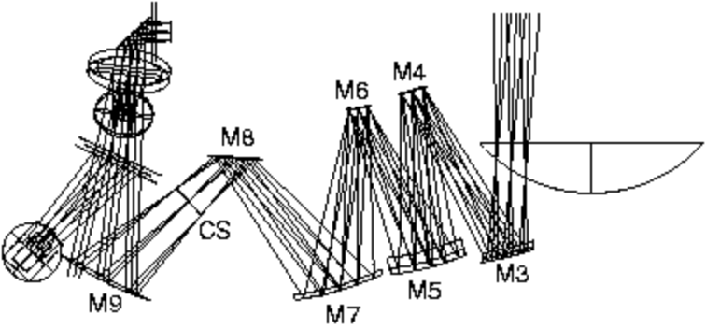
(a)
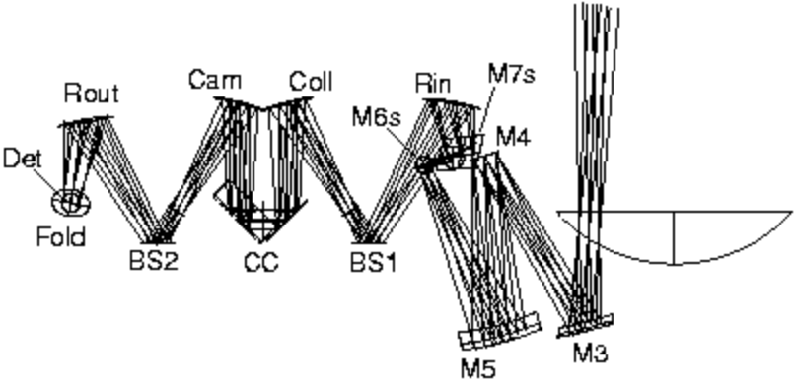
(b)
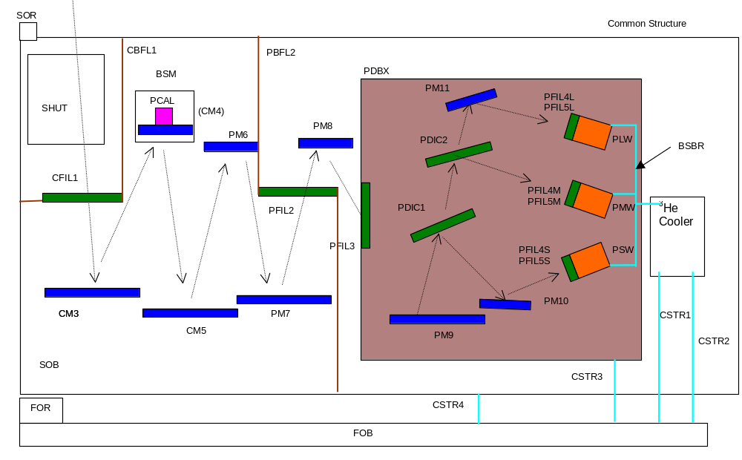
(c)
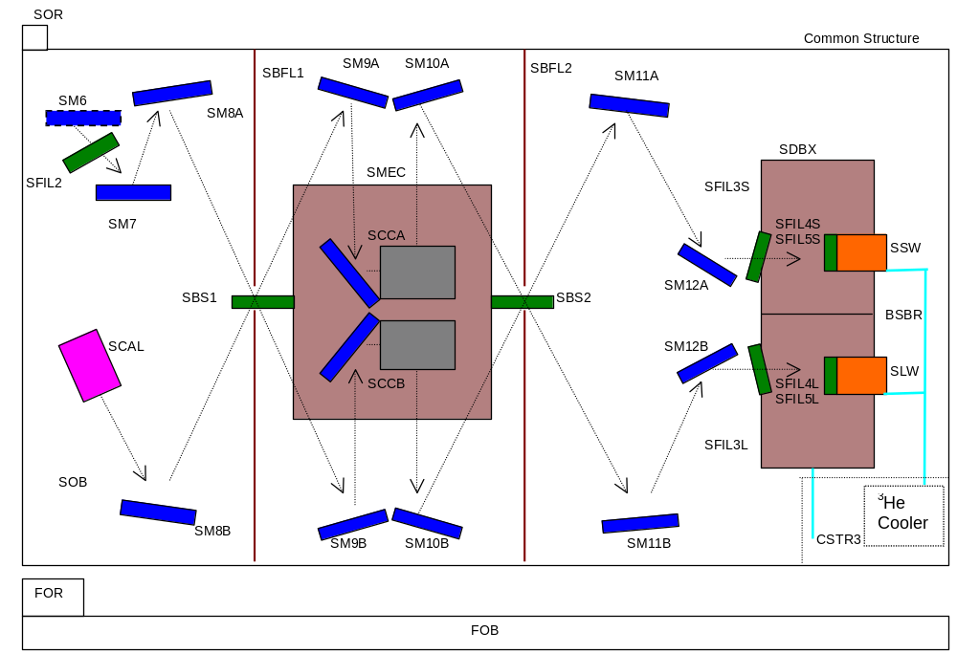
(d)

Synopsis of the alignment sequence:

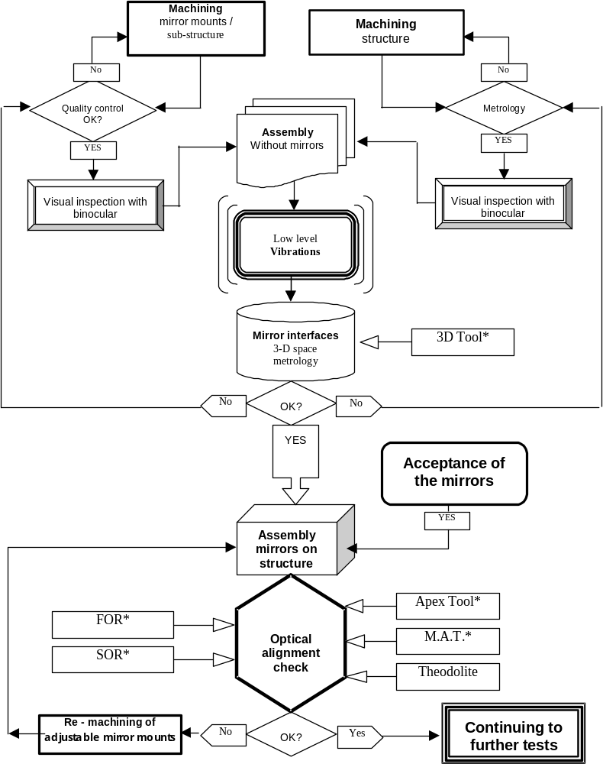
* 3D Tool = Specific tool for interfaces measurement
* Apex Tool = Tool which gives the direction and the lateral position of each mirror
* FOR, SOR = FIRST optical reference and SPIRE optical reference
* M.A.T. = Micro Alignment Telescope
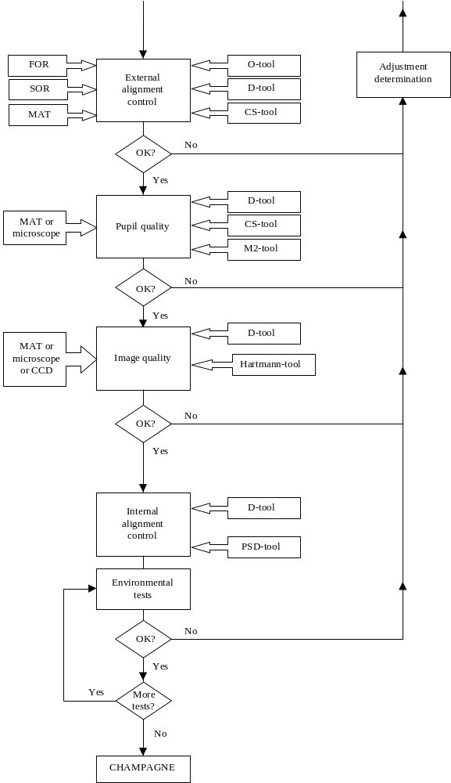

Description of tasks

Visual inspection
The first activity before starting the assembly is to do a visual inspection of all interfaces, between sub-structure, mounts, and mirrors. Great care must be taken during the inspection, especially of the mirror mounts, to avoid burrs, streaks or cuttings of metal. The use of a binocular is strongly advised.

3D-metrology
A 3-D space metrology will be performed on the mirror mount interfaces on the structure before the assembly of the mirrors to verify the coordinates and the orientation of the interface planes with respect to the optical design. The eventual differences will first be analyzed to know the basic cause and then corrected if the measured values are out of margins.
A specific "3D tool" will be used at the place of the mirror to ease the 3-D measurement and to avoid damage of the mirror surface. It allows to know the mechanical reference of the mirror interface which is the intersection of the bore and the supporting surface, and the orientation in 3D-space of the normal to this surface.
The 3D-space metrology will be performed at the end of the machining of the sub-structures and the mirror mounts. A check report will follow each part, with the “as-designd” and the “as-built” dimensions.

Alignment verification during integration
After the 3D-space verification of all the interfaces the optical alignment will be performed step by step during integration with the “Apex Tool” in place of each following mirror. This will allow to verify that the mirrors are properly mounted . Any poor contact between interface surfaces will be detected at this point.
In some cases the apex tool image will be projected behind the MAT, offering a virtual object. As the MAT is constructed only for real objects, a supplementary lens must then be mounted onto the MAT. The additive lens must be made with high tolerances to conserve the alignment of the MAT axis. This does not appear to be a major problem, the alignment is easily checked by rotation of the lens around its mechanical axis (cylindrical body of the MAT) : the image must not be deviated during the rotation.
The following figures show the concept of this procedure as implemented for an earlier design of the photometer.

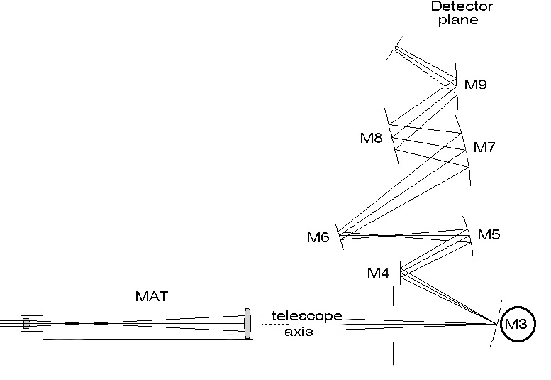 | 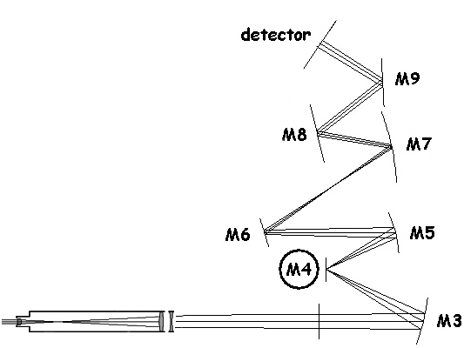
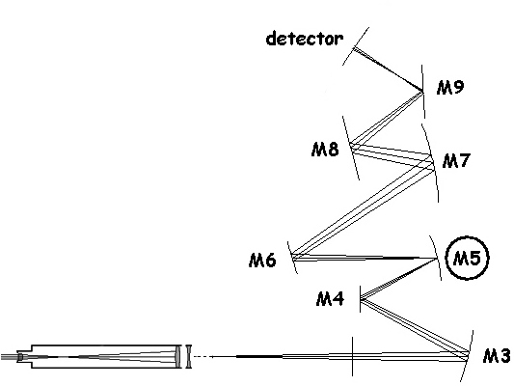 | 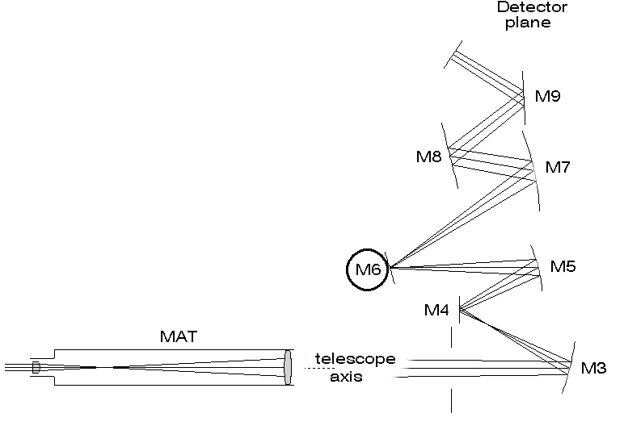
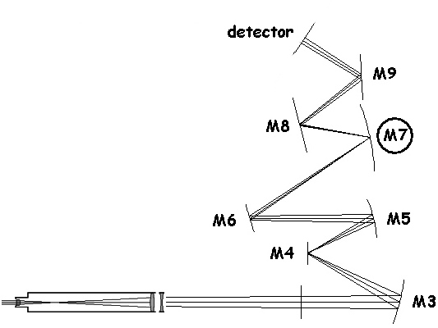 | 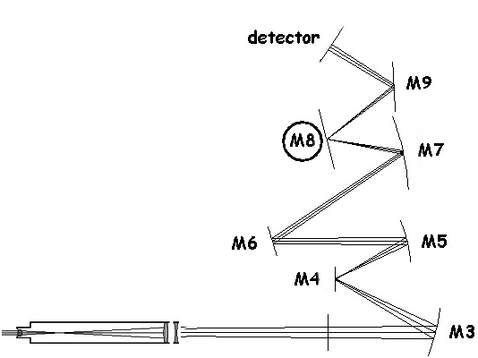
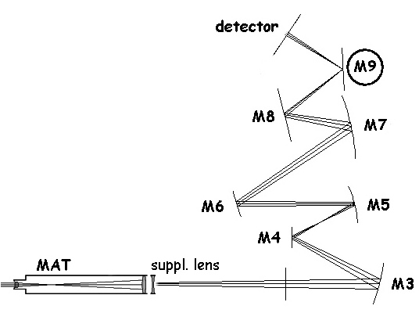 | 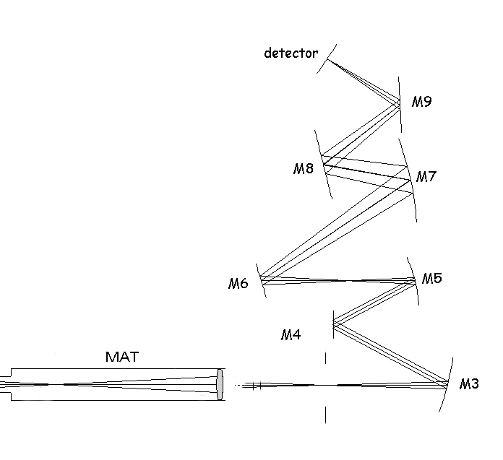

Interferometer optics
Alignment of the optics within the Mach-Zehnder interferometer arrangement follows particular sequence ensuring alignment of the two interferometer arms, as detailed in RD2. During this process the beamsplitters are replaced by pellicle beamsplitters which, with its virtually zero optical thickness, give a valid representation of the FIR beamsplitters.

Pupil quality verification
Verification of pupil aberrations, ie the relative pupil position for different points in the FOV, and absence of vignetting. The test could theoretically be done by imaging entire pupil on a CCD, but the etendue of the optical beam is too large for this to be practical. Best method is to observe the image if the CS as projected onto the plane of M2, ie 2.5m outside the instrument. In the location of M2 is placed the M2-tool as shown in the figure.
Procedure:
- With central source of D-tool lit, observe image of central reticule of CS-tool on M2-tool. Adjust M2-tool to make CS reticule coincide with M2 reticule.
- Move to edge of M2-tool, measure deviation of CS edge with M2-tool edge reticule, again sequentially for each source
- Repeat for the selected positions along M2 edge.
Compare with theoretically expected results. Large deviations indicate TBD action

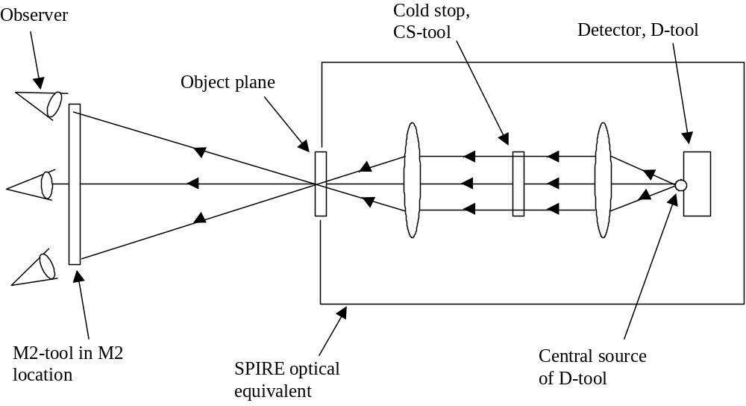

Image quality verification
We consider two options for verification of image quality: star test or Hartmann test. The star test, ie direct recording of point source images, is preferable due to its simplicity, but it may suffer from scattering of visible light in the system. The Hartmann test is more elaborate but should be insensitive to reasonable amounts of scattering. It will also provide wavefront analysis in terms of Zernike polynomials. Image quality should ideally be studied at several points in the FOV (centre and edges), but study of the centre point may be sufficient.
We propose to use the star test for image quality verification and apply the Hartmann test only if the star test reveals a serious image quality deficiency.
Star test: Verification of image quality at different points in the FOV could theoretically be done by imaging entire FOV on a CCD, but the etendue of SPIRE renders this impractical. Consider instead field points one by one, observed using travelling microscope or MAT (NB requires Fnumber < 8.68 or numerical apture > 0.06). Recording the observed images using a CCD camera is an advantage for analysis and documentation. Recording directly on naked CCD may also be appropriate.
Preparation:
- All optical components (except filters and dichroics) and the 2K box mounted on the SOB
- Alignment tools D and O in place. CS-tool better left out.
Procedure:
- Focalize on O-tool
- Localize D-tool source under study
- Observe (photograph) image of D-tool source
Analysis: Comparison with spot diagrams. Large deviations indicate TBD action
Hartmann test: A plate with a rectangular grid of holes (Hartmann-tool) is mounted in the cold stop. When lit by one of the sources in the D-tool (typically the central source), the projection of the holes through the system materializes geometrical ray paths. Detection of the grid in two planes above and below the SPIRE object plane, allows reconstruction of the geometrical spot diagram. Comparison with theoretical spot diagram provides a measure of the instrument image quality.
Preparation:
- All optical components (except filters and dichroics) and the 2K box mounted on the SOB
- Alignment tools D and Hartmann in place.
- CCD camera, naked or with macro lens, monted on xyz stage near SPIRE object plane.
Procedure:
- With central D-tool source lit, localize its image on the CCD
- Move CCD 20mm (TBC) towards M3, record image
- Move CCD 20+20mm (TBC) towards M2, record image
- Numerical treatment (localize Hartmann spots in both images, calculate ray slopes) allows creating spot diagram for SPIRE as built
Analysis: Comparison with theoretical spot diagrams. Large deviations indicate TBD action

Image position stability and reproducibility
This test verifies alignment of image and object planes. Required for verification of internal alignment during environmental testing.

A tool carrying a position sensitive detector (PSD) is mounted in the object plane of the instrument. Light emanating from the D-tool located in the detector position is focalised onto the PSD, see figure. Any relative movement between the two planes is detected.



