Contents:

This SPIRE structure subsystem description gives an outline of the design of the instrument together with the specification of its capabilities. Furthermore, the compliance of this design with the various requirements as stated in the instrument requirements documents and the instrument interface document part A and B are compared. All interfacing subsystems are listed together with the applicable ICD’s. This is for downward compatibility and traceability.

Distribution List :

RAL | B. M. Swinyard |  | K. King
RAL | J. Long (Proj. Office) | ATC | C. Cunningham
QMW | M. Griffin |  | P. A. R. Ade
CEA-Sap | Jean-Louis Auguères
LAM | D. Pouliquen |  | P. Dargent
 | K. Dohlen
JPL | G. Lillienthal |  | J. Bock
MSSL | J. Coker |  | A. Smith
MSSL | B. Winter

Revision Record:

 | Date | Brief description of change
0.1 | 4 June 2000 | Creation of the document
1.0 | 13 June 2000 | Official issue
1.1 | 1 October 2000 | Draft revision, based upon Review of SPIRE Sub-system Specification Documents by B. Swinyard, 10 August 2000
1.2 | 05-November-2000 | Continued revising the document conform following generic sub system specification

Table of contents

1. Scope of the document 5
2. Documents 5
2.1. Reference documents 5
2.2. Applicable documents 5
2.3. Applicable drawings 5
2.4. Glossary 6
3. Subsystem description 7
3.1. General Overview 7
3.2. Sub-system Design 10
3.2.1. SPIRE structure - RF sealing 10
3.2.2. Straylight 11
3.2.3. Thermal design 11
3.2.4. Grounding 12
3.2.5. SPIRE optical design 13
3.2.6. SPIRE structure 14
3.2.7. Structure suspension 15
3.2.8. SPIRE optical bench 15
3.2.9. Straylight baffles 15
3.2.10. Detector boxes 15
3.2.11. Mirror supports 15
3.2.12. Beam splitter supports 15
3.2.13. Mounting provisions for detectors 15
3.2.14. Mounting provisions for dichroics and filters 15
3.2.15. Mounting provision for the SMEC 16
3.2.16. Mounting provision for the ³He cooler 16
3.2.17. Mounting provision for BSM 16
3.2.18. Mounting provision for spectrometer calibration source 16
3.2.19. Mounting provision for shutter 16
3.2.20. Mounting provisions for thermal straps 16
3.2.21. Mounting provisions for filters 16
3.2.22. RF-seal (attenuation) for Common Structure 16
3.2.23. I/F to JFET box 16
3.2.24. Application of thermal finishes 16
3.2.25. Application of black material 17
3.2.26. Mounting provision for RF-filter box 17
3.3. Mission profile 17
3.4. Product tree 17
4. Specification 18
4.1. Functional 18
4.1.1. Performance specification 18
4.1.2. Technical requirements 22
4.2. Operational 23
4.2.1. Operational Safety 23
4.2.2. Lifetime 23
4.2.3. Operating modes 23
4.2.4. Telemetry 23
4.2.5. Telecommands 23
4.3. Interface requirements 23
4.4. Design and manufacture requirements 25
4.4.1. Design requirements 25
4.4.2. Design rules 25
4.4.3. Manufacture requirements 25
4.5. Logistic requirements 25
4.6. Environment requirements 26
4.6.1. Natural environment 26
4.6.2. Operating environment 26
4.7. Verification requirements 26
Appendix A 28

Scope of the document
This specification defines the requirements applied to the performances, the design and the qualification of the SPIRE structure. It is applicable to the STM, CQM, PFM and the FS.

Documents

Reference documents
ID | Title | Author | Reference | Date
RD1 | Instrument Requirements Document | B. M. Swinyard | SPIRE-RAL-PRJ-000034, issue 0.30 | May 2000
RD2 | Instrument Interface Document part A | H. Schaap/ A. Heske | PT-IID-A-04624, issue 0-2 | 15/02/2000
RD3 | Instrument Interface Document part B | C. Cunningham  B. Swinyard | PT-SPIRE-02124, issue 0-4 | 15/02/2000
RD4 | SPIRE Product Tree | K. King | SPIRE-RAL-PRJ-00030, issue 1 | September 1999
RD5 | FIRST SPIRE Optical Alignment Plan | Origne,  K. Dohlen | LOOM.KD.SPIRE.2000.001-1 | 3/1/2000
RD6 | SPIRE Sub-system Budget allocations | - | - | -
RD7 | Conceptual design for the 300 mK thermal strap | B. Swinyard | Technote, issue .00 | 24/05/2000
RD8 | A stray-light baffle design for thermal strap entry ports | A. Richards | SPIRE-RAL-NOT-000344, issue 1 | 2 March 2000
RD9 | SPIRE Instrument CQM requirements | B. Swinyard | SPIRE-RAL-NOT-000389, issue 0.1 | 18/04/2000
RD10 | ESA fax | B. Guillaume | SCI-PT/IFI/07222 | 05/11/99
RD11 | SPIRE Subsystem Block Diagram | B. Swinyard  K. King | SPIRE-RAL-NOT-000391 | 26/04/2000

Applicable documents
ID | Title | Author | Reference | Date
AD1 | Structure Design and Development Plan | B. Winter | SPIRE-MSS-PRJ-000426, issue 0.1 | 02-06-2000
AD2 | SPIRE structure/Optics ICD | D. Pouliquen  B. Winter | SPIRE-MSS-PRJ-000293, issue 0.3 | 06-06-200
AD3 | ICD 1.1/1.5.2 structure/FTS mechanism | D. Pouliquen  B. Winter | SPIRE-MSS-PRJ-000298, issue 0.2 | -
AD4 | ICD 1.1/1.2.1 structure/Filters | P. Hargrave  B. Winter | SPIRE-MSS-PRJ-000331, issue 0.- | -
AD5 | ICD 1.1/1.3 structure/cooler | L. Dubant  B. Winter
AD6

Applicable drawings
ID | Title | Author | Reference | Date
DR1 | Provisional SPIRE/FIRST Interface | J. Coker | A1-5264-300, issue 6, Snapshot in appendix A | 30/05/00
DR2

Glossary

AD | Applicable Document | Level 0 | Cryostat level 0 temperature is ~ 2 K (RD1)
ATC | Astronomy Technology Centre | Level 1 | Cryostat level 1 temperature is ~ 4 K (RD1)
BSM | Beam Steering Mechanism | Level 2 | Cryostat level 2 temperature is ~9-11 K (RD1)
CDR | Critical Design Review | MGSE | Mechanical Ground Support Equipment
CEA | Commissariat à l’ Energie Atomique | MSSL | Mullard Space Science Laboratory
CNES | Centre National des Etudes Spatiales | NA | Not Applicable
CoG | Centre of Gravity | OGSE | Optical Ground Support Equipment
CQM | Cryogenic Qualification Model | PFM | ProtoFlight Model
FIRST | Far Infra Red Space Telescope | QMW | Queen Mary and Westfield college
FOB | FIRST optical bench | RAL | Rutherford Appleton Laboratories
 |  | SCAL | Spectrometer Calibration source
FS | Flight Spare | SMEC | Spectrometer MEChanism
FTS | Fourier Transform Spectrometer | SOB | SPIRE Optical Bench
FOR | FIRST optical reference | SOR | SPIRE optical reference
GSFC | Goddard Space Flight Center
I/F | Interface | SPIRE | Spectro and Photometric Image REceiver
JFET | Junction Field Effect Transistor | TBC | To Be Confirmed
JPL | Jet Propulsion Laboratory | TBD | To Be Defined
LAM | Laboratoire d’Astronomie Marseille | TBI | To Be Issued

Subsystem description

Hereafter the contents of the various subsections is explained.

3.1. General Overview: Explaining how the structure looks like and how it works. This includes how it fits in the overall system design, using block diagrams
3.2. Sub-system Design: Gives a more detailed description of the design of each of the components within the sub-system.
3.3. Mission profile: Gives the expected lifetime of the structure including numbers of operations (tests) it will go through for each of the models. This includes transportation.
3.4. Product Tree: This tree lists all the components that are delivered and by whom for each instrument model.

General Overview
The SPIRE structure consists of a monocoque shell with a central optical bench. The structure is mounted on a fixed point (cone-shaped), suppressing translation in all directions. This fixed point is located on the corner of the optical bench. On the other side of the instrument (+Z direction) two A-frames are mounted suppressing each translation in the plane of the frame itself. All in all this results in a kinematic suspension with as a fixed reference with regard to the FIRST optical bench, the cone.
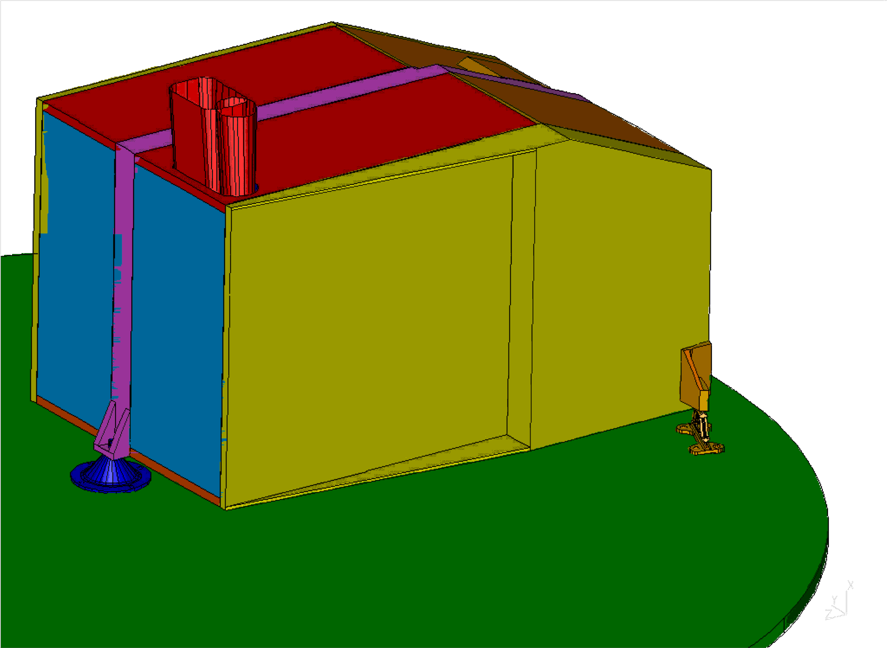
Figure 3.1-1: View of the outside of the instrument – Common Structure + Mounting

As said before the SPIRE instrument consists of a monocoque shell holding a bending stiff, internal, SPIRE optical bench. This optical bench supports a photometer and a spectrometer. All parts of these two sub-instruments are mounted on the SPIRE optical bench. See figure 3.1-2 for the photometer side of the optical bench, including IR-beams.

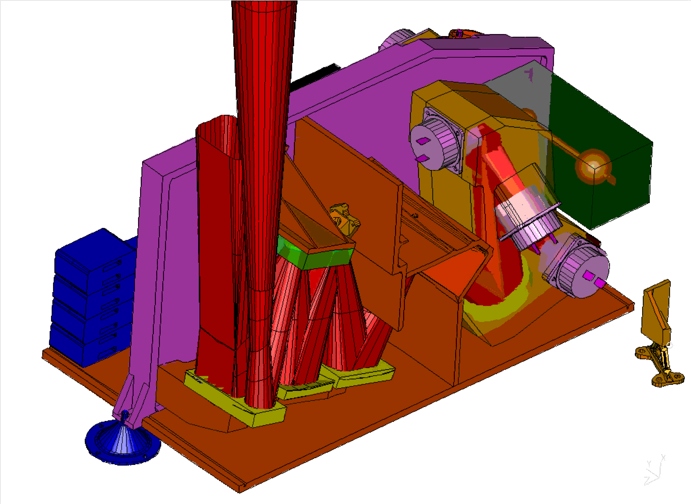
Figure 3.1-2: View of the inside of the instrument – photometer side, cover taken off

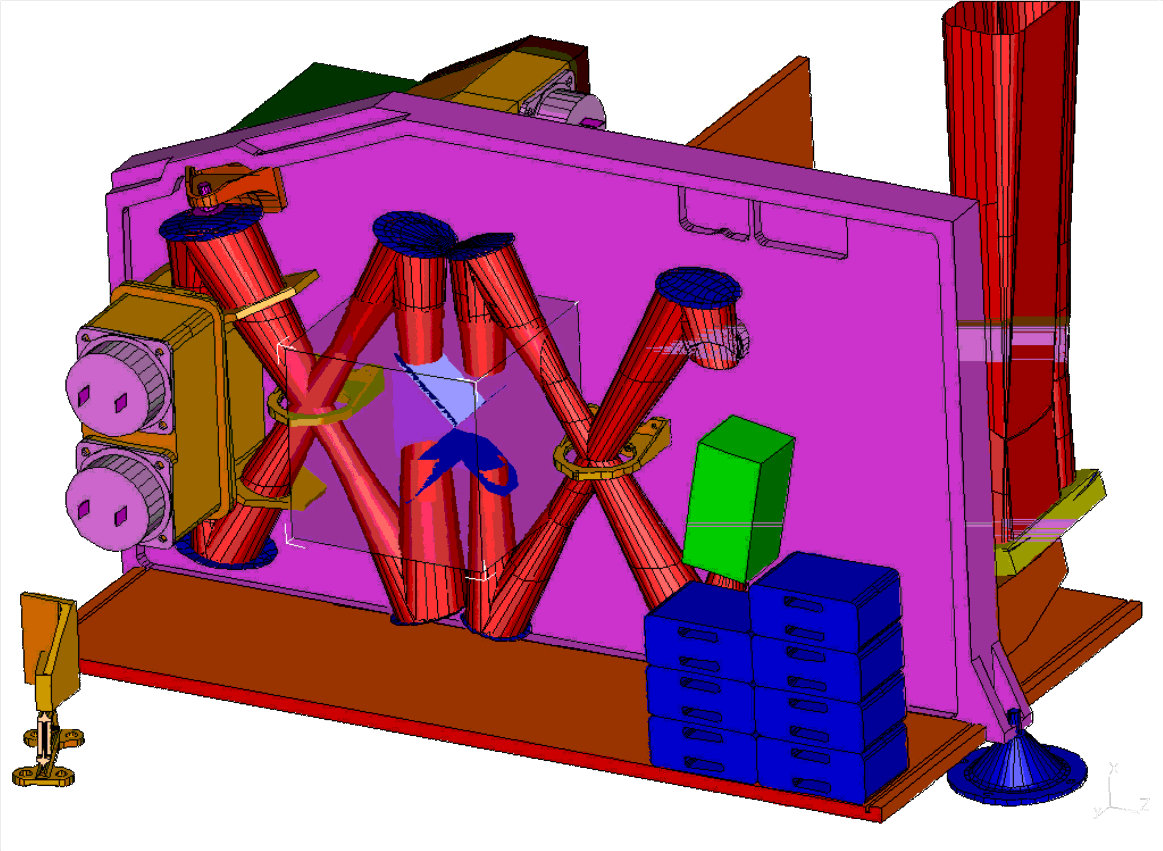
Figure 3.1-3: View of the inside of the instrument – spectrometer side, cover taken off

The instrument is divided into different temperature zones. The reason for this is the relative high interface temperature of the FIRST optical bench and the low operating temperature of the detectors inside the instrument. The interface temperature is 6-10 Kelvin where the operating temperature of the detectors is ~0.3 Kelvin. The temperature zones in between are the temperature of the monocoque structure with the optical bench at ~4 Kelvin and the boxes holding the detectors, filters and dichroics at ~2 Kelvin.

Hereafter the block diagram is given, showing the structure as part of the whole system.

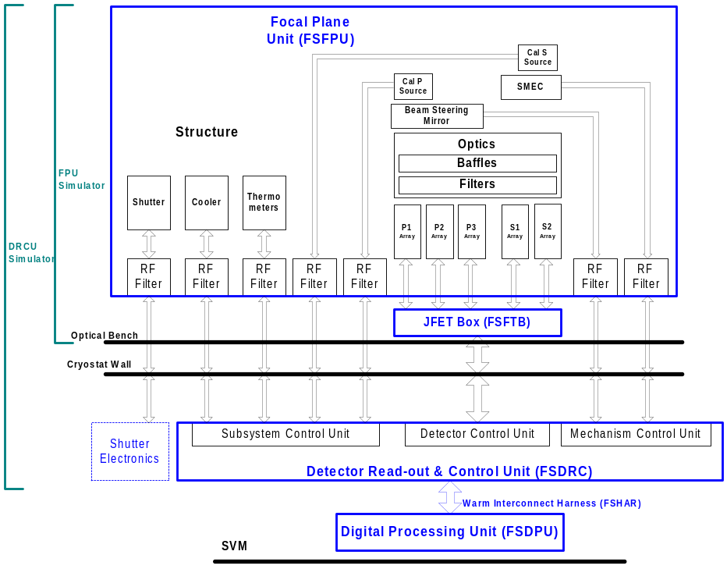
Block Diagram 3.1-1: SPIRE system

In the block diagram listed below the, many, interface with the various sub-systems is shown.

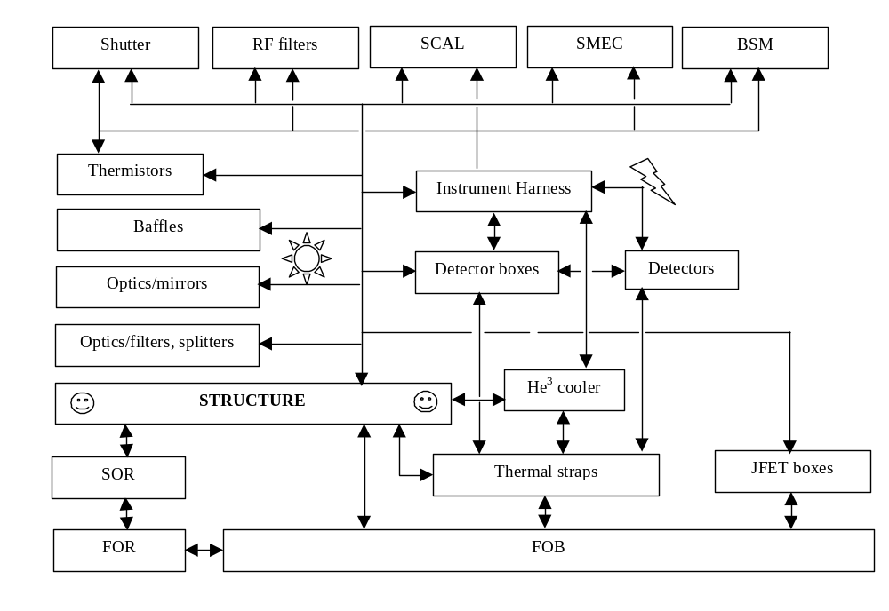
Block Diagram 3.1-2: SPIRE structure interfacing with other subsytems

In the block diagram listed below, the various components making up the structure are listed with the internal relationships.

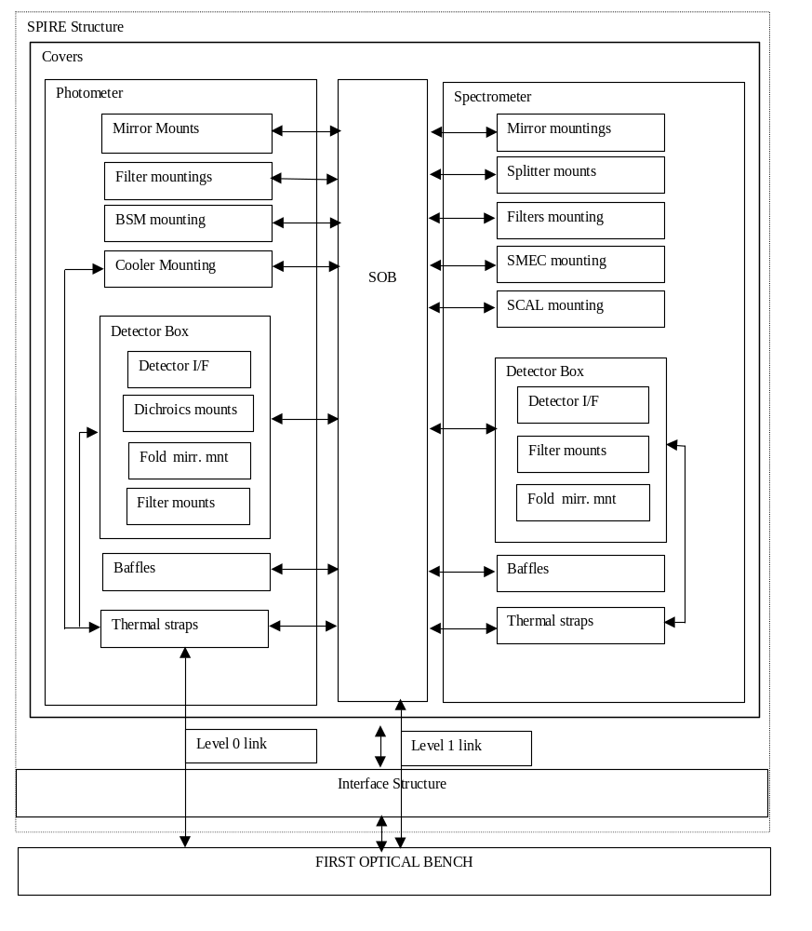
Block Diagram 3.1-3: SPIRE structure, relations between structural components

Sub-system Design
The SPIR structure is part of the SPIRE FPU, its place within the FPU is outlined in the block diagram 3.1-1. Here after the various components, together forming the design of the structure are listed and briefly addressed.

SPIRE structure - RF sealing
As stated in section 3.1 the structure uses a monocoque shell and an optical bench to hold all different parts of the instrument. The monocoque shell also serves as RF-attenuator/shield. For this all openings/seams in the instrument need to be closed such that the instrument works as a Faraday cage attenuating the RF radiation sufficiently in the specified frequency bands. For the signal and control wiring filters will be used to ensure proper operation/functionality of the electronics. An example of an RF-seal to be used in between the joints of the common structure panels is shown in figure 3.2.1-1. MSSL is responsible for implementing the RF-attenuation with regard to the structure. In principle the consortium as a whole is responsible for the RF-shielding of the instrument

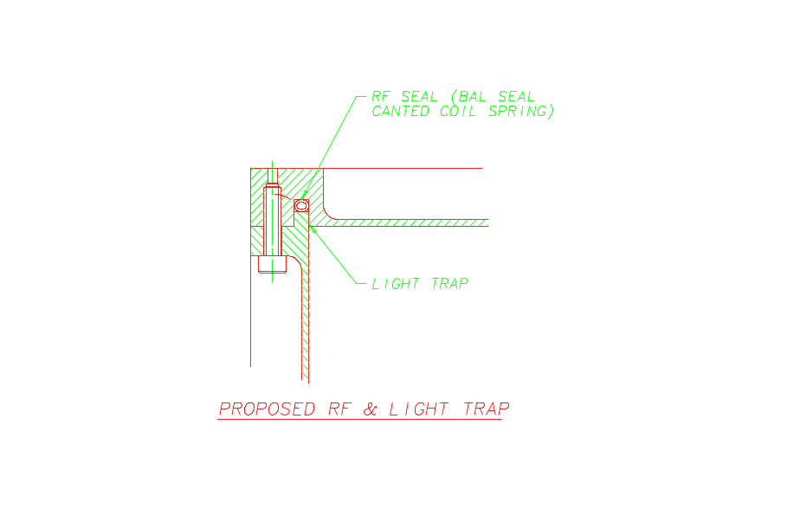
Figure 3.2.1-1

Straylight
The straylight will be attenuated as much as possible by utilising filters, black material, labyrinths and baffles where needed. The joints will have a small tight labyrinth as shown in figure 3.2.1-1. At the entry of the instrument the incoming IR beam will be filtered, excluding as much as possible the unwanted wave lengths. Inside the instrument (4 K environment) the beam will pass baffles, filters and finally, after being reflected via mirrors, end inside the detector boxes falling onto the detector noses. The proposed stray-light baffles around the thermal straps entering the common structure or the detector boxes will look like the one outlined in figure 3.2.2-1. (See for more details RD7 and RD8). MSSL is responsible for implementing the straylight shielding. RAL is responsible for the straylight modelling and advises MSSL on the implementation.

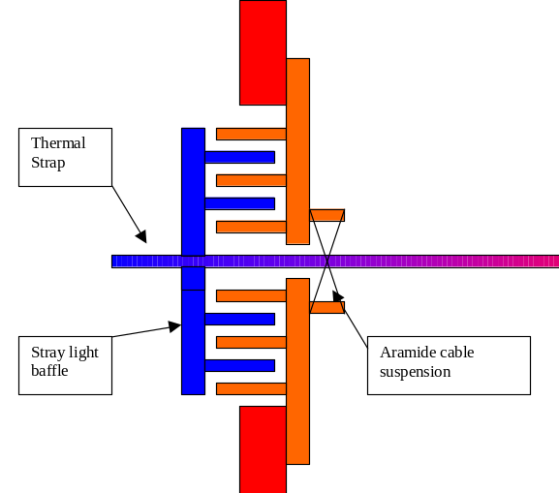
Figure 3.2.2-1: Outline of the stray-light baffle concept for thermal straps.

Thermal design

The various parts of the instrument will be connected with thermal straps to heat sinks inside the cryostat (~2 K and ~4 K). The detectors, mounted on the detector boxes, will be cooled using a thermal busbar connected to a helium-3 fridge. MSSL responsibility is manufacture and integration of the straps. The design and development responsibility is shared between CEA, RAL, QMW and MSSL.

The block diagram, listing the various thermal components in more detail than 3.1-3 does is listed hereafter in 3.2.3-1.

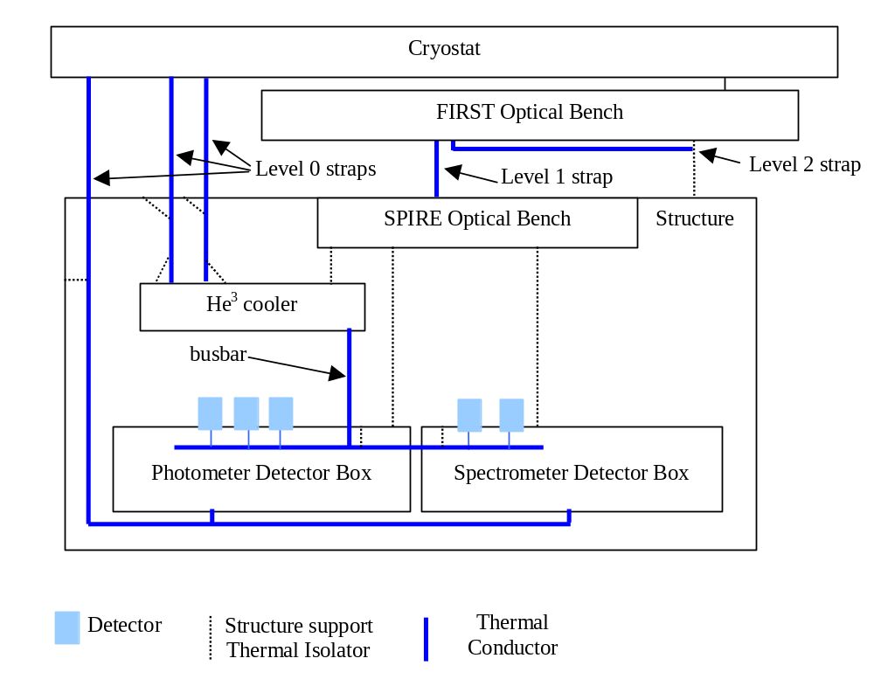
Block diagram 3.1-3: All thermal control hardware (except surface finishes)

Grounding
The instrument will be electrically isolated from the FIRST optical bench. The thermal straps will be electrically isolated from the cryostat. See for an outline of the baseline grounding scheme figure 3.2.4-1.

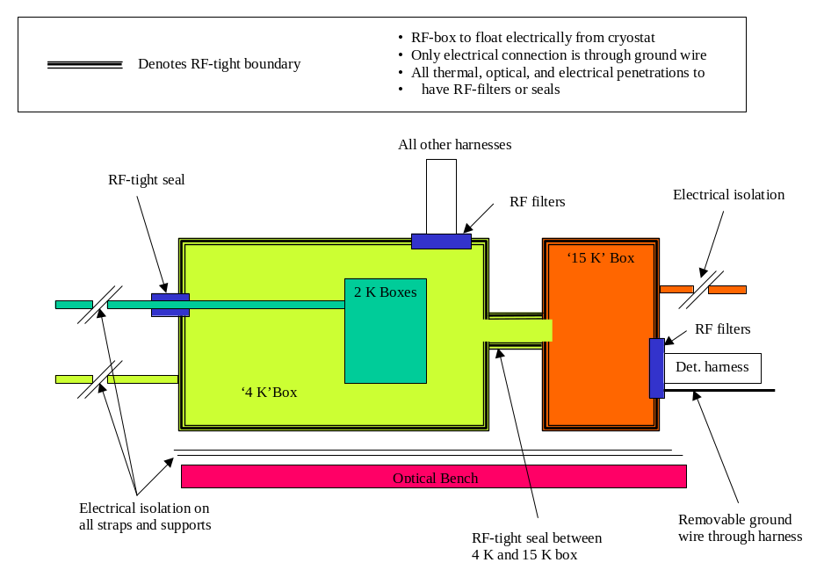
Figure 3.2.4-1: SPIRE baseline grounding scheme.

The grounding scheme is a consortium responsibility. The electrical isolation requirements will be defined by the consortium (RAL, ATC, QMW, JPL, LAM leading). And implementation by the sub-systems.

SPIRE optical design
Hereafter the topology of the optical lay-out of the instrument is given. First, the photometer side of the instrument is outlined (Figure 3.2.5-1), followed by the spectrometer side (Figure 3.2.5-2). The optical design is not a MSSL responsibility its design however defines in many ways the structure. Therefore all optical components are pictured in the two below listed figures. All relative positions of the components (following the light path) are correct.

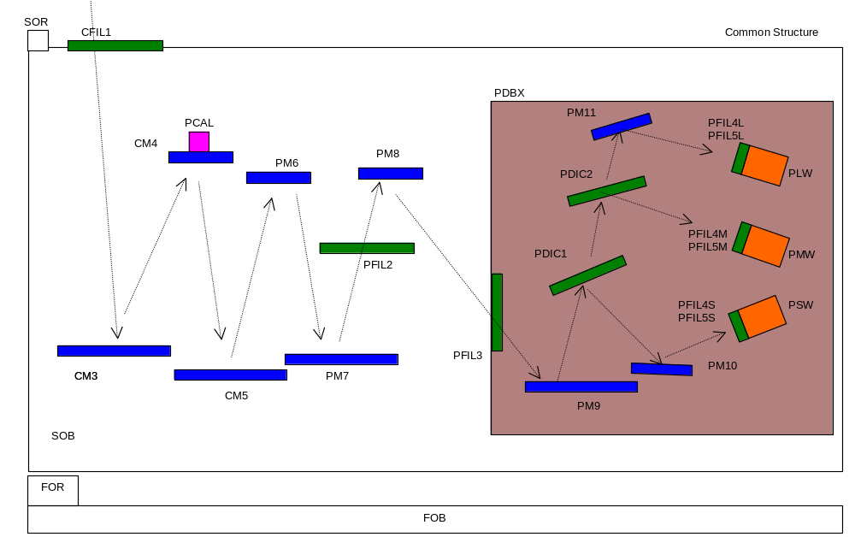
Figure 3.2.5-1: Photometer topology

Where :
CFIL1 Common Filter 1 (entry 4 K enclosure)
CM3-5 Common Mirror 3-5
FOB First Optical Bench
FOR First Optical Reference
PCAL Photometer CALibrationsource
PDBX Photometer Detector BoX
PDIC1 Photometer DIChroic 1
PDIC2 Photometer DIChroic 2
PFIL2 Photometer FILter (entrance PDBX)
PFIL3 Photometer FILter 2 (4 K-2 K enclosure)
PFIL4L/5L Photometer FILter 4 and 5 at nose PLW
PFIL4M/5M Photometer FILter 4 and 5 at nose PMW
PFIL4S/5S Photometer FILter 4 and 5 at nose PSW
PLW Photometer Long Wave detector
PM6-11 Photometer Mirror 6 to 11
PMW Photometer Medium Wave detector
PSW Photometer Short Wave detector
SOB Spire Optical Bench Panel
SOR Spire Optical Reference

Not included in the overview are the shutter, baffles and the cooler.

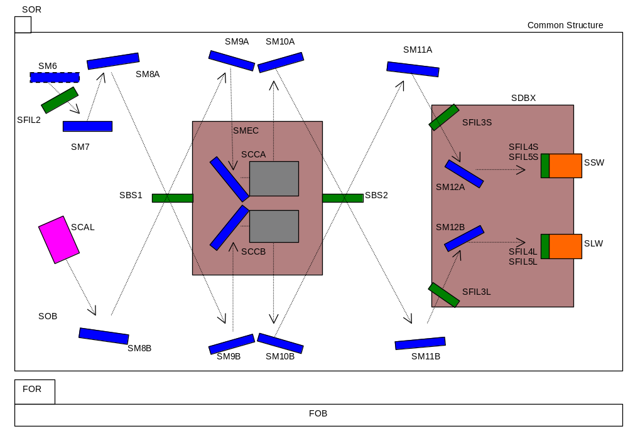
Figure 3.2.5-2: Spectrometer topology
Where:
FOB First Optical Bench
FOR Firs Optical Reference
SBS1 Spectrometer Beam Splitter 1
SBS2 Spectrometer Beam Splitter 2
SCCA Spectrometer Corner Cube +X
SCCB Spectrometer Corner Cube –X
SCAL Spectrometer CALibration source
SDBX Spectrometer Detector BoX
SFIL2 Spectrometer FILter 2 (4 K - 2 K enclosure)
SFIL3L Spectrometer FILter 3 (long wave)
SFIL3S Spectrometer FILter 3 (short wave)
SFIL4L/5L Spectrometer FILter at nose SLW
SFIL4S/5S Spectrometer FILter at nose SSW
SM6-7 Spectrometer Mirror6-7
SM8A-12A Spectrometer Mirror 8-12 +X chain
SM8B-12B Spectrometer Mirror 8-12 –X chain
SMEC Spectrometer MEChanism
SOB Spire Optical Bench Panel
SOR Spire Optical Reference

Hereafter each individual subsystem mounted on or inside the SPIRE structure and therefore interfacing with it is discussed in separate sections.

SPIRE structure
In order to prevent deformation of the structure due to thermal contraction of the interface with the spacecraft, it will be suspended kinematically on the FIRST optical bench (FOB). Furthermore in order to prevent excess deformation of the instrument due to it being cooled down, it will consist of one type of material for all structural parts. The material used to construct the instrument is aluminium 6082-T6. The only deformation present after cooling down from room temperature down to 4 Kelvin (nominally) is due to thermal contraction. Possible deformation due to thermal gradients over the structure (with all temperatures well below 6 Kelvin) will be negligible.

Structure suspension

The structure is mounted on a fixed point (cone shape support) and two A-frames. These items should ensure sufficient mounting stiffness, such that the overall dynamics of the instrument complies with the eigenfrequency requirements. Besides that they should provide for sufficient thermal insulation such that the total heat load running through the supports is minimised. The material used for these supports is stainless steel (321). The arrangement of the supports is such that the suspension of the structure is kinematic. The fixed point suspension serves as a reference with respect to the FOB. It is the only part of the instrument that will not move relative to this bench due to possible differential thermal contraction.

SPIRE optical bench

The SPIRE optical bench (SOB) is the part of the instrument where in principle all subsystems inside the instrument will be mounted on. The optical bench should be stiff. All items mounted on this bench will be aligned within 0.1 mm for each interface point.

Straylight baffles
Currently the following straylight baffles are foreseen:
- At beam entry of the instrument
- Between PM7 and PM8, dividing the photometer in two parts. One with the common optics and one with the photometer optics, including cooler and detector box.
- Two baffles within the spectrometer section of the instrument. Each one shielding the optics at each beam splitter

The surface finish will have an emissivity of less than 0.2. Except at the apertures, where possibly black material will be used to absorb IR-light.

Detector boxes
On both sides of the SOB detector boxes will be mounted to provide for a level 0 enclosure. The detectors will be mounted on the outside of these boxes with the detector nose, pointing inside the box. At the apertures possibly black material will be used to absorb IR-light.

Mirror supports
The mirrors will be mounted, baseline, on mirror mounts. These mirror mounts will be bolted on the optical bench. The exceptions are for mirrors mounted inside the detector boxes , some mirrors mounted on the central photometer straylight baffle and CM3, CM5 and CM7 mounted on a secondary optical bench. Mirror mounting is MSSL’s responsibility.

Beam splitter supports
Within the spectrometer two beam splitters are mounted on separate splitter mounts. Care will be taken to ensure the (co)planarity of these splitters.

Mounting provisions for detectors
The detectors will be mounted on the outside of the detector boxes with the nose pointing inwards. The detector harness will exit the detectors from the back, outside the detector boxes. The 0.3 K thermal strap will exit the detectors close to the nose of the detector, inside the detector box. The thermal strap will be attached to the 0.3 K thermal busbar. The harness of the detectors will be routed via the structure outside the instrument. This routing will be RF-shielded outside the instrument.

Mounting provisions for dichroics and filters
Two dichroics will be mounted inside the photometer detector box. Care will be taken to ensure the planarity of the dichroics. Filters will be mounted in various locations within the instrument. The first one will be located at the beam entry of the instrument. After that for each part of the instrument (photometer and spectrometer) two filters will be located in the optical train. For the spectrometer there will be one located at the optical bench beam entry. The other two at each beam entry of the spectrometer detector box. For the photometer there will be one located at the beam passing through the central photometer straylight baffle and one at the beam entry of the photometer detector box.

Mounting provision for the SMEC
The SMEC will be mounted on the optical bench between the two spectrometer straylight baffles (and beam splitters). There are 4 interface bolt holes. No provision for mounting a locking device (that is a SMEC internal interface). Harness will be routed via the structure to the RF-filter boxes.

Mounting provision for the ³He cooler
The cooler will be mounted next to the photometer detector box. It needs to be connected with two level 0 thermal straps to the cryostat dewar (outside the structure). The other thermal interface is with the 0.3 K thermal busbar. Harness will be routed via the structure to the RF-filter boxes.

Mounting provision for BSM
The BSM will be mounted on the optical bench within the photometer section of the instrument. The BSM will hold the CM4 mirror and the photometer calibration source. Harness will be routed via the structure to the RF-filter boxes. The BSM will provide for its own support.

Mounting provision for spectrometer calibration source
The spectrometer calibration source will be mounted with its own mount on the optical bench. Harness will be routed via the structure to the RF-filter boxes.

Mounting provision for shutter
The shutter will be mounted on the optical bench. The location is before the straylight entry baffle. Effectively between the entry filter and the secondary mirror. Harness will be routed via the structure to the RF-filter boxes.

Mounting provisions for thermal straps
The structure will provide for mounting provisions for the thermal straps and the thermal busbars. (see also section 3.2.3)
- Level 0 thermal strap to the evaporator interface with the cooler (including straylight baffle at the entry of the structure)
- Level 0 thermal strap to the pump interface with the cooler (including straylight baffle at the entry of the structure)
- Level 0 thermal strap to the photometer detector box, continuing to the spectrometer detector box (including straylight baffle at the entry of the structure)
- Level 1 thermal strap, attached to the SOB on the outside of the instrument.
- Thermal busbar, routed from the cooler to the inside of the photometer detector box and the spectrometer detector box
Sizing and conceptual design will be performed together with RAL and QMW.

The level 2 thermal strap has no direct interface with the instrument. The link between the level 2 vent line, and the instrument, is via the FIRST optical bench. The area around the mounting will be cooled using thermal links between the level 2 vent lines.

Mounting provisions for filters
The various filters will be mounted in the appropriate locations.

RF-seal (attenuation) for Common Structure
The various panels, comprising the outside of the structure will be RF-sealed. Such to attenuate incoming RF radiation sufficiently

I/F to JFET box
The structure will interface with the two JFET boxes on the outside of the instrument. The main concerns there are RF shielding of the detector harness outside the structure, thermal insulation from the (possibly hot) JFET box and grounding.

Application of thermal finishes
The instrument will have a low emissive finish on the inside and outside of the instrument. This to provide for a cold background inside the instrument and for thermal radiation shielding on the outside of the instrument.

Application of black material
At the various apertures within the instrument where the IR-beam will pass through possibly black material will be applied to absorb excess/stray IR-light.

Mounting provision for RF-filter box
All harness inside the instrument (except for the detector harness) will be routed via the structure to the RF-filter boxes, These are located within the spectrometer section of the instrument. The RF-filter boxes will interface with the cryo-harness inside the cryotstat. This harness comprises the harness from the cooler, the various mechanisms, calibrators and the thermistors.

Thermometers
There is a requirement to have thermometers to monitor the temperature of the various structure parts. Such as the common structure, SPIRE optical bench and the detector boxes. In principle the harness of the sub-systems mounted inside the structure will be used a much as possible to route the harness of the thermometers. The actual number of thermometers that have to be mounted and routed by MSSL is TBD.

Mission profile
All parts will be baked out before integration (TBC).

The SPIRE CQM structure will be subjected to several tests. These tests consist of an STM test, which is a structural test verifying the dynamic properties of the structure (stiffness, strength, mass), and the CQM test programme (requirements outlined in RD9). After that a PFM model will be built, tested and mounted on the spacecraft. On the spacecraft it will go through the spacecraft proto-flight programme. The CQM will be refurbished (TBC) to serve as flight spare.

In the table hereafter (3.3-1) the allowable times a certain handling/test is performed or the allowable amount of time
Model: | STM | CQM | PFM | FS
Integration | 2 | 2 | 5 | 1
Cold cycles (down to 2-4 K) | 5 (TBC) | 15 (TBC) | 5 (TBC) | 5 (TBC)
Mounting and dismounting detector boxes | 15 (TBC) | 15 (TBC) | 5 (TBC) | 5 (TBC)
Mounting and dismounting mirror mounts | 15 (TBC) | 5 (TBC) | 3 (TBC) | 3 (TBC)
Mounting and dismounting instrument suspension | 15 (TBC) | 15 (TBC) | 5 (TBC) | 5 (TBC)
General use¹ | 1 Yr | 2 Yr | 2 Yr | 1 Yr
Storage | 1 Yr | 2 Yr | 2 Yr | 2 Yr
In orbit | - | - | 4.25 Yr | 4.25 Yr
Table: 3.3-1: Overview life of the structure (split in the different models)

¹ General use encompasses 1 qualification test or two proto-flight test programmes. If the structure is needed for more tests, fatigue critical components need to be replaced.

After successfully, withstanding the qualification tests, the PFM will be constructed. The PFM will be subjected to the same tests as the CQM (except STM testing). After successfully withstanding the proto-qualification tests the PFM will be integrated in the spacecraft. Integrated in the spacecraft it will be subjected to the spacecraft proto-qualification programme. If these tests prove successful the spacecraft will be launched. More details can be found in AD1. The CQM model will be refurbished to act as a flight spare. The FS will be interchangeable with the PFM unit.

If the FS goes through a proto-qualification programme or a qualification programme it needs to be refurbished

Product tree

Hereafter the parts as listed in the product tree (RD4) are listed.

ID | Product Item | Descriptor | STM | AVM | CQM | PFM | FS | RESP
1.1 | Structure | STRC | x |  | X | x | x | MSSL
1.1 | Common Structure (incl. Interface wit JFET and RF filter box and FIRST optical bench) | C4K | x |  | X | x | x | MSSL
1.1 | Photometer detector box | PDBX | x |  | X | x | x | MSSL
1.1 | Spectrometer detector box | SDBX | x |  | X | x | x | MSSL
1.1 | Mounting provisions for thermal straps |  | x |  | X | x | x | MSSL
1.1 | Mounting provision for thermal interface with level 0 |  | x |  | X | x | x | MSSL
1.1 | Mounting provision for thermal interface with level 1 |  | x |  | X | x | x | MSSL
1.1 | Mounting provisions for thermal straps from cooler to detectors |  | x |  | X | x | x | MSSL
1.1 | Alignment reference mirror | SOR | x |  | X | x | x | MSSL
1.1.1.1 | Structure thermistors | T_PDBX_1  T_PDBX_2  T_SDBX_1  T_SDBX_1  T_C4K_1  T_C4K_2 | x |  | X | x | x | MSSL
1.2 | Photometer mirror mounts |  | x |  | X | x | x | MSSL
1.2 | Spectrometer mirror mounts |  | x |  | X | x | x | MSSL
1.2.1 | Filters, Dichroics and beam splitters mountings |  | x |  | X | x | x | MSSL
1.2.2 | Baffles | BAFF | x |  | X | x | x | MSSL
1.3 | Cooler I/F | COOL | x |  | X | x | x | MSSL
1.4.1 | Detector I/F |  | x |  | X | x | x | MSSL
1.4.2 | Detector I/F |  | x |  | X | x | X | MSSL
1.5.2 | SMEC I/F |  | x |  | X | x | X | MSSL
1.5.3 | Shutter I/F |  | x |  | X | x | X | MSSL
1.6.2 | Spectrometer calibration I/F |  | x |  | X | x | X | MSSL
1.7 | JFET I/F |  | x |  | X | x | X | JPL/MSSL
1.7 | RF I/F |  | x |  | X | x | X | JPL/MSSL
5.3 | Mechanical ground support equipment | MGSE | x |  | X | x | X | MSSL
 | Mathematical model structure | FEM |  |  |  |  |  | MSSL

A more detailed list of deliverables is part of the development plan (AD1)

Specification

Functional

Performance specification
The focal plane unit structure will hold all cold sub-systems in the focal unit. This includes all thermometers necessary
to monitor the instrument during cool down and operation.

Hereafter the performance of the subsystem is specified and compared with the required performances and general requirements as set out in RD1.

The mass requirements are listed in the budget allocations (RD6). The mass of the current baseline design meets the strict requirements as set out in section 3.4.3 of RD1.

IRD-SUBS-R03: The mass of the structure, including 20% contingency instrument is 32.6 kg

Included in this mass are the straylight baffles, mirror mounts, filter splitter and dichroic clamps/mounts. The straylight baffles are not strictly a part of the structure, nor are the various subsystem supports. However they will be deliverables and are therefore added to this mass budget. The budget does not include the fasteners required to mount the various subsystems in/on the common structure or one of the detector boxes. See for a more detailed mass allocation section 4.1.2, with the technical (implementation) requirements.

The subsystem structure is further specified hereafter. The specifications are compared with the requirements.

The alignment of the structure with respect to the FOB depends on the machining tolerance of the FOB. At present the machining tolerance is expected to be within +/- 0.05 mm for each interface bolt.
ID | Description | Value | Source
IRD-STRC-R01 | Alignment ot the instrument w.r.t. FIRST optical axis | The common structure shall allow the alignment of the instrument and the telescope axis to within +/- 2.5 mm (TBC) lateral, TBD arcmin rotational about any axis. | RD1/table 3.5.-1

The structure consists of aluminium panels, milled down to a nominal thickness of 1.5 mm. At the connection between the panels an RF-attenuating seal is provided. See figure 3.1-4.
ID | Description | Value | Source
IRD-STRC-R02 | Attenuation of RF by Common Structure | The covers as fitted on the instrument will attenuate all frequencies lower than 8 GHz by TBD dB. | RD1/table 3.5.-1

The photometer and spectrometer will be mounted on the SOB.
ID | Description | Value | Source
IRD-STRC-R03 | Items required support from the Common Structure | Photometer and common subsystems, Spectrometer | RD1/table 3.5.-1

The structure will be aligned as specified in RD5.
ID | Description | Value | Source
IRD-STRC-R04 | Optics and associated sub-system alignment | Specified in RD5 | RD1/table 3.5.-1

The structure will have a surface finish with an ε < 0.2
ID | Description | Value | Source
IRD-STRC-R05 | Surface finish of the Common Structure cover | The inside and the outside of the box shall have a finish with a low emissivity. At least less than ε = 0.2. Parts may be blackened as part of stray light control. | RD1/table 3.5.-1

The total effective pumping capacity has to be analysed.
ID | Description | Value | Source
IRD-STRC-R06 | Pumping port | The total effective pumping conductance of the common structure shall be ≥7.8 l/s | RD1/table 3.5.-1

The structure will be equipped with the specified number of thermometers
ID | Description | Value | Source
IRD-STRC-R07 | Thermometry | See 3.3/1.1.1.1 | RD1/table 3.5.-1

The surface finish on the outside of the instrument will have an emissivity with an ε < 0.2
ID | Description | Value | Source
IRD-STRC-R08 | Attenuation of radiation from cryostat | Requirement <2x10⁻⁵ | RD1/table 3.5.-1

The structure, supported on its mounts, will have an eigenfrequency > 120 Hz
ID | Description | Value | Source
IRD-STRC-R09 | First natural frequency | The structures eigenfrequency shall be above 100 Hz (req.) and preferably above 120 Hz (goal) | RD1/table 3.5-2

The instrument will be mounted on the FOB with electrically insulating washers.
ID | Description | Value | Source
IRD-STRC-R10 | Instr. mechanical interface | The I/F will be directly to the FIRST optical bench. The instrument will be in direct thermal contact | RD1/table 3.5-2

All parts of the structure will be electrically connected, one to the other, with an resistance less than than 0.1 Ω.
ID | Description | Value | Source
IRD-STRC-R12 | Grounding | All parts of the SPIRE structure shall be electrically connected one to another. Resistance to be no more than 0.1 Ω (TBC) | RD1/table 3.5-2

The instrument will be mounted on the FOB with electrically insulating washers.
ID | Description | Value | Source
IRD-STRC-R13 | Electrical isolation from FIRST | All parts of the SPIRE structure shall be electrically isolated from the FIRST optical bench and cryostat. Resistance to be greater than TBD Ω | RD1/table 3.5-2

The conductance from level 2 to level 1, via the supports of the instrument, will be less than 6 mW with boundary temperatures of 9.0 K and 4.0 K respectively.
ID | Description | Value | Source
IRD-STRC-R14 | Thermal isolation | The conductance from the level 2 to level 1 stage is required to be no more than 6 mW (TBC) assuming level 2 is 9 K and level 1 is 4 K. | RD1/table 3.5-2

The photometer detector box shall support the level 0 optics, dichroics, filter, detectors, straylight baffles and thermal strap supports for the detectors
ID | Description | Value | Source
IRD-STRP-R01 | Items supporting | The photometer detector box shall support the level 0 optics, dichroics, filter, detectors, and thermal strap for detectors | RD1/table 3.5-3

The structure will be aligned as specified in RD5.
ID | Description | Value | Source
IRD-STRP-R02 | Optics and filter alignment | See RD5 | RD1/table 3.5-3

The structure will be aligned as specified in RD5.
ID | Description | Value | Source
IRD-STRP-R03 | Array module alignment | See RD5 | RD1/table 3.5-3

The structure will have a surface finish with an ε < 0.2
ID | Description | Value | Source
IRD-STRP-R04 | Surface finish | The outside of the box shall have a finish with a low emissivity. At least ε = 0.2. The inside shall have a low reflective finish on all non-optical surfaces.. | RD1/table 3.5-4

The effective pumping capacity has yet to be analysed.
ID | Description | Value | Source
IRD-STRP-R05 | Pumping port | The total effective pumping conductance of the detector box shall be ≥ 5.6 l/s | RD1/table 3.5-4

The structure will have a surface finish with an ε < 0.2
ID | Description | Value | Source
IRD-STRP-R06 | Attenuation from common structure | Requirement: 5x10⁻⁷ with a goal of 5x10⁻⁸ | RD1/table 3.5-4

The first eigenfrequency of the photometer detector box on its mounts will be greater than 150 Hz
ID | Description | Value | Source
IRD-STRP-R07 | First natural frequency | The first eigenfrequency of the photometer detector box on its mounts shall be greater than 100 Hz, with a goal of 150 Hz | RD1/table 3.5-4

The thermal conductance from the structure to the photometer detector box will be less than 0.75 mW via the supports, with a boundary condition of 4.0 K and 2.0 K respectively.
ID | Description | Value | Source
IRD-STRP-R09 | Thermal isolation | The conductance from the common structure to the detector box shall be less than 0.75 mW. (TBC) | RD1/table 3.5-4

The spectrometer detector box shall support the level 0 optics, filter, detectors, straylight baffles and thermal strap supports for the detectors.
ID | Description | Value | Source
IRD-STRS-R01 | Items supporting | The photometer detector box shall support the level 0 optics, filter, detectors, and thermal strap for detectors | RD1/table 3.5-4

The structure will be aligned as specified in RD5.
ID | Description | Value | Source
IRD-STRS-R02 | Optics and filter alignment | See RD5 | RD1/table 3.5-4

The structure will be aligned as specified in RD5.
ID | Description | Value | Source
IRD-STRS-R03 | Array module alignment | See RD5 | RD1/table 3.5-4

The structure will have a surface finish with an ε < 0.2
ID | Description | Value | Source
IRD-STRS-R04 | Surface finish | The outside of the box shall have a finish with a low emissivity. At least ε = 0.2. The inside shall have a low reflective finish on all non-optical surfaces.. | RD1/table 3.5-4

The effective pumping conductance of the structure has yet to be analysed
ID | Description | Value | Source
IRD-STRS-R05 | Pumping port | The total effective pumping conductance of the detector box shall be ≥ 5.6 l/s | RD1/table 3.5-4

The structure will have a surface finish with an ε < 0.2
ID | Description | Value | Source
IRD-STRS-R06 | Attenuation from common structure | Requirement: 5x10⁻⁷ with a goal of 5x10⁻⁸ | RD1/table 3.5-4

The first eigenfrequency of the spectrometer detector box on its mounts will be greater than 150 Hz
ID | Description | Value | Source
IRD-STRS-R07 | First natural frequency | The first eigenfrequency of the spectrometer detector box on its mounts shall be greater than 100 Hz, with a goal of 150 Hz | RD1/table 3.5-4

The thermal conductance from the structure to the photometer detector box will be less than 0.75 mW via the supports, with a boundary condition of 4.0 K and 2.0 K respectively.
ID | Description | Value | Source
IRD-STRS-R09 | Thermal isolation | The conductance from the common structure to the detector box shall be less than 0.75 mW. (TBC) | RD1/table 3.5-4

Technical requirements

The following co-ordinate system as reference to the cryostat shall be taken into account (RD3). See also DR1 and appendix A.
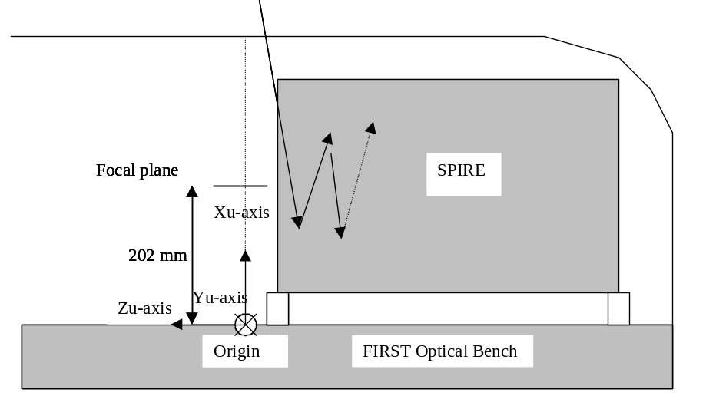
Figure 4.1.2-1 Cryostat reference co-ordinate system.

The following local co-ordinate system shall be taken into account for the SOB mounted subsystems. See also DR1 and appendix A. The origin lies on the optical bench datum point. This is visible and reachable both before, during and after integration. It will however not be visible from outside the spacecraft cryostat. As optical reference an optical alignment cube will be used, mounted on top of the optical bench, outside the common structure, closest to the spacecraft optical axis and visible from outside the cryostat. The advantage of the datum point on the optical bench is that all co-ordinates inside the instrument are positive. Both the co-ordinate systems, are co-aligned with the S/C co-ordinate system, only the origins differ.

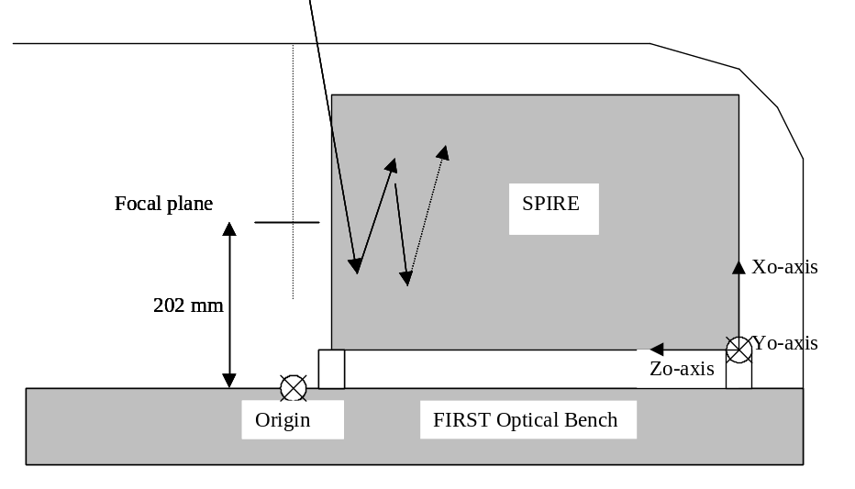
Figure 4.1.2-2 Spire optical bench reference co-ordinate system.

For the current baseline design the following mass distribution holds:

SPIRE – structure
Contingency taken into account: 20%
 | Nett | Contg. | Total
Photometer cover | 7.43 | 1.49 | 8.92 | [kg]
Spectrometer cover | 5.69 | 1.14 | 6.82 | [kg]
Optical bench | 7.10 | 1.42 | 8.52 | [kg]
Mounting common structure | 0.57 | 0.11 | 0.69 | [kg]
RF-attenuation | 0.25 | 0.05 | 0.30 | [kg]
Phot. det. box | 1.58 | 0.32 | 1.89 | [kg]
Spect. det. box | 1.10 | 0.22 | 1.32 | [kg]
Mounts, Clamps Phot. | 1.04 | 0.21 | 1.17 | [kg]
Mounts, Clamps Spect. | 1.06 | 0.21 | 1.42 | [kg]
Straylight Baffles | 1.38 | 0.28 | 1.66 | [kg]
total | 27.20 | 5.44 | 32.64 | [kg]
Excluding: | Thermal straps
 | Harness wiring
 | RF-filter boxes
 | JFET I/F structure
 | Spect. Cal.
 | Shutter
 | Cooler I/F
 | Straylight baffles (around straps)
Table 4.1.2-1: Mass distribution SPIRE structure and related

Implementation requirements still to be defined:

Thermal flow characteristic through A-frame and fixed point suspension. (RD3, section 5.9.1.2, total 6 mW)
Thermal flow characteristic through detector box suspension. (RD3, section 5.9.1.2, total 1.5 mW)

Operational

Operational Safety
N.A.

Lifetime
Expected integrated lifetime is 9 years, including on orbit life, TBC

Operating modes
N.A.

Telemetry
NA

Telecommands
NA

Interface requirements

The interface with the FIRST optical bench is given by ja1-5264-300, pictured in appendix A.

Hereafter all subsystem interfaces and the applicable ICD’s are listed. The ICD’s contain the interface drawings

ICD | Part name | ICD | Other party
1.1 - 1.2 | Mirrors/Optics | AD2 | LAS
1.1 - 1.5.2 | FTS mechanism | AD3 | LAS
1.1 - 1.2.2 | Straylight attenuation | TBI | RAL
1.1 - 1.2.1 | Filters, splitters & dichroics | AD4 | QMW
1.1 - 1.4.1/2 | Detectors | TBI | JPL
1.1 - 1.5.1 | BSM | TBI | ATC
1.1 - 1.6.1 | Calibration source Photometer | TBI | QMW?
1.1 - 1.6.2 | Calibration source Spectrometer | TBI | QMW?
1.1 - 1.5.3 | Shutter mechanism | TBI | UoS
1.1 - 1.3 | He³ Cooler | AD5 | CEA-Grenoble
1.1 - ? | Thermal hardware | TBI | ?
Table 4.3-1: ICD list

Hereafter the general requirements for the subsystems are given.

The sine and random input at the interfaces considered in this document will be updated after the coupled analysis. The input spectra hold for all interfaces with subsystems mounted of the optical bench. The spectra given here are a guideline and are subject to changes in the IID-A. At all times the spectra specified in the individual ICDs will supersede the ones specified below. Again, the spectra defined in the individual ICDs are subject to changes in the IID-A which has not been issued officially at the time this document was written.
Quasi-Static
The qualification levels are provisional, copied from the qualification loads of ISO. Since they are less severe than the specified sine loads, the requirement is covered by these sine vibration loads. (RD1)
Quasi Static levels | Case 1 | Case 2 | Case 3 | Case 4
x-direction | 22.5 g (TBC) | 22.5 g (TBC) | - | -
y-direction | 3 g (TBC) | - | 6 (TBC) | -
z-direction | - | 3 g (TBC) | - | 6 (TBC)
Table 4.3-1: Qualification levels for quasi static vibration
Sine
The qualification levels are derived from the coupled analysis with the instrument structure with the input at base of the instrument following the requirements stated in AD**. These levels include the required qualification margin (factor 1.5). They do not include any further margin with respect to design loads. These will have to be added by the subsystems.

Sine vibration levels | Frequency range | Input at base (QUAL)
X-direction | 5-18 Hz  18-100 Hz | 22 mm (peak-peak)  40 g
Y-direction | 5-18 Hz  18-100 Hz | 22 mm (peak-peak)  50 g
Z-direction | 5-18 Hz  18-100 Hz | 22 mm (peak-peak)  50 g
Table 4.3-2: Qualification levels for sine vibration (sweep rate 2.0 oct/min)

Random
The qualification levels are provisional, copied from the qualification loads of ISO.
Random vibration levels | Frequency range | Input at base (QUAL.)
X-direction | 5 – 150 Hz  150-700 Hz  700 – 2000 Hz | +6 dB  0.15 g²/Hz  -3 dB
Y-direction | 5 – 150 Hz  150-700 Hz  700 – 2000 Hz | +6 dB  0.15 g²/Hz  -3 dB
Z-direction | 5 – 150 Hz  150-700 Hz  700 – 2000 Hz | +6 dB  0.15 g²/Hz  -3 dB
Table 4.3-3: Qualification levels for random vibration (20 g_{rms})

Design and manufacture requirements

Design requirements
The key baseline design requirements and implementation are the following

1 -Stiffness

In order to provide for the required stiffness the baseline design of the structure consists of a monocoque structure with a central stiff optical bench panel. In principle all sub-systems are mounted on the optical bench panel. In order to comply with the sine vibration input specification the design goal set for the structure is to reach an first natural frequency of 120 Hz or higher. Because of the uncertainty taken into account for the frequency prediction of 10% the baseline design should have its predicted first natural frequency of at least 133 Hz. Furthermore the various sub-systems need to be decoupled (dynamically) as much as possible. The eigenfrequency of the SOB should be at least 20 % higher than the first overall natural frequency (160 Hz). The minimal eigenfrequency of all subsystems and detector boxes should be at least 25% higher (200 Hz). Ideally the eigenfrequency of a subsystem mounted on an other should be a factor 1.41 higher in order to avoid any amplification due to the coupling. This is in practice not possible.

2 - Thermal

The structure will be thermally isolated from the FIRST optical bench as much as possible. Assuming a 6.0 K interface temperature and a 4.0 K structure temperature the maximum heat flow through the mounting of the structure should be less than 2 mW.

3 - Electrical

The structure will be electrical isolated from the FIRST optical bench. This to allow for controlled grounding of the structure and its various subsystems. The thermal straps routed along various locations within the structure will be electrically isolated from the structure.

Design rules
No specific design rules as yet.

Manufacture requirements
TBD

Logistic requirements

RD2, 5.15.1.1: For all deliverable units, transport containers shall be provided.

- Each model will have its transportation container and handling frame. Only one set of integration tools is required. (If applicable) Since the FS will be a refurbished CQM model, only two sets of transportation containers and handling frames are required. One for the CQM/FS and one for the PFM.
- The subsystem will be transported from MSSL to RAL, and from RAL to ESTEC (TBC)
- The container shall be vacuum tight, be purged and slightly overpressured with dry nitrogen gas.
- The instrument will be mounted using shock absorber supports
- Shock recorders shall be mounted at TBD location
- IID-B shall list size and mass of the container as well as the overall mass including the instrument package

Environment requirements
These requirements describe the environment the structure needs to be able to sustain during its life. Life includes all ground operations and tests, launch and all on orbit operations. For the structure it is assumed that the warm vibration test, followed by the CQM qualification programme envelopes the worst case environment for the structure. Therefore the structure

Natural environment
This is the description of the natural environment around the subsystem during its life.

# | Parameter | Value | IRD | Note
EN1 | Vacuum | Less than 10-4 Pa |  | In operation
EN2 | Operating temperature | during system qualif and on orbit = 4K
EN3 | Storage and handling temperature | -20 to +30 °C |  | Overall, on ground
 | Humidity | Less than 45% |  | In clean room
 | Cleanliness | TBD |  | In clean room
EN4 | Radiations | Less than 3.5 kRAD |  | On orbit

Operating environment
N.A.

Verification requirements
RD1 lists in section 2.6 the verification requirement for the instrument. They are repeated hereafter and the compliance is indicated.

ID | Description | Response | Compliant
IRD-VER-01 | STM verification: stiffness and strength of the structure | STM sine vibartion test (warm) | yes
IRD-VER-R02 | AVM verification | Not applicable | -
IRD-VER-R03 | CQM verification  1 correct operation (all operating modes) at cryogenic temperatures  3 thermal dissipation  6 Straylight | 1 Cryogenic test  3 Cryogenic test  6 Cryogenic test | 1 yes  3 yes  6 yes
IRD-VER-R04 | PFM and FS  same as for CQM verification (structure) | Cryogenic test | yes

Prior to the STM and CQM test, mathematical models will be used to verify the strength and stiffness of the proposed structure. The mechanical tests will be simulated for as far as the software allows doing that. The principle loads will be derived from these analyses and forwarded to all subsystems, if required, via the ICD.

At present the draft mechanical environment requirements as issued by ESA (RD10) are listed hereafter. These apply for the structure subsystems as a whole. Not for the subsystems individual.

Mechanical environment
Quasi-Static
The qualification levels are provisional, copied from the qualification loads of ISO.
Quasi Static levels | Case 1 | Case 2 | Case 3 | Case 4
x-direction | 22.5 g (TBC) | 22.5 g (TBC) | - | -
y-direction | 3 g (TBC) | - | 6 (TBC) | -
z-direction | - | 3 g (TBC) | - | 6 (TBC)
Table 2.4-1: Qualification levels for quasi static vibration
Sine
The sine vibration environment qualification loads taken from ESA fax, SCI-PT/IFI/07222, d.d. 05/11/99. These are the input acceleration at the base of the SPIRE instrument. The sweep rate is 2.0 oct/min (TBC) RD2 echo’s this fax and adds the low level sweep to the specification.

Sine vibration levels | Frequency range | Input at base (QUAL)
X-direction | 5-18 Hz  18-70 Hz  70-100 Hz | 22 mm (peak-peak)  15 g  7.5 g
Y-direction | 5-18 Hz  18-50 Hz  50-100 Hz | 22 mm (peak-peak)  15 g  7.5 g
Z-direction | 5-18 Hz  18-50 Hz  50-100 Hz | 22 mm (peak-peak)  15 g  7.5 g
Table 2.4-2: Qualification levels for sine vibration

For all axis the a signature run of 0.5 g from 5.0 to 2000 Hz will be performed as the first and the last sweep. RD3, table 9.5.3.3.2-2.

Random
The qualification levels are provisional, copied from the qualification loads of ISO.

Random vibration levels | Frequency range | Input at base (QUAL.)
X-direction | 5 – 150 Hz  150-700 Hz  700 – 2000 Hz | +6 dB Hz  0.04 g²/Hz  -3 dB
Y-direction | 5 – 150 Hz  150-700 Hz  700 – 2000 Hz | +6 dB Hz  0.04 g²/Hz  -3 dB
Z-direction | 5 – 150 Hz  150-700 Hz  700 – 2000 Hz | +6 dB Hz  0.04 g²/Hz  -3 dB
Table 2.4-3: Qualification levels for random vibration

Appendix A

Interface drawing SPIRE-FIRST



