Introduction
This note attempts to seek a consensus on how to approach the issue of a possible failure of the SPIRE 300 mK cooler. The loss of the cooler was pointed up as the only potential catastrophic failure for the SPIRE instrument at the PDR in July 1999. In a previous note (appended) I looked at the issues related to providing redundancy in the cold part of the cooler hardware (i.e. more than one cooler, multiple heat switches etc). Since that note was produced both further information has come to light and there is a better understanding of the constraints imposed by the mechanical design of the SPIRE instrument. In the present note the new information and constraints on the approach to the redundancy are taken into consideration and the implementation of the wiring and electronics are discussed.

New Information and Constraints
The following can now be taken into consideration in determining how best to approach the redundancy of the coolers:

- Under the ESA TRP contract a FMEA has been carried out (TN-CSL/SC/99005) on the cold unit of the cooler prototype design. The draft version of this that we have seen concludes that the major failure risk is leakage of the gas in the cooler due to mechanical failure.

- The mechanical design of the SPIRE instrument has advanced sufficiently to show that it will be extremely difficult to accommodate a second complete cooler.
- We believe we can fit two extra heat switches within the available mechanical envelope with little impact on the mass of the cooler.
- Two reports are available from SBT on the detailed design of the cooler being manufactured under the TRP contract TN/SBT/SC/99-04 and SBT/SC/GS/99-01. These give details of the expected performance of the cooler and its detailed mechanical implementation.

Possible failure modes of the cooler
Here we recapitulate the possible failures that can occur and give a commentary on their likelihood. The failure modes are divided into those directly related to the cooler, and those that will affect the cooler performance but are related to the systems design of the instrument and/or satellite.

Cooler Failure Modes:
- Mechanical failure leading to loss of coolant:
We believe that the development programme underway on the TRP cooler and the subsequent redesign for the SPIRE specific cooler will render this extremely unlikely. There are some outstanding issues related the titanium alloy Ta6V (examples of contamination that makes it brittle have been reported, etc.) that will be used for the main structural support. These are under extensive investigation as is the behaviour of the Kevlar cords at room temperature: fatigue, creep, influence of pulley diameter, speed of traction, baked or not baked, etc. No peculiar behaviour has been reported to date.

In case we do have a failure of a cord, we believe the remaining cords will sustain the cooler. SBT are currently doing a full finite element model of the cooler and will provide a definitive answer on this soon. In addition, for the flight model, the design of the snubbers (launch bumper stops in case of failure) will be optimised to further reduce the chances of actually breaking and losing the gas.

- Heat switch fails open or short circuit by mechanical failure

Again we believe that at the end of the qualification we'll have a pretty good idea about whether the heat switches are likely to mechanically fail and what that failure mode will be. The switches are equipped with snubbers (both for the switch end and for the miniature sorption pump) and because of more flexibility in the design (in comparison with the suspended spheres) we can really design very efficient snubbers. We could also further reduce the risk, for instance, by adding an extra tube that mounts around the thin wall tube. Our feeling at this moment is that it is unlikely we'll break one. Further, even if one were to fail mechanically, it is very much more likely to result in a loss of gas and therefore to fail open circuit than it is to acquire a significant thermal conduction by parts of the switch touching internally.

- Heat switch fails open circuit by harness failure

There are a large number of wires in the FIRST harness and random failure is a distinct possibility. This must be catered for by the use of cold redundancy either by extra heat switches and/or by extra heaters. Note that each additional heat switch on the evaporator adds an extra ~4-5 μW load at 300 mK.

- Pump heater fails off by mechanical failure or harness failure

Mechanical failure here means breaking wires or heater elements internally to the pump. To minimise the risk of this we intend using heaters that are already space qualified although we have
yet to identify a suitable product. The pump heaters will also be made fully redundant with two heaters each with double wiring and electronics (see below).

- Heat switch fails open circuit by electrical failure or pump heater fails off by electrical failure

There will be fully redundant electronics for the cooler (see below)

- Pump heater fails on by electrical failure or heat switch fails on by electrical failure

This possibility is remote and will anyway be avoided by design of the electronics (see below)

- Thermal straps between heat switches ends and pump or evaporator ends

Unlikely to fail mechanically, but will require our attention during the design and qualification of the SPIRE specific cooler.

Systems Failure Modes
- Mechanical failure of the thermal straps to the main tank resulting in too large a thermal gradient.

This will have a significant impact on performance, in the worst case recycling would no longer be possible. The design and implementation of these straps is beyond the control of the SPIRE project but will need to be closely monitored by us.

- Unexpected parasitic loads.

For instance such that the heat switches can never be turned off, "large load", or such that the duty cycle efficiency is significantly affected, "small load" of a few µW. The latter possibility should be minimised by careful attention to the thermo-mechanical design and the case of the heat switches is discussed above. However, in the case of the “small load” situation arising after launch we would have to change our observing strategy to accommodate any decrease in cooler efficiency.

- Mechanical failure of the thermal straps to the detectors leading to a large thermal gradient.

This possibility is difficult to insure against except by careful design and thorough quality assurance procedures and ground testing.

- Failure to recycle during ground testing due to the orientation

This situation can definitely be avoided during instrument level testing as the instrument will be orientated with the pump vertically above the evaporator. We place a requirement on the satellite level MGSE that we can rotate the FIRST cryostat and the CQM cryostat by up to ±30º about the satellite Z axis.

- Mechanical failure of the cooler mounting support, i.e. the interface with the SPIRE 4-K structure

This will be avoided be design and qualification testing.

Possible Configurations of the Cooler
Given the above discussion we propose three possible configurations of the cooler that could provide the required level of redundancy. The difference between the options is the degree of insurance provided against certain failure modes and the thermal load onto the liquid helium tank.

The following assumptions are made:

Assumption 1: The heat switches will never fail with a significant thermal short.
Assumption 2: It is possible to have double heaters on a single heat switch miniature sorption pump.
Assumption 3: Failure of the thermometers associated with the cooler (not mentioned so far) is not critical to the operation of the cooler and can be accommodated by using other thermometers associated with the thermal straps and detector sub-system.

Electronics and wiring for all options:
See figures 1 through 3. All options are electrically identical. All heaters are made functionally cold redundant with double independent wiring to each heater. The independent wiring is connected to one of two fully redundant sets of drive electronics, each of which is powered separately from the system power distribution unit.

If we denote the heaters as ES1 for evaporator heat switch 1 heater etc. and the electronics units as EA and EB then the following combinations of heaters and electronics units are available.

Evaporator Heat Switch | Pump Heater | Pump Heat Switch
ES1.EA | PH1.EA | PS1.EA
ES2.EA | PH2.EA | PS2.EA
ES1.EB | PH1.EB | PS1.EB
ES2.EB | PH2.EB | PS2.EB
Table 1 : Possible Combinations of heaters and electronics units

This wiring and electronics scheme means:
Full or partial loss of either electronics A or electronics B leaves full redundancy intact.
Loss of any one wire leaves full electrical redundancy intact
Loss of any two wires leaves full electrical redundancy intact.
Loss of any one heater leaves full electrical redundancy intact.

Although this scheme means that either electronics unit can be used independently of the other and still maintain redundancy, it could be that, if necessary, both electronics A and electronics B could be used together to power individual heaters. This then affords a second level of redundancy at the expense of some complication in the implementation of the electronics and commanding software. This would have to be looked at closely to see if it affords any real extra security.

Cold Unit Configurations:
Option 1: Double parallel heat switches on both pump and evaporator.

See figure 1.

Advantages
This configuration ensures against any single mechanical failure in a heat switch and provides full redundancy for the wiring – all heaters have double wiring provided to them and can be run from either of the redundant electronics units.

Disadvantages
Extra heat switches increase the mass slightly and may push the volume envelope
Extra heat switches change the design of the cooler from that being developed under the TRP contract; leads to reduction in design heritage.
Extra heat switch on the evaporator leads to an extra 4-5 μW heat load at 300 mK.
Extra heat switch on the pump leads to some increase in the parasitic load on the LHe tank (TBD).

Option 2: Double parallel heat switch on evaporator – single heat switch on pump with double heaters and parallel thermal weak link.

See figure 2. This is a possibility only if one accepts an increase of the average power dissipated over one cycle from ~3 mW to maybe ~5 mW. Indeed the switch on the pump could be replaced or "helped" by some permanent thermal link, as its role (the switch) is not dictated by the physics (the evaporator switch is required because of the physics) but by the goal of improving the efficiency of the cooler. It is however important to note that the sizing of the thermal link is driven by two opposite requirements: smallest thermal conductance between 2K - 40 K, highest thermal conductance between 2K - 3K (thus the use of a switch).
Advantages:
This configuration ensures against any single mechanical failure in a heat switch and provides full redundancy for the wiring – all heaters have double wiring provided to them and can be run from either of the redundant electronics units. It has the advantage over Option 1 in having to provide only one extra heat switch which will be easier to accommodate within the available envelope.

Disadvantages
Extra heat switch increases the mass slightly
Extra heat switch and thermal link change the design of the cooler from that being developed under the TRP contract; leads to reduction in design heritage.
Extra heat switch on the evaporator leads to an extra 4-5 μW heat load at 300 mK.
Permanent thermal link to pump leads to some increase in the parasitic load on the LHe tank (2 mW TBC).

Option 3: Single heat switches on pump and evaporator with double heaters

See figure 3. This could also be implemented with the permanent thermal link to the pump as described for option 2.

Advantages:
This configuration provides full redundancy for the wiring – all heaters have double wiring provided to them and can be run from either of the redundant electronics units.
It has the advantage over Options 1 and 2 in not having any extra heat load onto the 300 mK or LHe tank.
It also preserves the design heritage of the development cooler.
With the sub-option of including the permanent link to the pump it could provide redundancy against mechanical failure of the pump heat switch as in Option 2.

Disadvantages:
No redundancy against mechanical failure in the evaporator heat switch – this failure gives total loss of the cooler.
If implemented the permanent thermal link to pump leads to some increase in the parasitic load on the LHe tank (2 mW TBC).

Conclusions
- It is not possible to have complete insurance against the random mechanical failure of the cooler pressure vessel or mechanical support – this must be achieved by design and test.
- The wiring and electronics can and should be made fully redundant
- It is possible to give full insurance against the mechanical failure of any single heat switch but only at the expense of reduced thermal efficiency and/or 300 mK performance.
- Of the three configurations presented, Option 2 should only be considered if the four heat switch configuration cannot, for some reason, be accommodated. It offers no real extra security compared to Option 1 and is likely to be much less thermally efficient.
- Option 3 can be considered as the most favourable from a systems implementation point of view. However, it can only be considered if the risk of the evaporator heat switch failing mechanically has been essentially eliminated by a rigorous qualification and test programme.
- As long as the loss of design heritage is not considered critical, Option 1 should, perhaps, be considered the default.

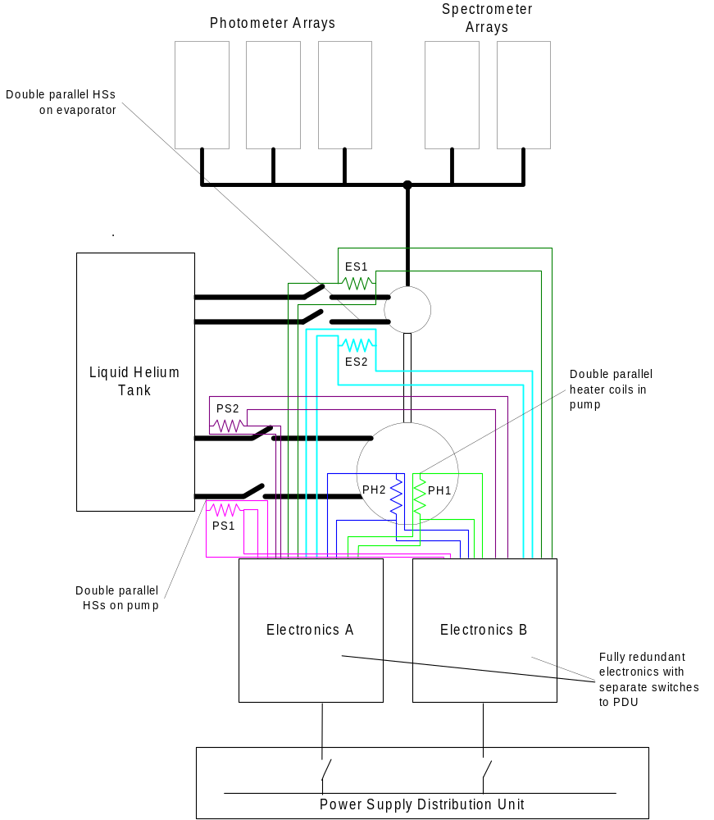
Figure 1: Option 1 configuration for the cooler with double parallel heat switches on both the pump and the evaporator. Notice the double wiring onto each heater going via separate connectors to separate electronics units.

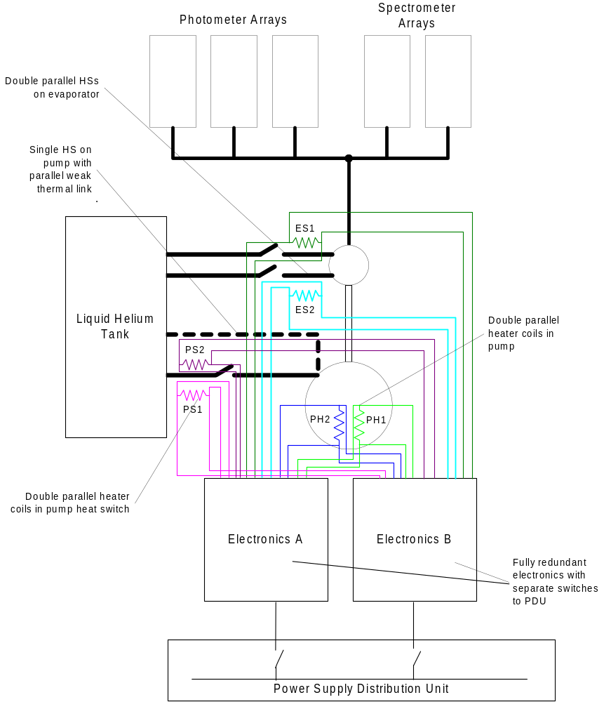
Figure 2: Option 2 configuration for the cooler. Here the second heat switch on the pump has been replaced by a permanent weak thermal link. The remaining pump heat switch has two heaters in its miniature sorption pump and the electrical configuration is the same as for Option 1.
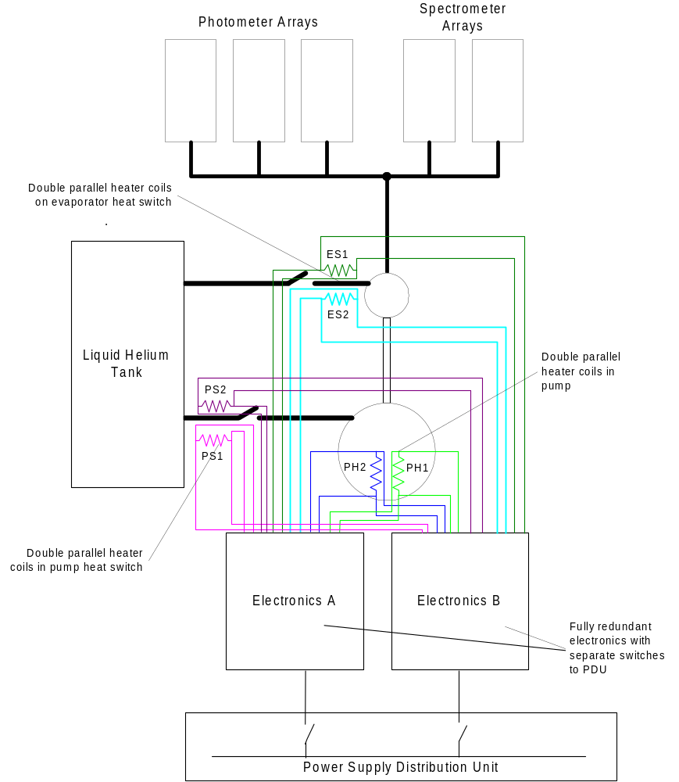
Figure 3: Option 3 configuration for the cooler. Only single heat switches are implemented on both the pump and the evaporator. The heat switches have double heaters on their miniature sorption pumps. Again the electrical configuration remains the same as for Options 1 and 2.
APPENDIX:
PREVIOUS NOTE ON THE COOLER REDUNDANCY.

Introduction
The SPIRE instrument will employ five bolometer arrays to detect radiation between 200 and 670 μm. In order to function correctly these arrays need the be cooled to 300 mK from the base temperature of the FIRST liquid helium cryostat of ~1.7-2 K. To achieve this a ³He sorption cooler will be fitted to the SPIRE instrument. This will be provided by CEA-SBT, Grenoble and is similar in design to the one that flew on the Japanese IRTS experiment. The design of the cooler was presented at the SPIRE PDR in July 1999.∗

The PDR review board highlighted the cooler sub-system as a potential single point failure for the SPIRE instrument and asked the instrument team to look at the possibilities for reducing the risk of total loss of instrument function. This note attempts to set out the constraints and options for the provision of cooler redundancy.

System Constraints
The major limitation on the provision of cooler redundancy is the extremely limited amount of space available. The 100x100x200mm envelope of the cooler can be accommodated – just – within the overall envelope of the instrument box. Fitting in a second cooler or a large increase in the envelope for the cooler will be very difficult to accommodate.

The second system constraint on the cooler is the thermal load on the liquid helium tank. The present design gives an average load of about 3 mW over the operational cycle. About 1 mW of this is the constant parasitic load and the other 2 mW comes from the recycling of the sorption pump. The SPIRE consortium is currently considering one of three options for the bolometer arrays – these have rather different thermal loads onto the liquid helium tank.

The total worst case thermal load from SPIRE into the helium tank is, including the cooler, about 10 mW for one of the detector options; the GSFC TES type. For another of the options, the JPL/Caltech spider web bolometers, the load comes entirely from the cooler and the structure parasitic load. Any increase in the load onto the helium bath has a direct effect on the mission lifetime and any increase must be strongly justified on the grounds of reliability, especially in the case where the cooler is the dominant load.

Other systems constraints such as wiring; mass; warm electronics etc are likely to be of second order difficulty compared to the envelope and thermal dissipation problems.

Options for redundancy
The possible options for providing a reliable cooler are described in this section. They range from two extremes – complete redundancy i.e. two separate coolers – to limited redundancy i.e. a single cooler as shown in the PDR with some extra components.

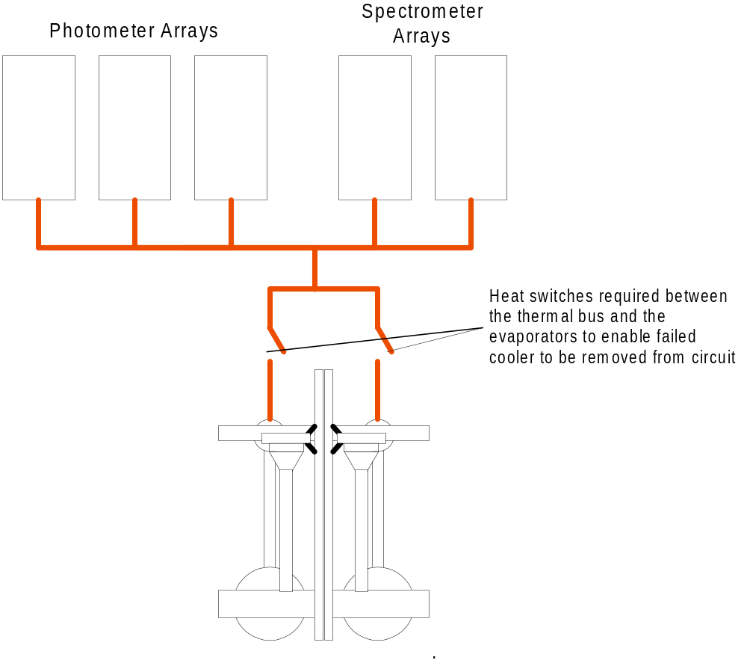
- Two coolers to all detectors:
In this option two complete cooler units would be fitted each of them connected to the thermal circuit that connects all five detector arrays. It is assumed that there would be no extra redundancy in the heat switches between the evaporator and the pump and the 2-K temperature stage. This option should provide insurance against any single random failure in any part of either cooler and still allow full operation of the instrument.
Figure 1: Option of two coolers in parallel for all five detector arrays

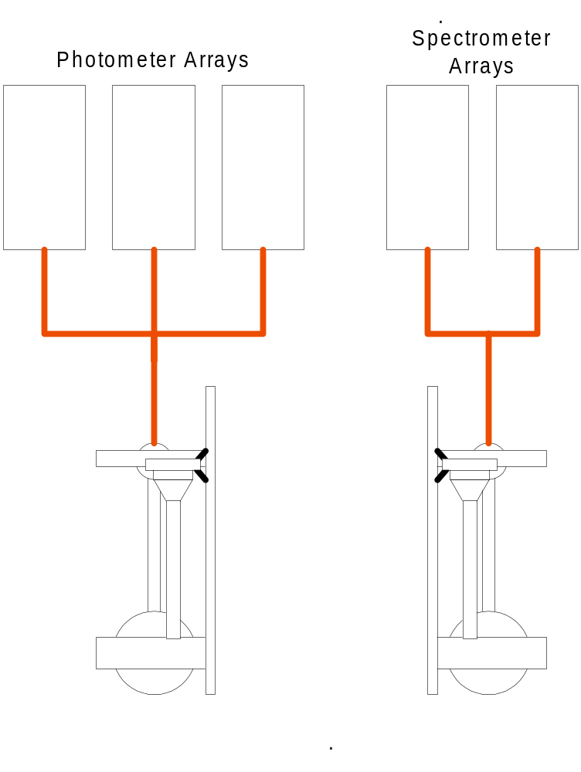
- Two coolers one for photometer one for spectrometer
Here the two sub-instruments each has its own cooler – again the assumption is that there would be no extra redundancy in the heat switches for the evaporator and pump in either of the coolers. This option would leave one or other of the sub-instruments operating in the event of a random failure in any part of either cooler.
Figure 2: Option of one cooler for photometer arrays and one for the spectrometer arrays
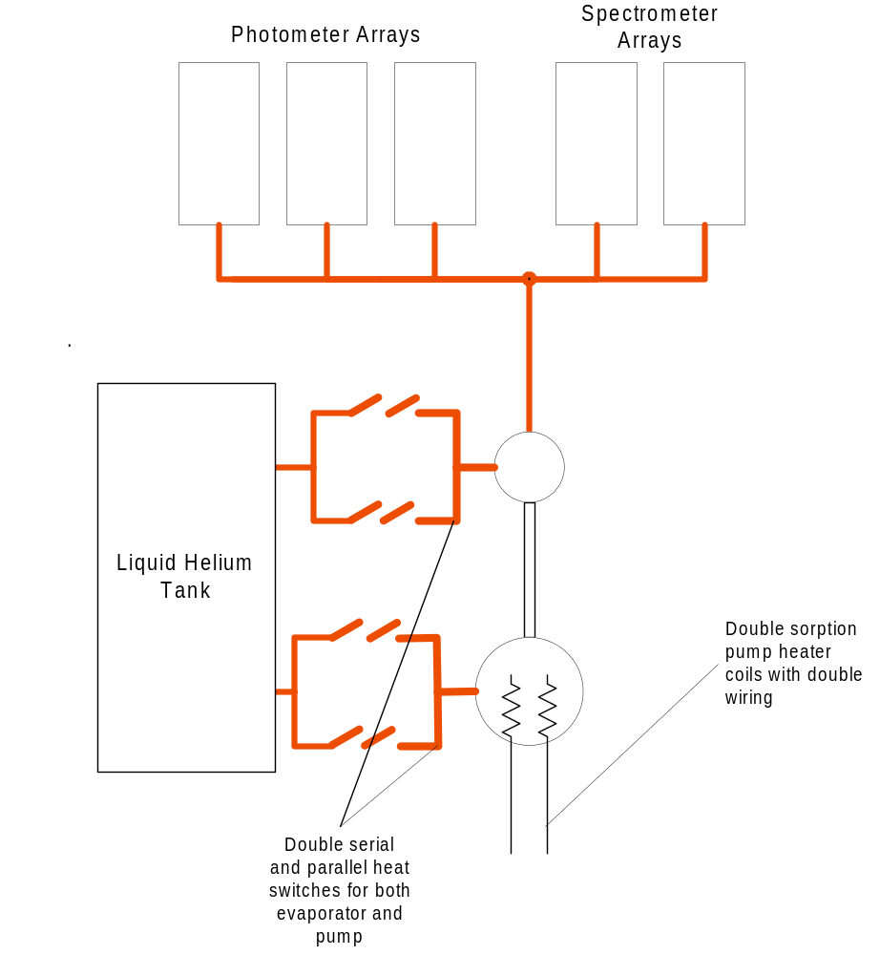
- Single cooler with fully redundant heat switches and heaters
In this option a single cooler is used with two serial pairs of heat switches in parallel on both the evaporator and the pump. In this way a failure of any one heat switch in the ON configuration – leading to a thermal shunt between the 2-K stage and the detectors – could be isolated by having its pair in serial switched off. The cooler would then be operated using the parallel pair of switches. In addition a second heating element could be provided as insurance against random failure of the pump heater. This option gives protection against random failure in all cooler elements except a rupture of the pumping line or poisoning of the pump charcoal.
Figure 3: Option for fully redundant heat switches and pump heater elements
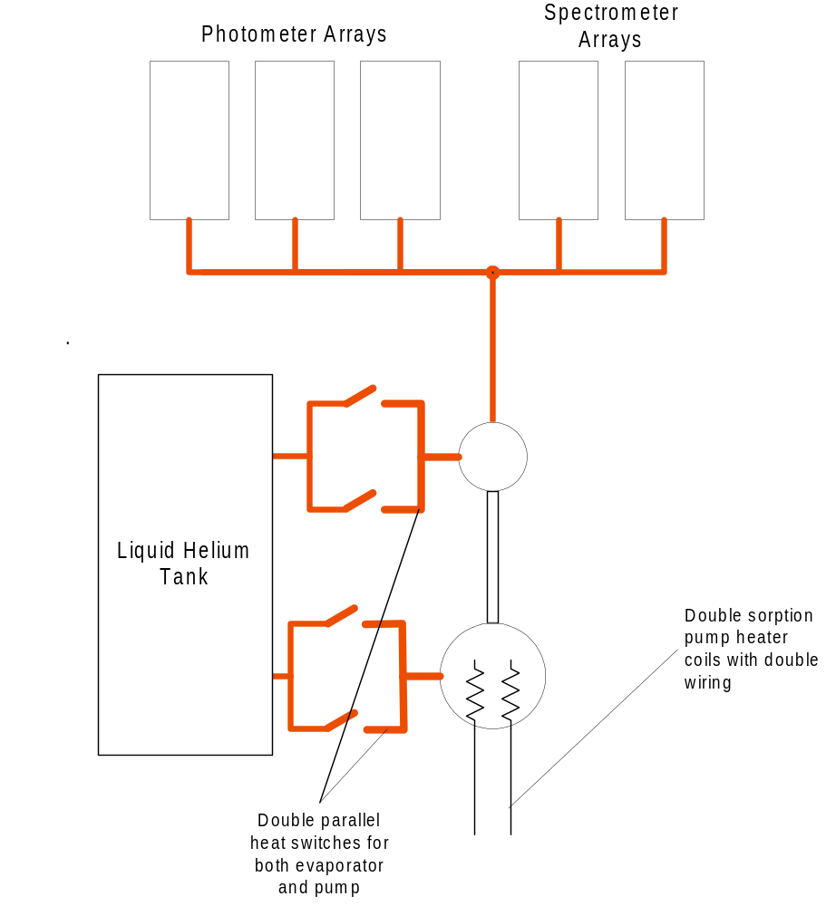
- Single cooler with partially redundant heat switches and fully redundant heater.
If we make the assumption that the failure of a heat switch can only occur by either a failure of the sorption pump or by the concentric shells touching with a weak thermal contact; then fully redundant serial pairs may not be necessary. In this option there are only parallel pairs of heat switches on the evaporator and pump and a double heating element in the pump. This protects against a random failure in any single heat switch if, and only if, the assumption stated here is correct. If a heat switch fails in such a way as to connect the evaporator to the 2-K stage the instrument is lost. If a heat switch fails connecting the pump to the 2-K stage, the instrument may still be able to function with reduced efficiency and increased thermal load on the liquid helium tank (Lionel – comment?).
Figure 4: Option for partially redundant heat switches and fully redundant pump heating elements.
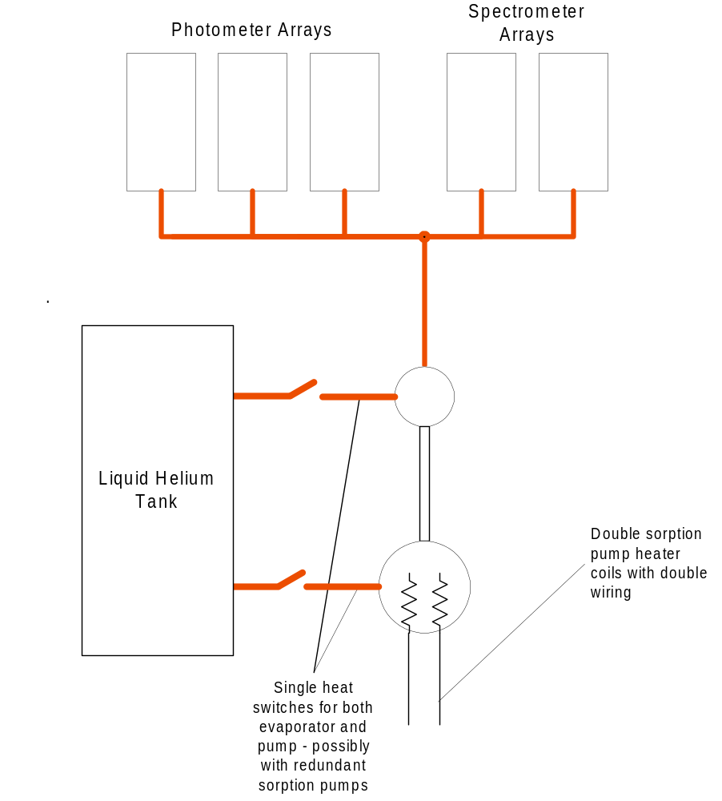
- Single cooler with redundant heating elements and single heat switches
This is essentially the cooler as presented at the PDR with the addition of an extra heating element in the pump. In the event of a failure of either heat switch sorption pump all instrument operation is lost. If there is a failure of the evaporator heat switch with a large thermal conductance the instrument is also lost. One could imagine a variation on this design that would offer more protection if it were possible to have two separate sorption pumps on each heat switch.
Figure 5: Option for present baseline with redundant pump heating elements and possibly redundant sorption pumps on the single heat switches.
- Single cooler with double pump chamber
Another variation on all the single cooler options would be to have a second complete pump unit on a single pumping line to the evaporator. This, in addition to insuring against failure of the heater element, would be presumed to give protection against poisoning of the charcoal in one or other of the pumps. I’m not sure that this assumption is valid as, without invoking the use of a vacuum valve, they would share the same gas. Therefore any contamination would likely end up in both pumps.
Assessment of the options
Here I give an assessment of the advantages and disadvantages of each of the options in terms of how well in insures against loss of the instrument and its impact on the system with respect to the current baseline. I have weighted the various items according to difficulty for the overall instrument design and impact on the overall reliability of the instrument. In doing the weighting I have considered that the most likely random failure modes, and therefore the ones that will attract higher scores if the option gives good redundancy, are (in order):
- Loss of pump heater element
- Loss of heat switch sorption pump heater element
- Launch failure of heat switch causing low thermal conductance across switch
- Launch failure of heat switch causing high thermal conductance across switch
- Poisoning of pump charcoal
- Rupture of pressure system
- Mechanical failure in Kevlar support system

Table 1 gives an assessment of the relative merits of the various options. For the systems issues a negative score has been given to each option in a range according to the adjudged severity of the systems impact of that option. For the risk reduction a single positive value is allocated to the option if it removes the perceived risk. These values are weighted between 1 and 10 depending on the estimated likelihood of the failure occurring. An additional score is given for the two cooler option 1 as it is the only one that will, potentially, remove the risk of any failure in the instrument operation for a single random failure in the cooler. This is mainly to differentiate this option from option 2.

Discussion
Estimation and interpretation of risk is, naturally, highly uncertain and this exercise is no different. However, it does show that using two coolers does not necessarily provide a total solution to our problem. This would be especially true if the true weight of “completely impossible” were given to the issue of accommodating a whole second cooler into the instrument. Adding a complete second pump also doesn’t appear to offer very much advantage over doubling up the heating element in a single pump.

What is the choice between the other options? If it were possible to have redundant sorption pumps on the heat switches, my choice would be option 5 as this will have least impact on the system. If not then option 4 is the next best. Whatever else a much more thorough study on the likely failure modes of the heat switches would be extremely useful. Note that none of these options protects against a design fault in the cooler components. The only way around this would be, for instance, different heater technology for the redundant pump heating elements and a different heat switch technology for the redundant heat switches. I don’t know whether this is feasible
 | Score  or  Range | Option 1:  Two coolers all detectors | Option 2:  Two coolers phot/spec | Option 3:  Single cooler  Full Red. HS/Heater | Option 4:  Single Cooler  Part. Red. HS  Red Heater | Option 5:  Single Cooler  No red. HS  Red. Heater | Option 6:  Option 3-5 with red. pump  Add to score
Systems Issues
Accommodation | -10 to 0 | -10 | -10 | -5 | -3 | 0 | -7
Thermal load | -5 to 0 | -5 | -3 | -1 | 0 | 0 | -1
Complexity | -5 to 0 | -5 | -3 | -3 | -1 | 0 | -3
Risk Insurance |  | 0
Pump Heater | 10 | 10 | 10 | 10 | 10 | 10 | -
HS Sorption Pump | 7 | 7 | 7 | 7 | 7 | 0 (7)¹ | -
HS fails on - low conductance | 5 | 5 | 5 | 5 | 5 | 0 | -
HS fails on - high conductance | 3 | 3 | 3 | 3 | 0 | 0 | -
Pump poisoning | 2 | 2 | 2 | 0 | 0 | 0 | 0 (2)²
Pressure vessel rupture | 1 | 1 | 1 | 0 | 0 | 0 | -
Failure of Kevlar support | 1 | 1 | 1 | 0 | 0 | 0 | -
Partial instrument loss | 3 | 3 | 0 | 0 | 0 | 0 | -
Total Score | 34 (max) | 12 | 13 | 16 | 18 | 10 (17) | -11 (-9)
Table 2: Assessment of relative merits of the cooler redundancy options.
¹ If redundant sorption pump heaters can be fitted then this option gets full score.
² If it can be shown that the redundant pump protects against poisoning then this option gets full score.

 The vu-graphs from the PDR presentation are available from the SPIRE project office on request if you don’t have DMS access.

